# CS410c Lab NoteBook

Taisheng Guo

Baiwei Yu



**CS410c Lab NoteBook** **1**

**ARP Lab #1 (Option #2) (Taisheng)** **4**

**ARP Lab #2 (Baiwei)** **7**

**Network Lab #1 (Netsim) (Taisheng)** **12**

**Network Lab #2 (IPv6) (Baiwei)** **15**

**Network Lab #3 (nmap) (Baiwei)** **20**

**Network Lab #4 (Subnets in the cloud)(Taisheng)** **24**

**Transport Lab #1: netstat, nc (Baiwei)** **27**

**Transport Lab #2: iperf and TCP cwnd (Taisheng)** **32**

**HTTP Lab #1: HTTP headers, DevTools(Baiwei)** **39**

**HTTP Lab #2: QUIC/HTTP2(Baiwei)** **43**

**DNS Lab #1: Basics(Baiwei)** **46**

**DNS Lab #2: Iterative lookup(Baiwei)** **51**

**DNS Lab #3: Names of hosts on a subnet(Baiwei)** **58**

**Network Recap Lab #1: Full trace analysis(Baiwei)** **61**

**CDN Lab #1: Geographic DNS (Baiwei)** **67**

**CDN Lab #2: HTTP load balancing(Baiwei)** **74**

**Databases Lab #1(Baiwei)** **81**

**Databases Lab #2 (Cloud SQL)(Baiwei)** **82**

**Container Lab #1(Taisheng)** **87**

**Container Lab #2(Taisheng)** **93**

**Container Lab #3 (Taisheng)** **95**

**Container Lab #4 (Taisheng)** **96**

**Cloud Storage Lab #1 (Baiwei)** **100**

**IAM Lab #1 (Taisheng)** **103**

**Google Cloud Storage Lab #2 (Baiwei)** **104**

**Compute Engine Lab #1 (Taisheng)** **111**

**App Engine Lab #1 (Taisheng)** **119**

**App Engine Lab #2 (Taisheng)** **122**

**Cloud Datastore Lab #1(Taisheng)** **128**

**Spanner Lab #1(Taisheng)** **139**

**Kubernetes Lab #1(Taisheng)** **141**

**Cloud Functions Lab #1(Taisheng)** **150**

**Cloud Functions Lab #2(Taisheng)** **152**

**Cloud Functions Lab #3(Taisheng)** **159**

**ML APIs Lab #1(Taisheng)** **167**

**ML APIs Lab #2(Taisheng)** **175**

**ML APIs Lab #3(Taisheng)** **182**

**Firebase Lab #1(Taisheng)** **188**

**BigQuery Lab #1(Taisheng)** **202**

**BigQuery Lab #2(Taisheng)** **207**

**BigQuery Lab #3(Taisheng)** **213**

**Cloud Datalab Lab #1(Taisheng)** **219**

**Cloud Datalab #2(Taisheng)** **225**

**Cloud Dataproc Lab #1(Taisheng)** **228**

**Cloud Dataflow Lab #1(Taisheng)** **236**

**Data Science Lab #1(Taisheng)** **243**

# 

# ARP Lab #1 (Option #2) (Taisheng)

* **ssh** [**cs410c@pochacco.cs.pdx.edu**](mailto:cs410c@pochacco.cs.pdx.edu) **(password given in class)**
  + **Zodiac machines on this subnet are**
  + **rabbit.cs.pdx.edu**
  + **boar.cs.pdx.edu**
  + **dragon.cs.pdx.edu**
  + **ox.cs.pdx.edu**
  + **rat.cs.pdx.edu**
  + **dog.cs.pdx.edu**
  + **horse.cs.pdx.edu**
  + **monkey.cs.pdx.edu**
* **Use the** ifconfig **command to find the IP address and hardware address of the local ethernet card interface**
  + 
* **Use the** arp **command to list all entries in your machine's ARP cache**
  + 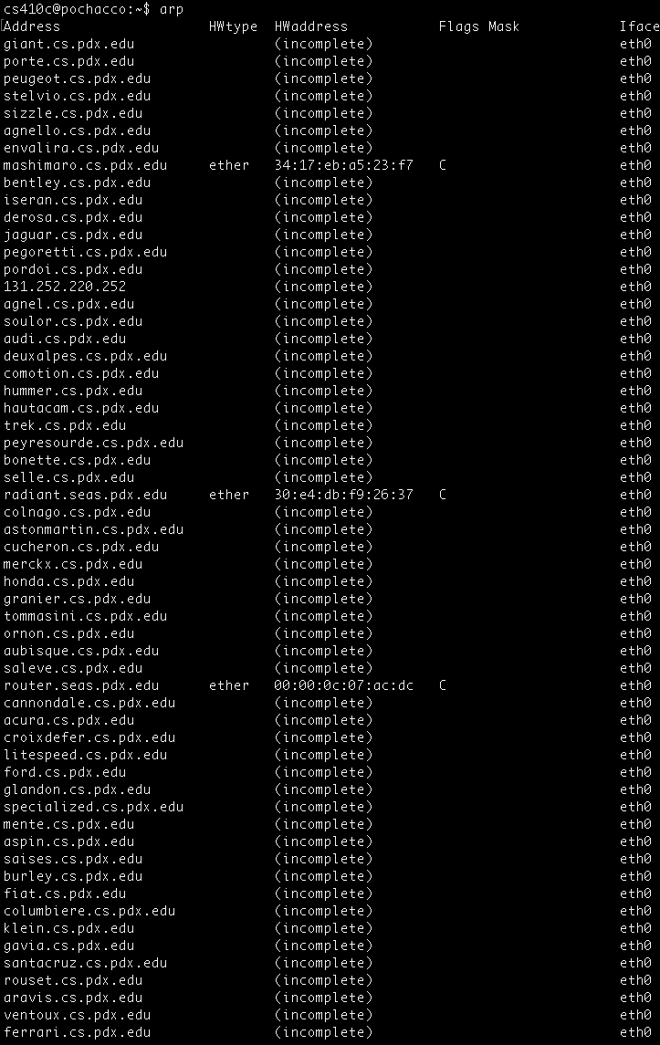
  + 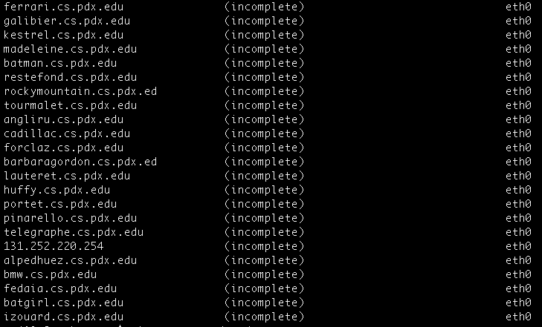
* **Then, find a Zodiac machine not in your ARP cache (or that has an incomplete entry)**
  + rat.cs.pdx.edu is not in the ARP cache.
  + **If you can not find one, let the instructor know or wait 5 minutes**
  + ping **the machine**
    - 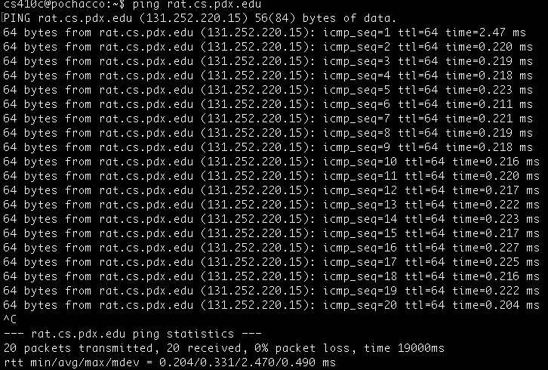
  + **Run the** arp **command again and locate the machine's hardware address**
    - 

# ARP Lab #2 (Baiwei)

* **On your UbuntuVM, install** wireshark
  + **sudo apt-get update**
  + **sudo apt-get install –y wireshark**

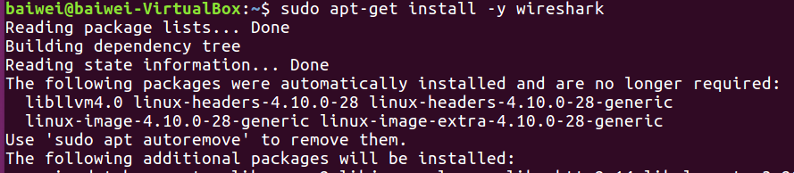

* **Use the** ifconfig **command to find the IP address and hardware address of the local virtual ethernet card interface**

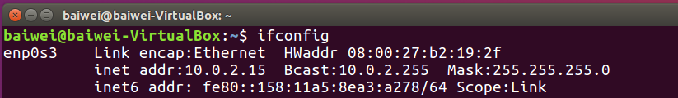

* **Perform a** netstat –rn **to find default router's IP address**

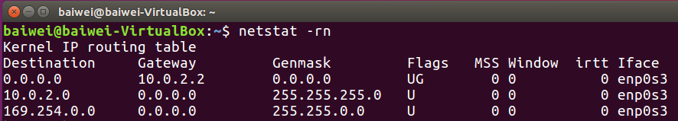

The default router’s IP address is 10.0.2.2

This also matches the networking setting in VM:

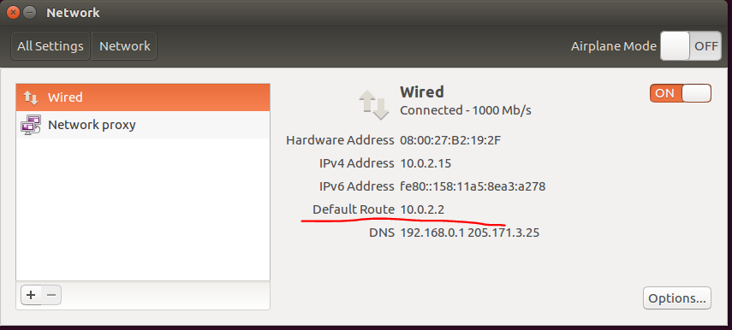

* **Ping the default router and use arp to find its hardware address**

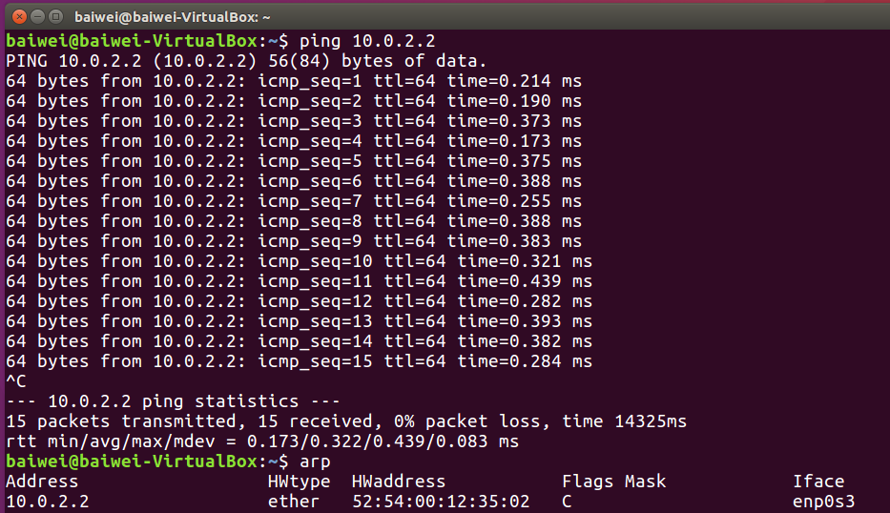

* **Perform a** sudo wireshark
  + **Begin capture on your VMs virtual ethernet interface**
  + 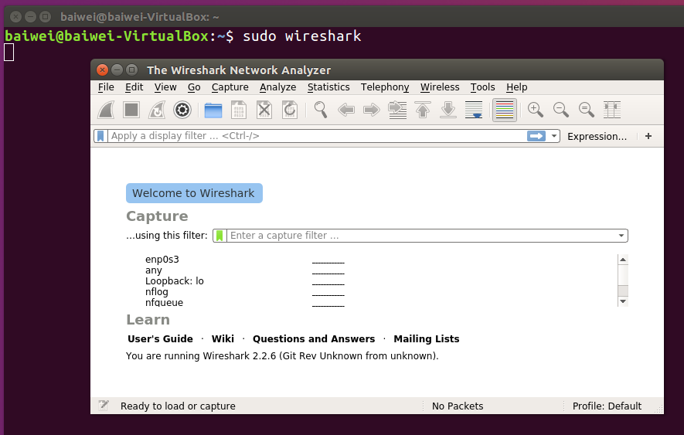
  + **Use a Capture Filter to capture ICMP (more later)**

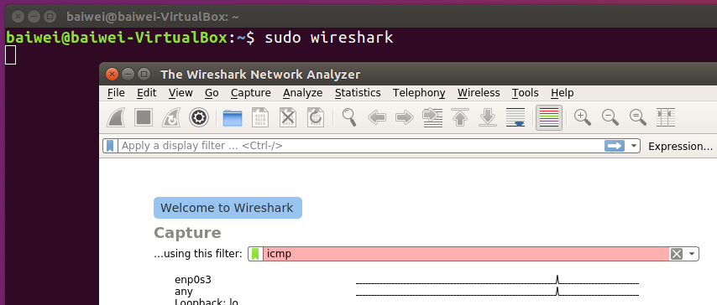

* + **Then, in a separate terminal, ping** [**www.google.com**](http://www.google.com)
  + 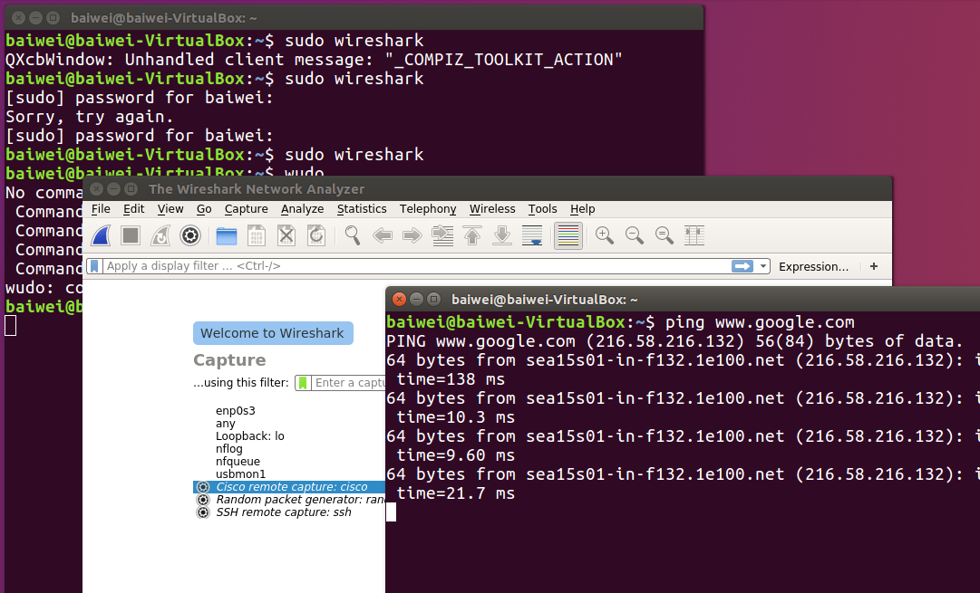
  + **Click on the request packet in the top window**
    - **In the middle window, expand the data-link layer packet and click on the source and destination hardware addresses**

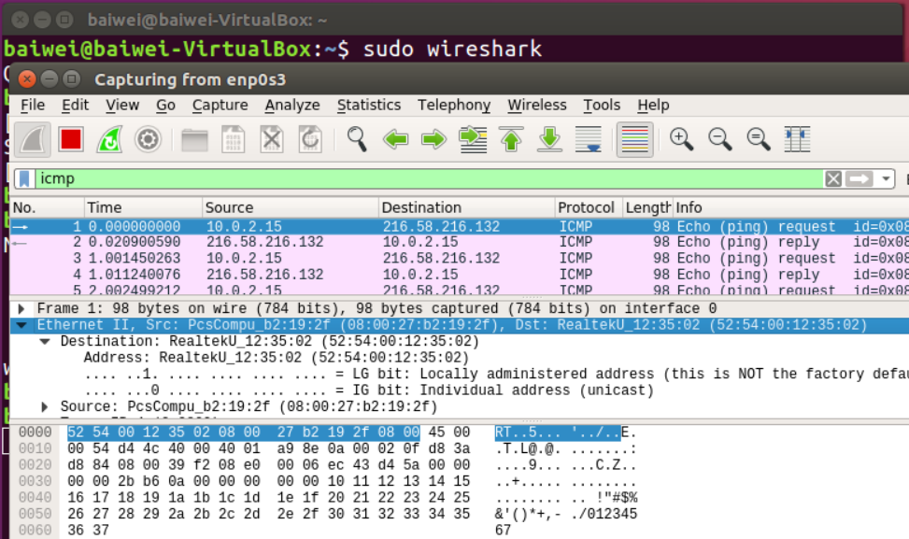

* + **Who owns the destination hardware address of the packet?**

**-** It is owned by Realtek.

* + **Show the bytes in the packet dump window as shown below**

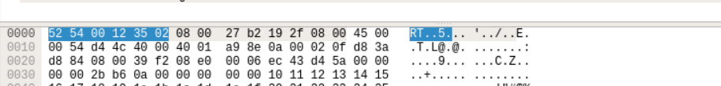

* + **Repeat using with the response packet**

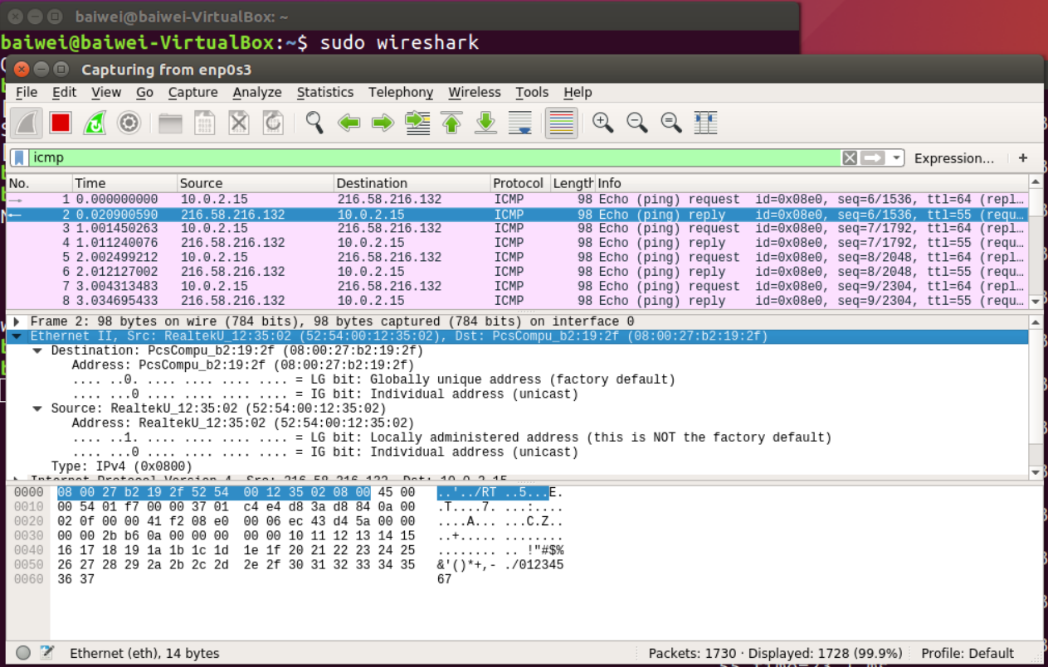

# Network Lab #1 (Netsim) (Taisheng)

* **Create an account and complete all levels of Netsim**
  + [**https://netsim.erinn.io**](https://netsim.erinn.io)
* **Show screenshot of completed list of levels**
* **For Level #5**
  + **Show packet before it hits modem**
    - 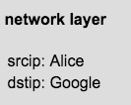
    - 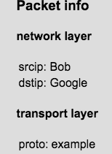
  + **Show packet after it leaves modem**
    - 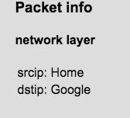
    - 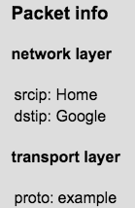
* **For the ping and traceroute levels, ensure ICMP is capitalized when specifying the proto field3**
  + 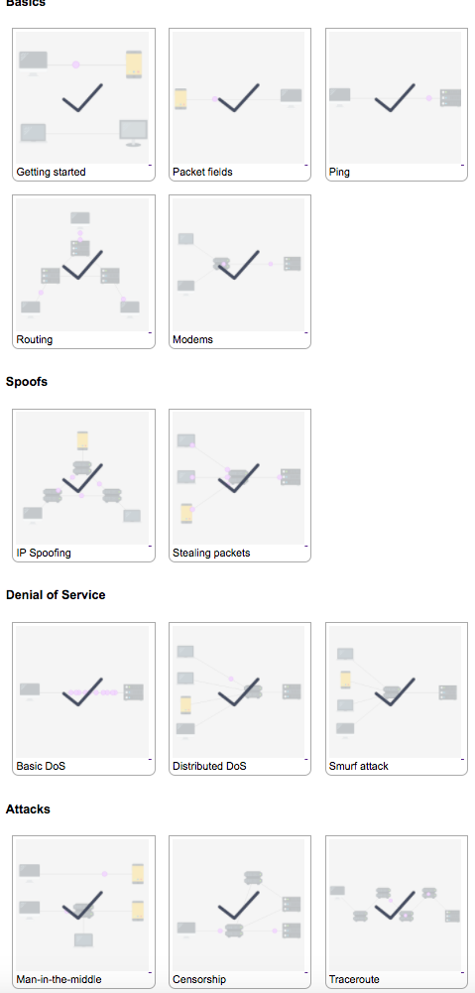

# Network Lab #2 (IPv6) (Baiwei)

* **ping/ping6**
  + **Find your favorite machine in the Particle lab**
    - [**https://cat.pdx.edu/labstatus/labs/cslinlabb/**](https://cat.pdx.edu/labstatus/labs/cslinlabb/)

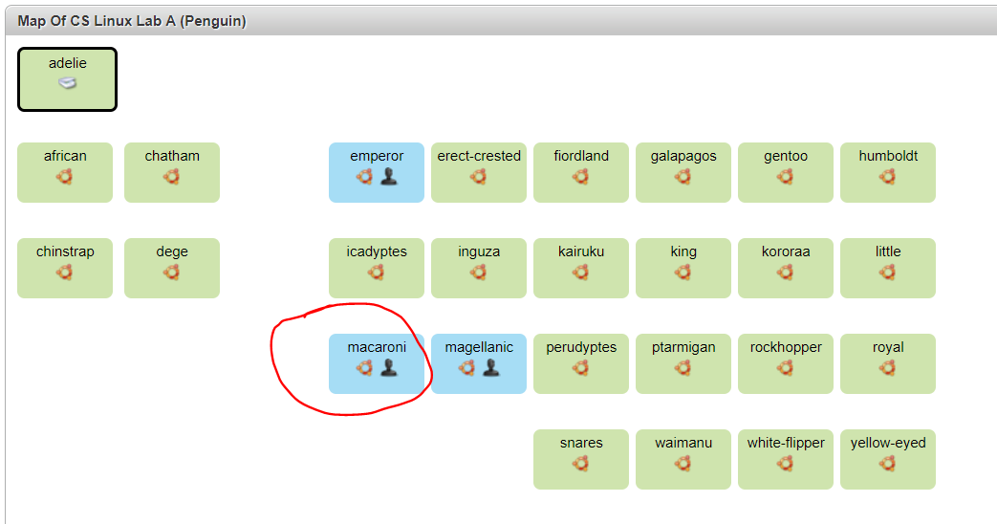

I pick this machine to do the lab.

* + **Find its IPv4 and IPv6 address by ssh'ing into it and performing an ifconfig**

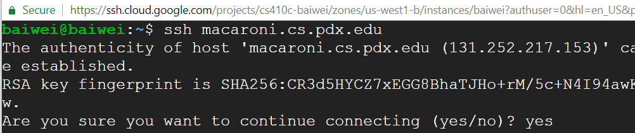

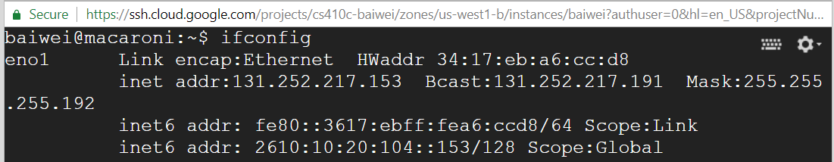

* + **From your local Penguin machine, use both ping and ping6 to ping its IPv4 and IPv6 addresses**

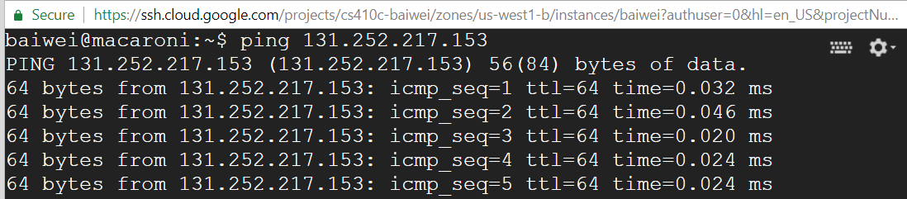

(ping)

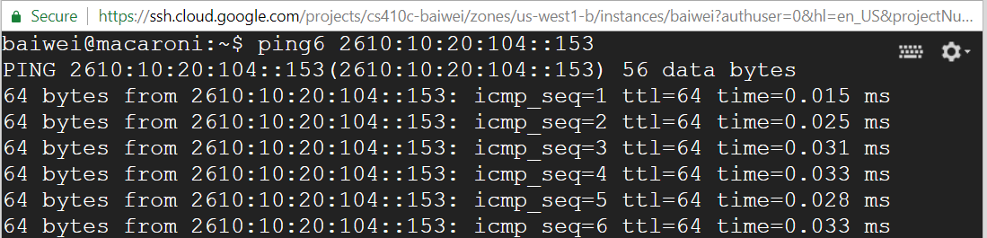

(ping6)

* **traceroute/traceroute6**
  + **Perform a traceroute to 1.1.1.1**
    - **What is the name that traceroute returns for this IP address?**

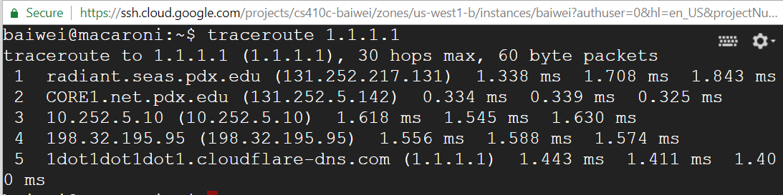

The name returns for this IP address is

**

* + - **With that name, perform the following and examine the "ANSWER" section to find the IPv6 addresses associated with the name**
      * + **dig -t AAAA <name>**

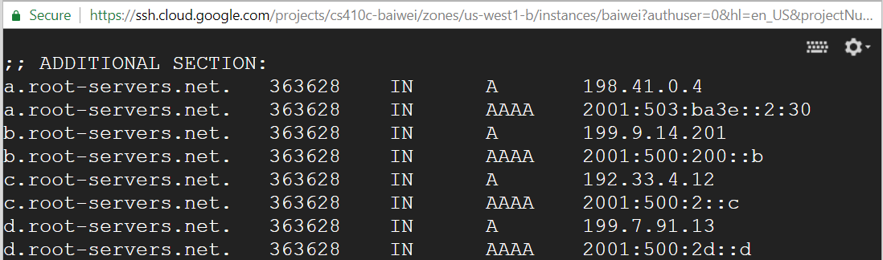

One of the IPv6 address is 

* + - **Then, perform a traceroute6 to one of its IPv6 addresses**

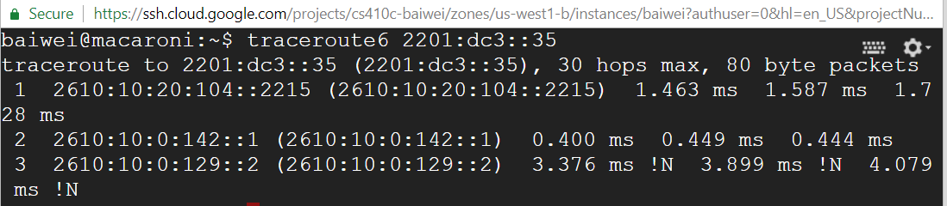

* + - **Does the traceroute end up at the same place?**

The traceroute6 doesn’t end up at the same place.

* **Perform a traceroute to up.edu and facebook.com**
  + **Do the packets stay in Oregon?**

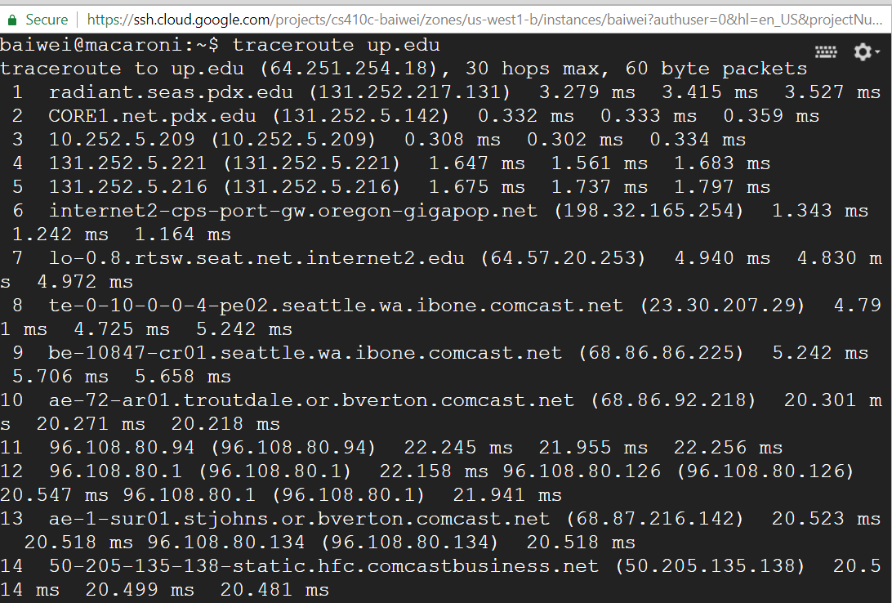

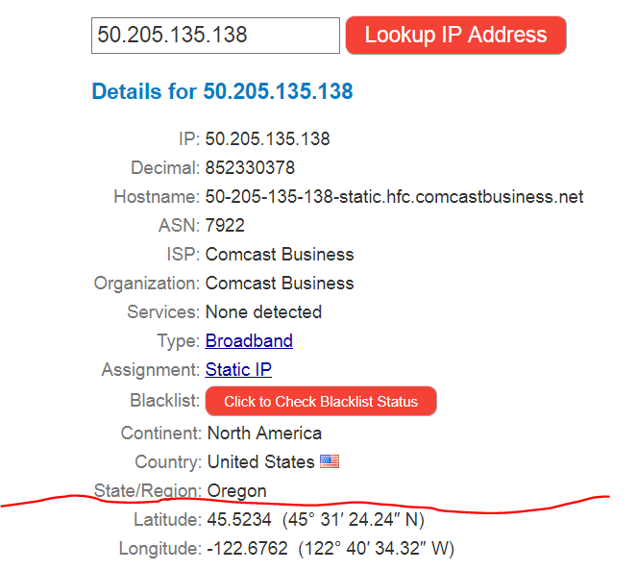

(*up.edu* ends up staying in Oregon.)

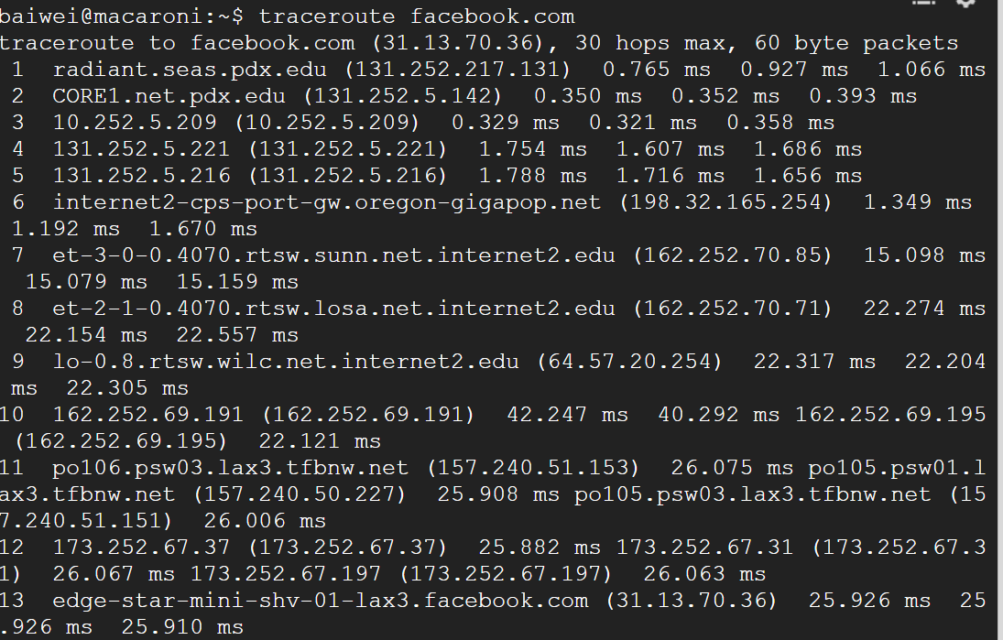

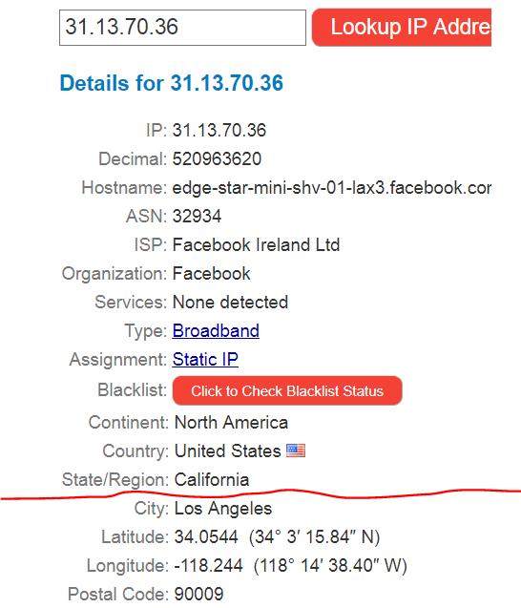

(*facebook.com* doesn’t stay in Oregon)

# Network Lab #3 (nmap) (Baiwei)

* **This lab will give you experience with Google's Compute Engine and its offerings in Cloud Launcher as well with nmap, a standard tool for performing network security auditsewf**
* **Launch a Ubuntu 16.04 instance on Compute Engine using the default machine type (3.75 GB of memory)**
  + **Then**
    - **sudo apt-get update**



* + - **sudo apt-get install nmap**

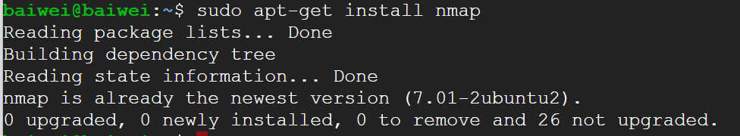

* **Go to Google Cloud Launcher**

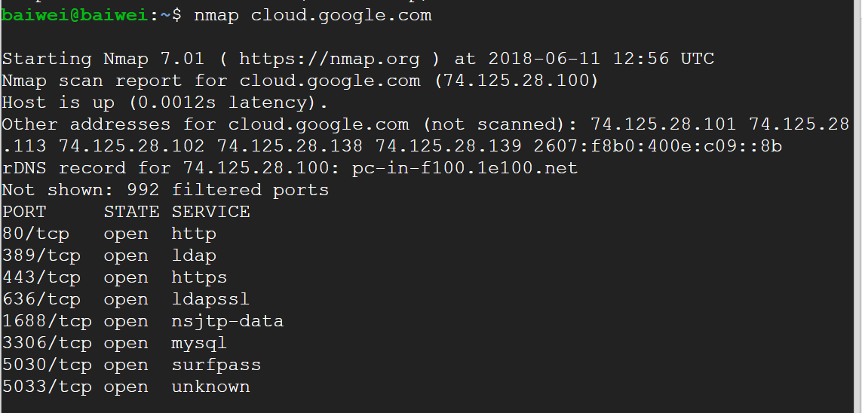

* + **Filter on Virtual Machines**
  + **Then select Blog & CMS as the Category**
  + **Bring up 3 solutions with the following settings**
    - **Zone: us-west1-b**
    - **Machine type: micro**
    - **Deselect “Allow HTTPS traffic”**
    - **Show the landing page for each VM to ensure it has been deployed properly**

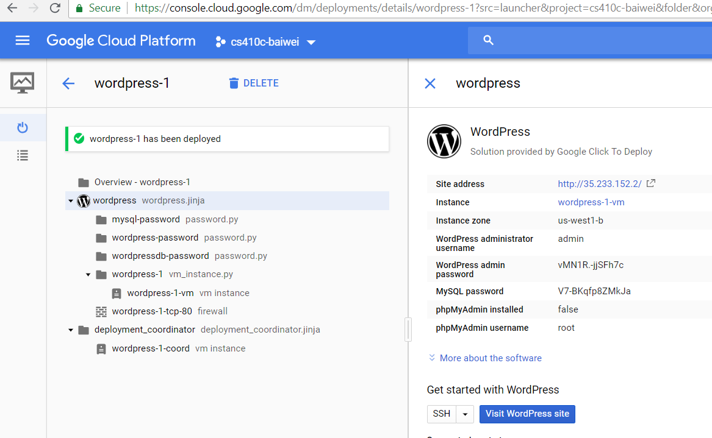

* + - **Note the “Internal IP address” of each instance**

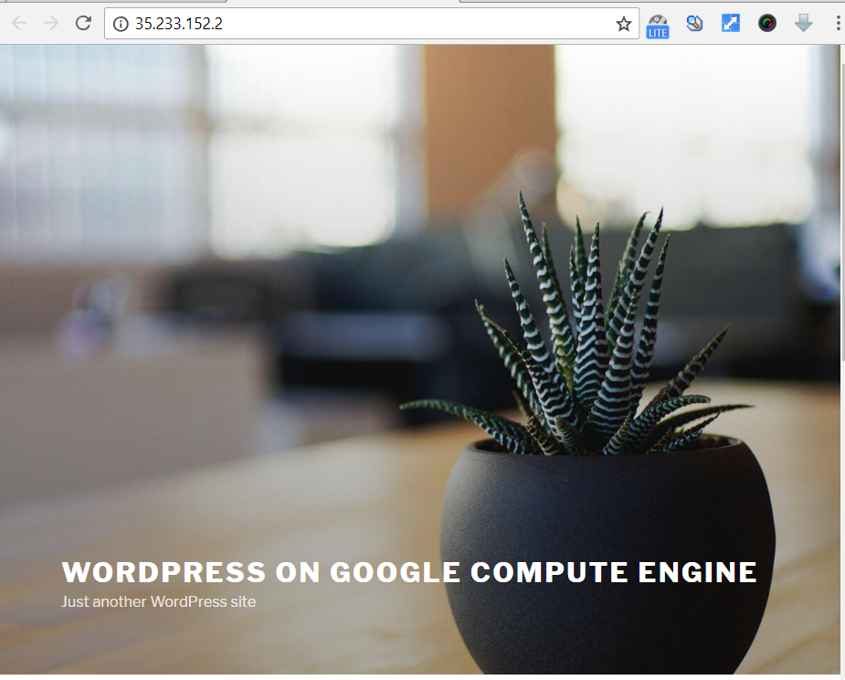

* **Run nmap on the internal subnet the instances have been placed on**
  + **nmap w.x.y.z/24**
  + **Show output for the scan**

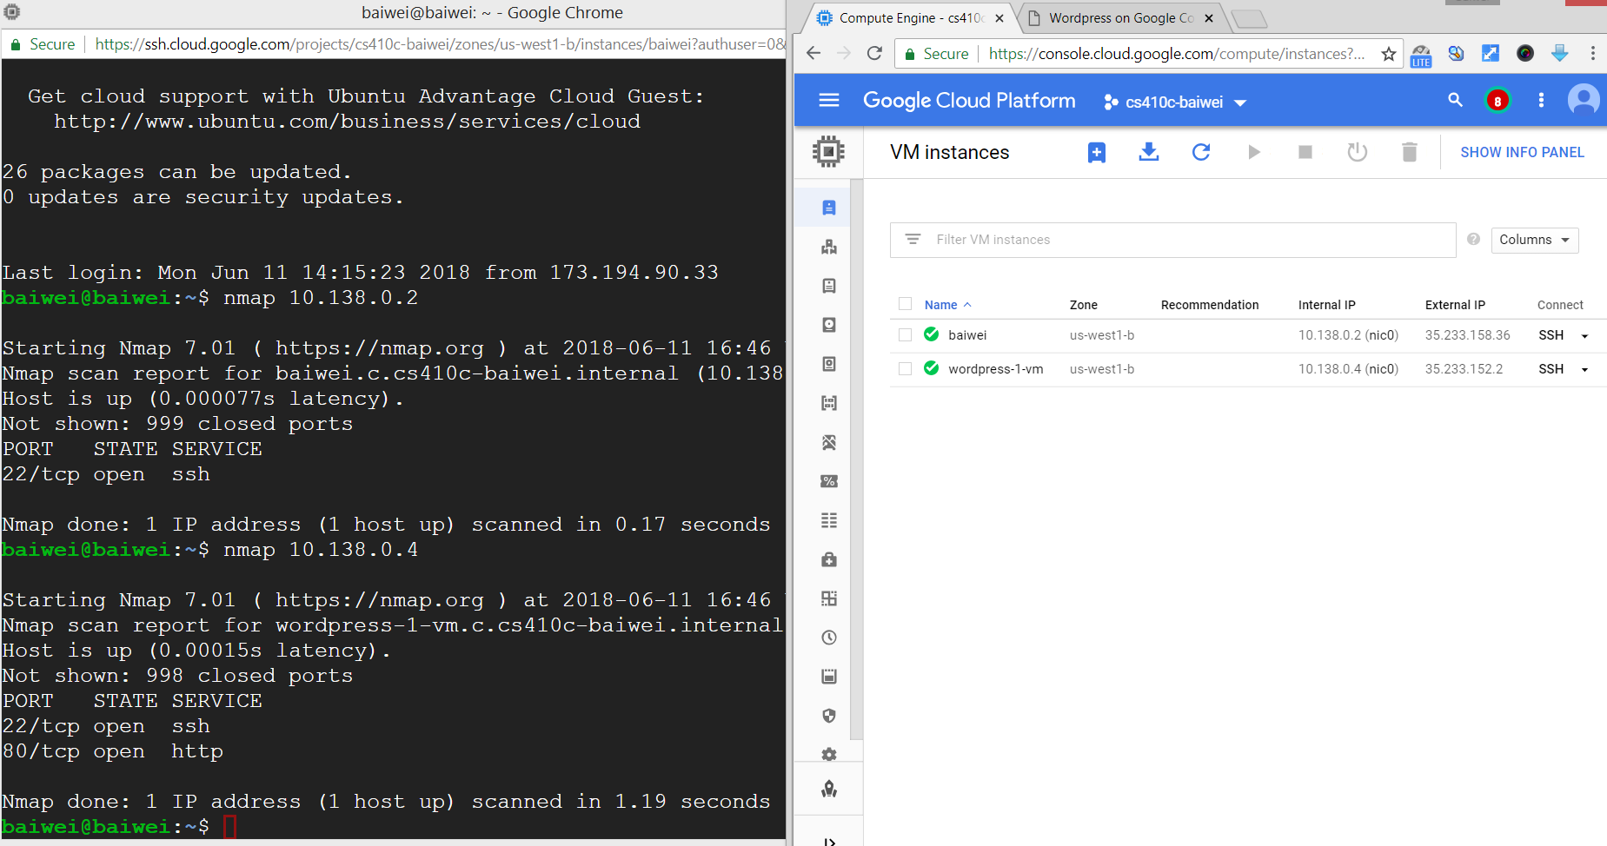

* **Shutdown the instances**

# Network Lab #4 (Subnets in the cloud)(Taisheng)

[**https://codelabs.developers.google.com/codelabs/cloud-subnetworks**](https://codelabs.developers.google.com/codelabs/clou)

* **Setup and requirements**
  + 
* **Initialize your project environment**
  + 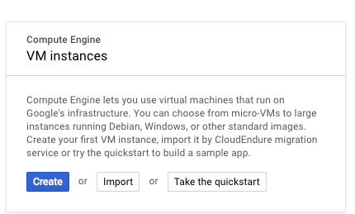
* **Start cloud shell**
  + **set region/zone to local Google datacenter**
  + 
* **Regional subnetworks**
  + 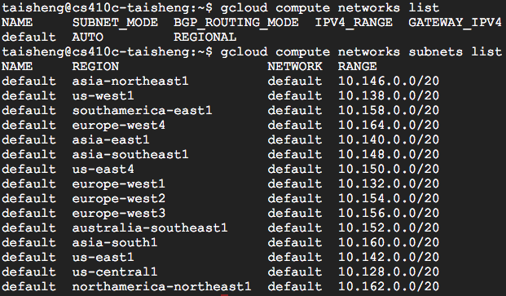
  + create a virtual machines:
  + 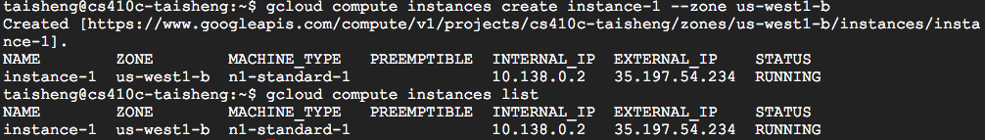
* **Custom subnetworks**
  + Create a custom network
  + 
  + Create subnetworks within it
  + 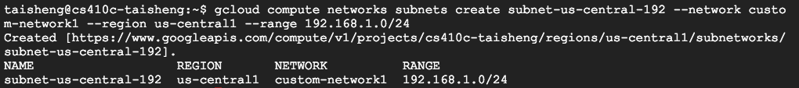
  + 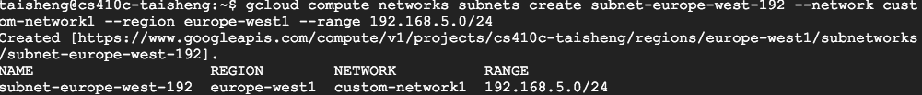
  + 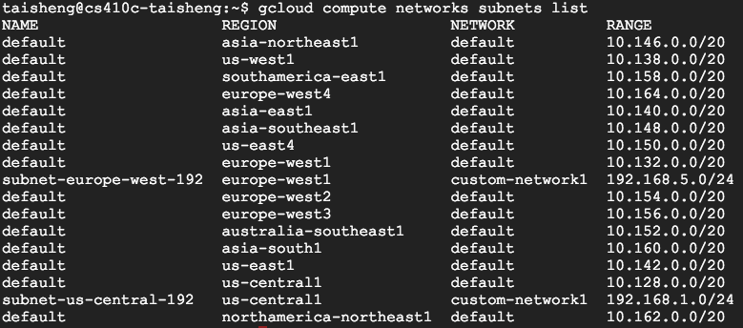
* **Isolating subnetworks**
  + Create instances on each of the subnetworks
  + 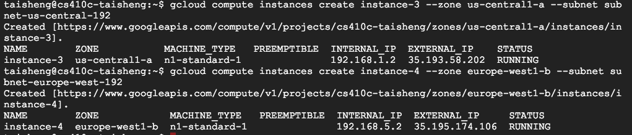

# Transport Lab #1: netstat, nc (Baiwei)

* **Login to a linuxlab machine**
  + **Perform a netstat –l –t -4 to find all listening sockets on the machine (those accepting incoming connections)**
    - **The command flags specify sockets listening on TCP ports on IPv4 interfaces**
      * **If the -4 flag does not work, omit it (you are on an IPv4-only machine)**
      * **Note that as a superuser, you can add a –p flag to determine the program that owns each socket**

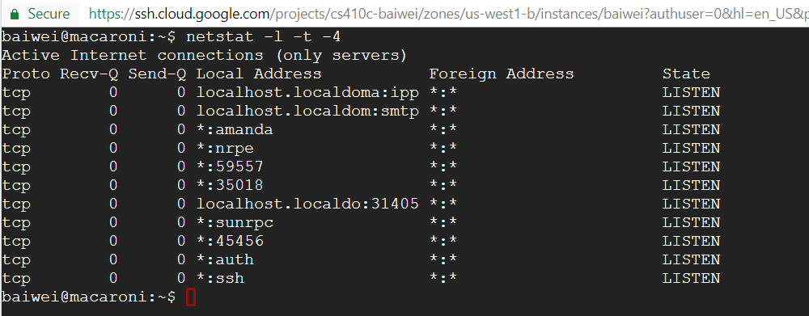

* + - **Examine the "Local Address" field**
      * **Servers such as ssh and nginx typically listen on "*" to accept connections from on any interface (INADDR_ANY when specifying socket)**
      * **Servers intended for local access listen only on the loopback interface (INADDR_LOOPBACK) (described via man 7 ip)**
    - **For the named services**
      * **Identify whether they are listening on all interfaces or are local**

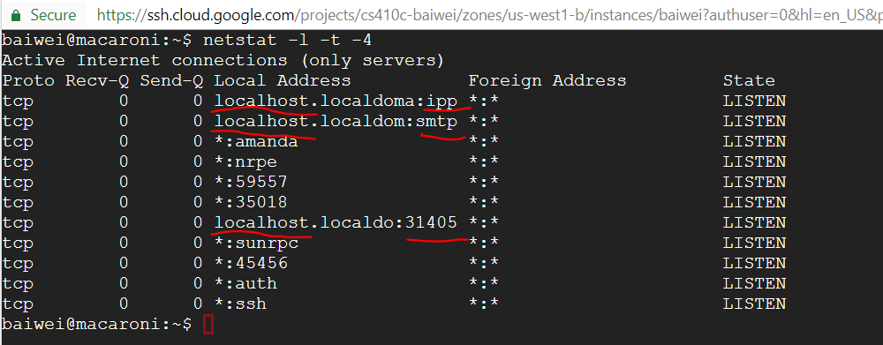

The local services are highlighted above.

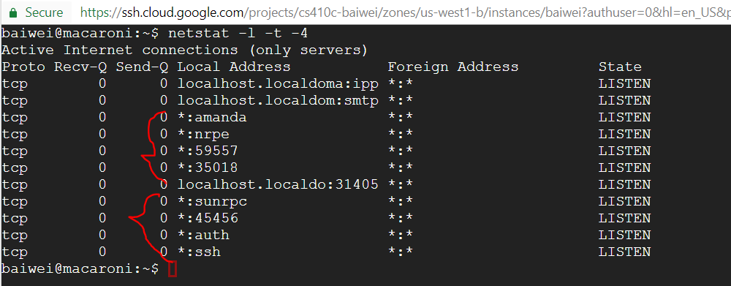

Service are listening on interfaces above.

* + - * **Then, look up their descriptions in /etc/services to find out what they are**















* + - * **Note: netstat *should* provide the same information as an external nmap scan from the previous lab unless malware has been installed to hide itself locally on the machine**
  + **Repeat the exercise on your Ubuntu VM to identify what default services are installed**

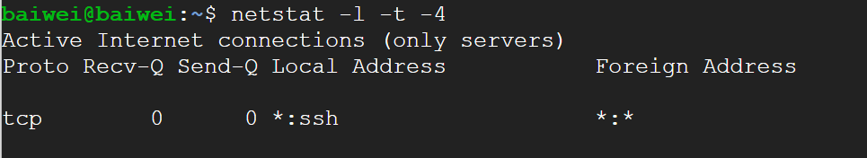





* **On the linuxlab machine**
  + **Use ifconfig to find the IP address of the machine**

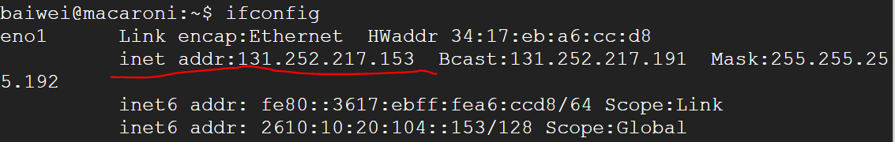

* + **netcat (nc) is a program that can connect to arbitrary ports on a server**
    - **For example, the following command connects up to the web server (port 80) of 131.252.220.66**
      * **nc 131.252.220.66 80**
  + **Using the IP address of the machine, use nc to connect up to the ssh port in order to identify the version of ssh that is being used on linuxlab machines (Control-c to exit)**

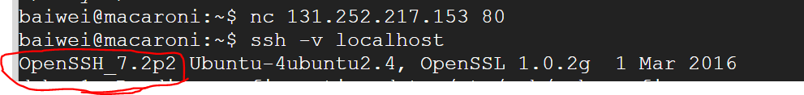

* + **Recall the "Local Address" settings previously listed**
    - **Using the IP address of the machine, try and use nc to connect up to the mail transfer port. What happens?**

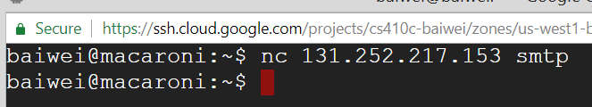

I am not sure if I did something wrong here. The command above has no response.

* + - **Replace the IP address with localhost and try again. What software is being used to transfer mail on this machine?**

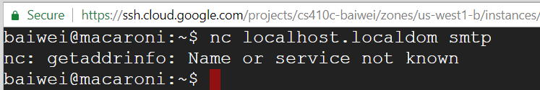

The same result as above, the command has no response.

# Transport Lab #2: iperf and TCP cwnd (Taisheng)

* **In this lab, we'll look at TCP throughput (as determined by its window size) based on round-trip times**
* **On GCP, go to Compute Engine and create 3 VMs**
  + **Zone: one in us-west1-b, one in Australia, and one in Europe**
  + **Machine type: micro**
  + **Boot disk: Ubuntu 16.04**
  + **Allow HTTP on both**

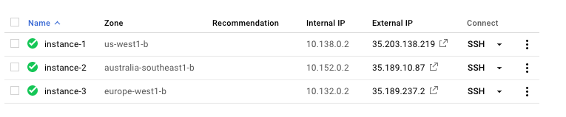

* **ssh into each and install** iperf
  + sudo apt-get update
  + sudo apt-get install iperf

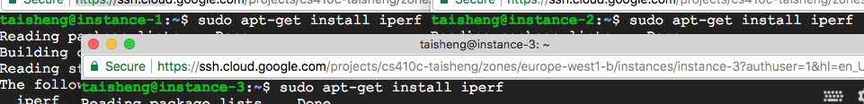

* **Start the** iperf **server on the HTTP port (80) of all VMs and note the external IP address of each instance**
  + sudo iperf –s –p 80



* **On your Ubuntu 16.04 VM on linuxlab**
  + **Perform the following to install** xmgrace **and** iperf
    - sudo apt-get update
    - sudo apt-get install iperf grace
    - 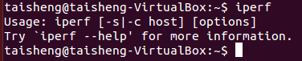
  + **Install the TCP probe module into the Linux kernel and set it to trace connections to/from port 80. Make the probe output readable**
    - sudo modprobe -r tcp_probe
    - sudo modprobe tcp_probe port=80 full=1
    - sudo chmod 444 /proc/net/tcpprobe



* + **In this setup, your local VM will attempt to send as much data as possible to each of the 3 GCP VMs. The** tcp_probe **kernel module will periodically sample the state of TCP in order for it to be dumped out.**
* **Trace the connection to the us-west server**

cat /proc/net/tcpprobe > uswest.raw &

TCPCAP=$!

iperf -c 35.203.138.219 -p 80

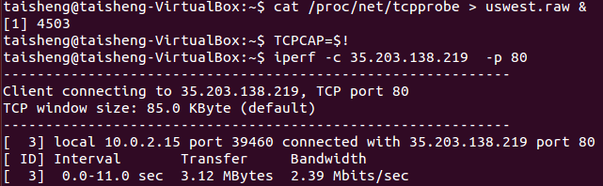

**(Wait for 10 seconds)**

kill $TCPCAP

cat uswest.raw | awk '{print $1 " " $7}' >| uswest.out



* /proc/net/tcpprobe **is the file system interface for pulling data out of the kernel module. Performing a** cat **on it will stream the measurements into the file** uswest.raw
* $! **in the shell gives the PID of the backgrounded** cat **process. Its value is saved into an environment variable before killed**
* awk **statement prints the first and seventh field of the file (timestamp and** cwnd **value)**
* **Repeat for the European server**

cat /proc/net/tcpprobe > ~/eu.raw &

TCPCAP=$!

iperf -c 35.189.237.2 -p 80

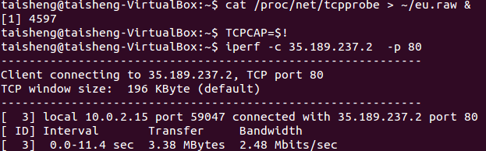

**(Wait for 10 seconds)**

kill $TCPCAP

cat eu.raw | awk '{print $1 " " $7}' >| eu.out



* **Repeat for the Australian server (10 seconds)**

cat /proc/net/tcpprobe > ~/aust.raw &

TCPCAP=$!

iperf -c 35.189.10.87 -p 80

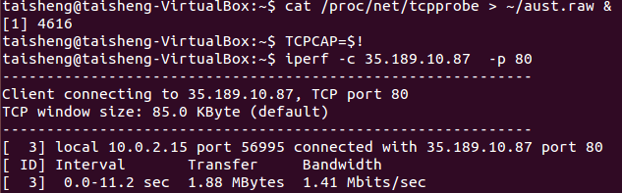

**(Wait for 10 seconds)**

kill $TCPCAP

cat aust.raw | awk '{print $1 " " $7}' >| aust.out



* **Plot the output using xmgrace and take screenshots of each (or plot them all together)**

xmgrace uswest.out

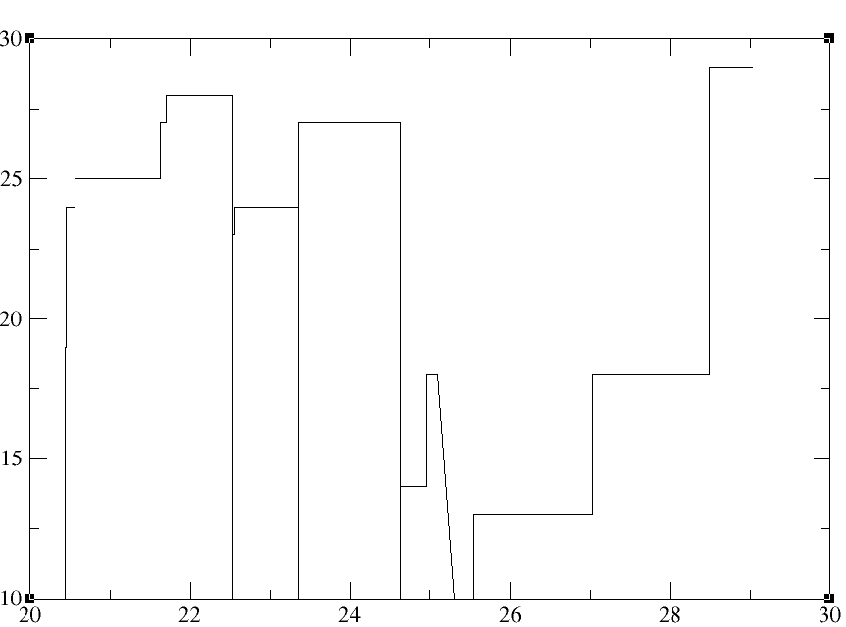

xmgrace eu.out

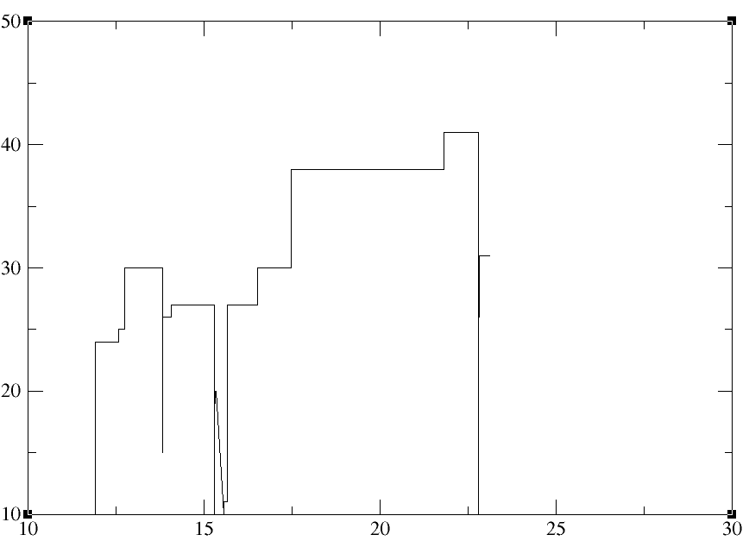

xmgrace aust.out

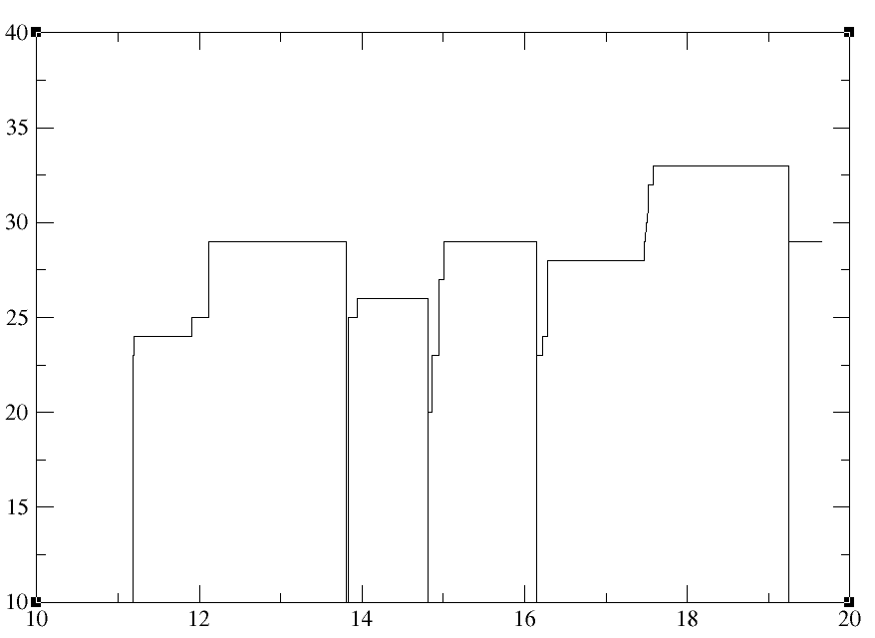

**or**

xmgrace *.out

* **What do the results indicate when compared?**

cwnd value rank:

European > Australian > us-west

So the European get the largest bandwidth.

* **Take down all instances when complete**

# HTTP Lab #1: HTTP headers, DevTools(Baiwei)

* **HTTP headers**
* **Install Chrome (either on your Desktop or UbuntuVM)**
  + **For Ubuntu**
    - **sudo apt-get install -y gdebi**
    - **wget** [**https://dl.google.com/linux/direct/google-chrome-stable_current_amd64.deb**](https://dl.google.com/linux/direct/google-chrome-stable_current_amd64.deb)
    - **sudo gdebi google-chrome-stable_current_amd64.deb**

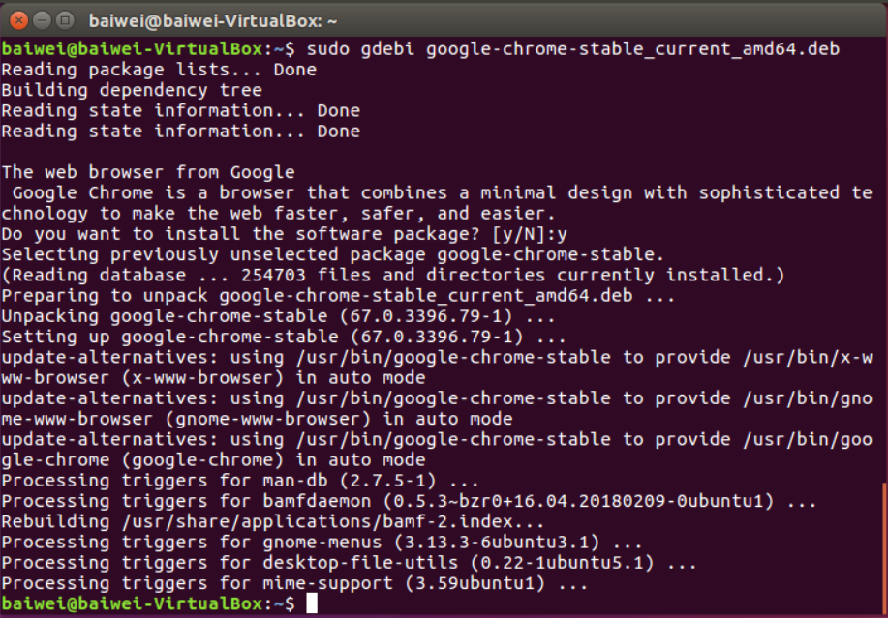

* **Bring up the Chrome Developer Tools**
  + **Find the network headers**

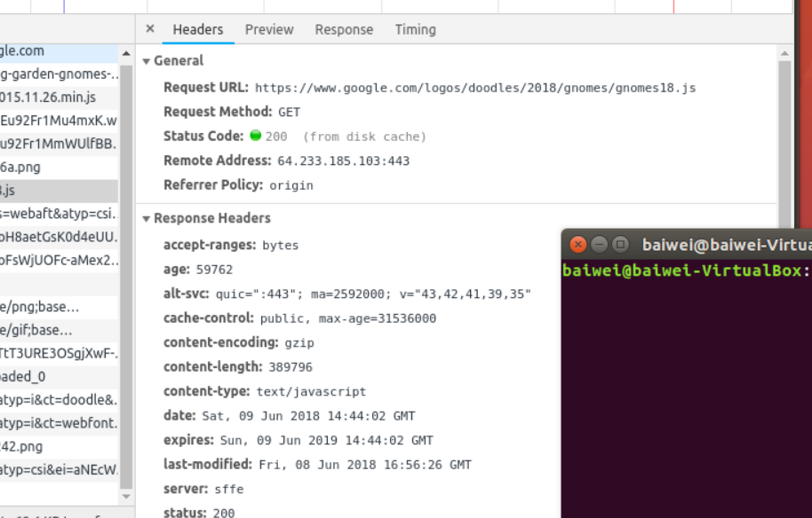

* + **Visit natas0.natas.labs.overthewire.org**

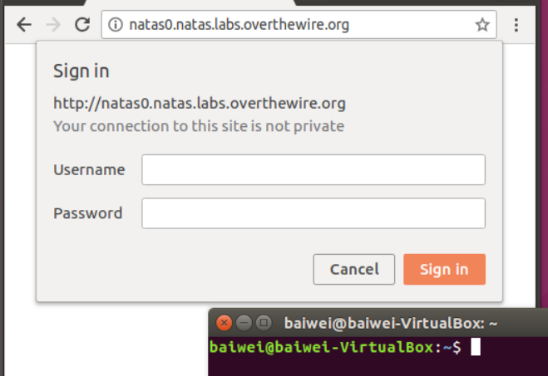

* + **List the initial authenticate response header**

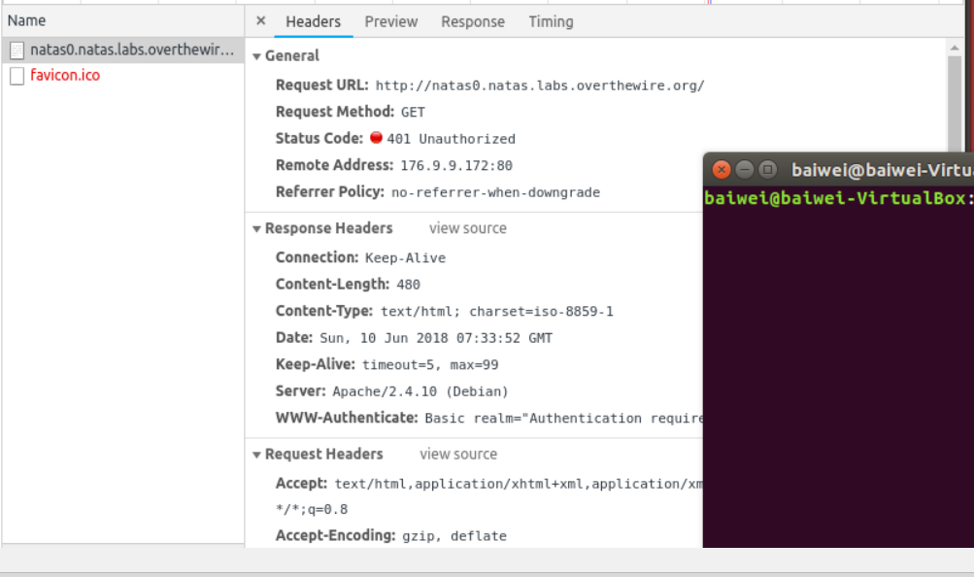

* + **Authenticate with natas0:natas0**
  + **List the subsequent authorization request header**

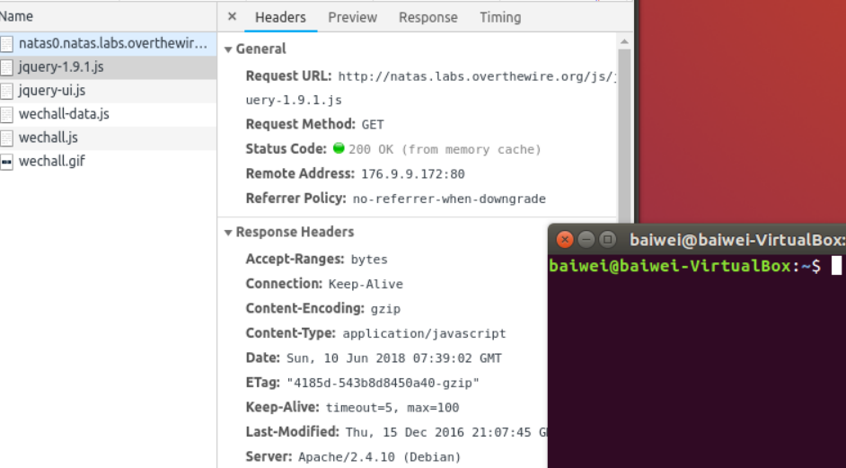

* **Repeat using Wireshark**
  + **Show the cookies and initial authenticate response header**

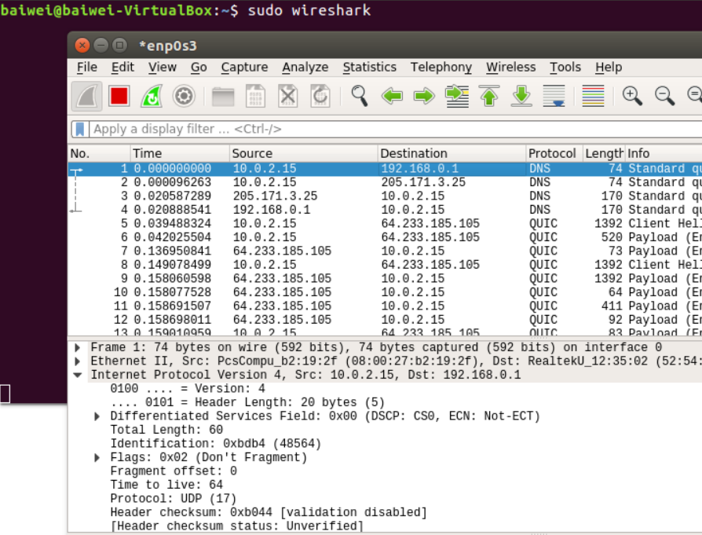

* + **and the authorization request header in packet payloads**

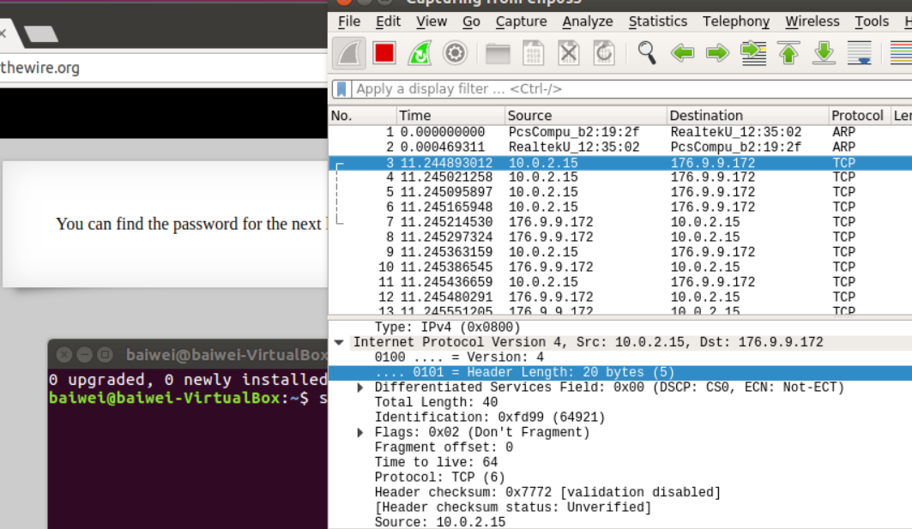

# HTTP Lab #2: QUIC/HTTP2(Baiwei)

* **On a linuxlab machine**
  + **Open google-chrome**
  + **Open chrome://flags**
    - **Find and enable the QUIC protocol**

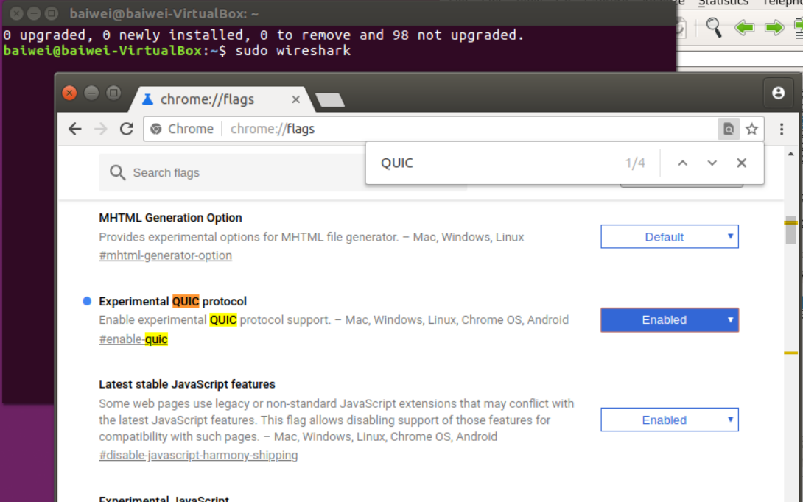

* + **Open chrome://net-internals/**

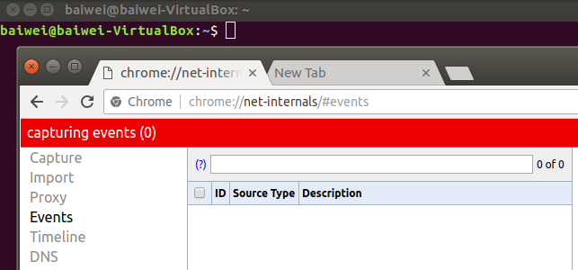

* + **Stream video for a short time from vimeo.com and youtube.com**

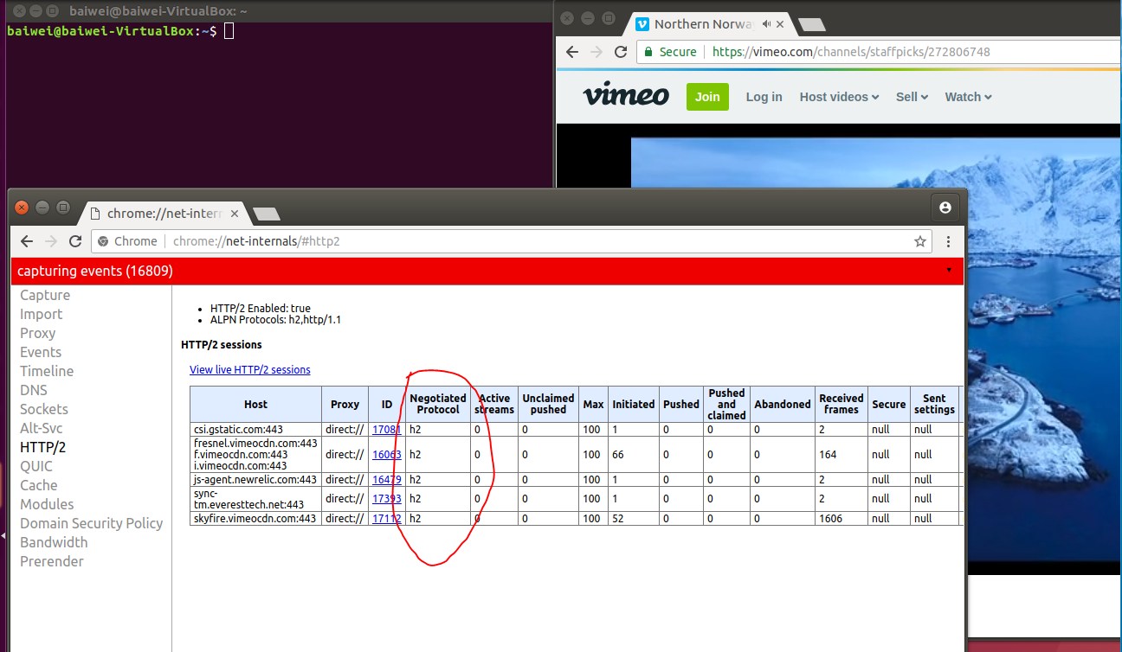

(Figure 1: Http/2 section, video from vimeo)

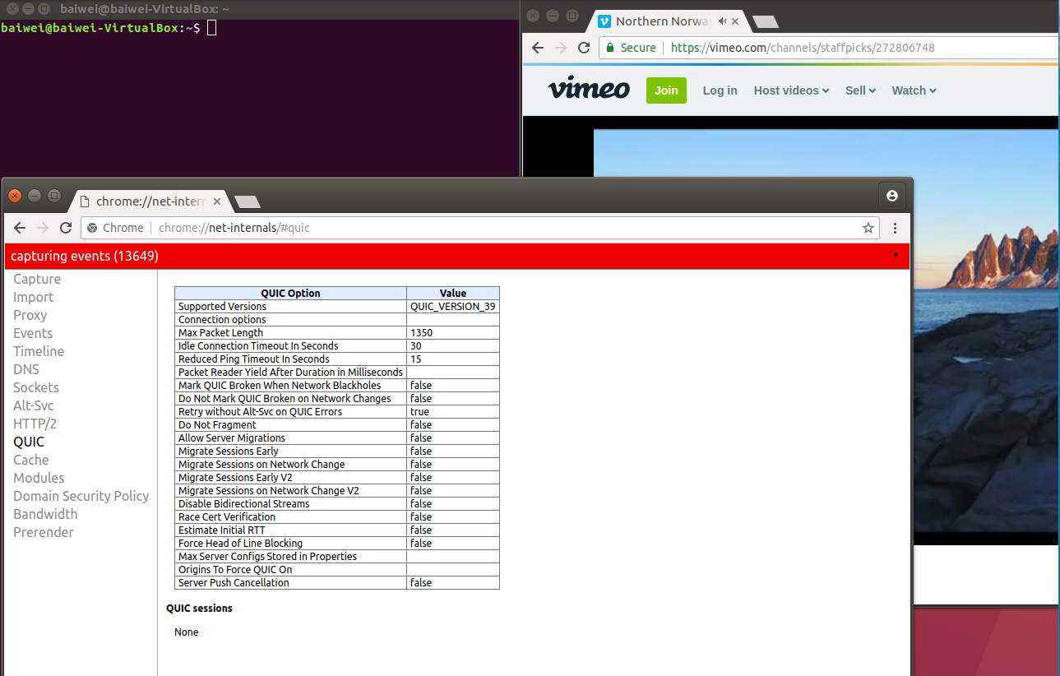

(Figure 2: QUIC section, video from vimeo)

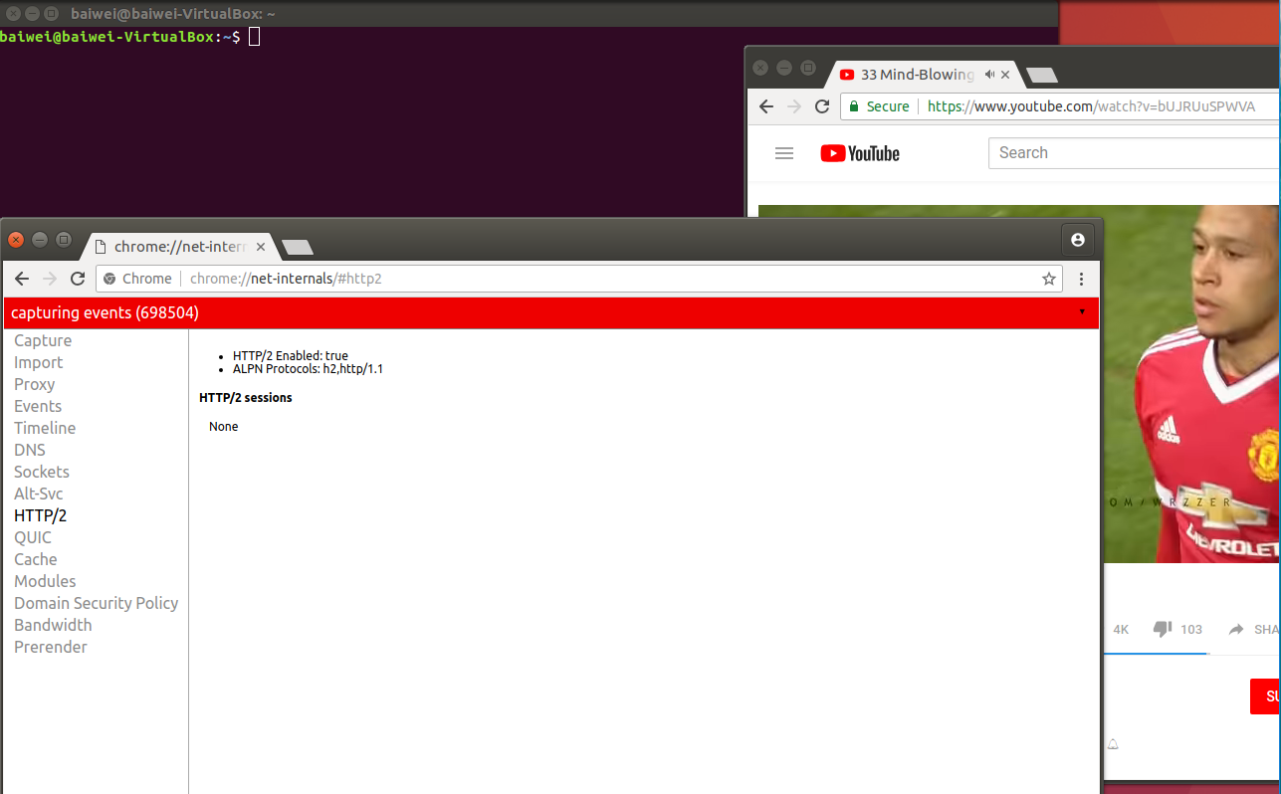

(Figure 3: Http/2 section, video from YouTube)

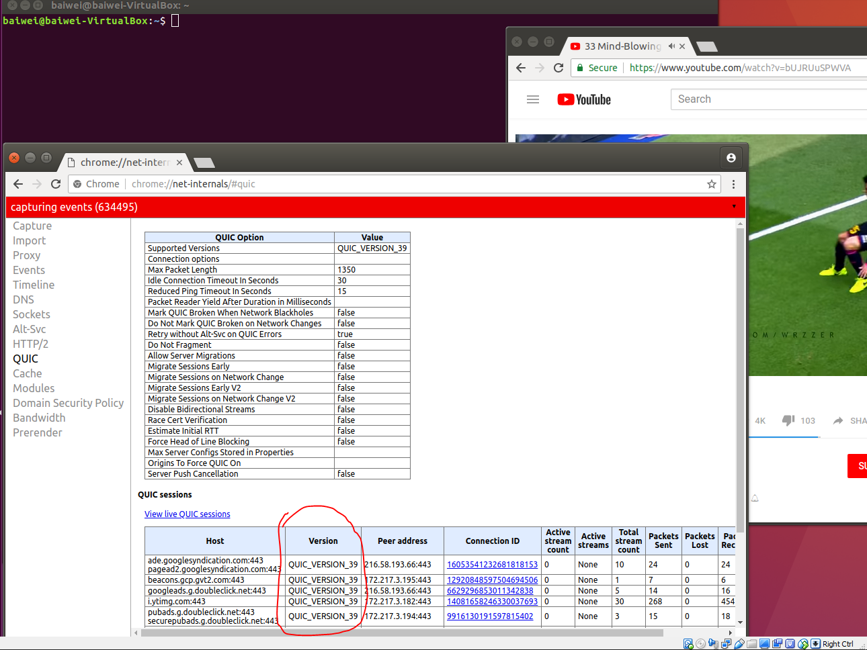

(Figure 4: QUIC section, video from YouTube)

* + **Show whether HTTP/2 and/or QUIC are used via the browser's tools and for which sites**

Figure 1 shows vimeo is using http/2.

Figure 4 shows YouTube is using Quic.

* **On your UbuntuVM, open up Wireshark and perform the same process but only for youtube.com**
  + **Show the QUIC transport being used within Wireshark's packet trace**

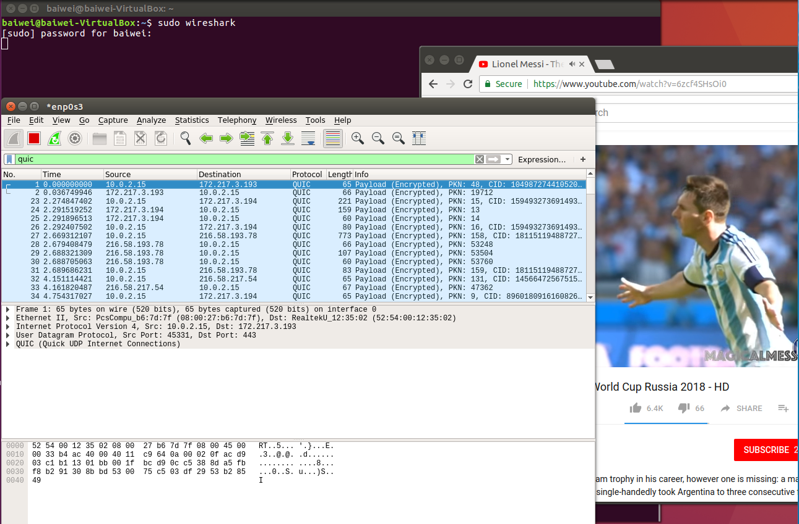

# DNS Lab #1: Basics(Baiwei)

* **DNS reconnaissance**
  + **On a linuxlab machine, cat /etc/resolv.conf to find the local DNS server for the client resolver**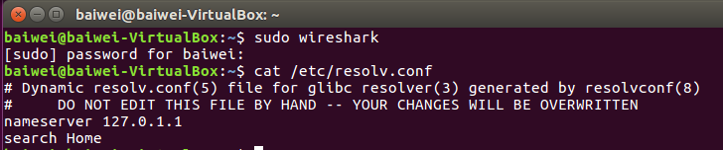
  + **Run dig with no arguments to list all root DNS servers**
  + 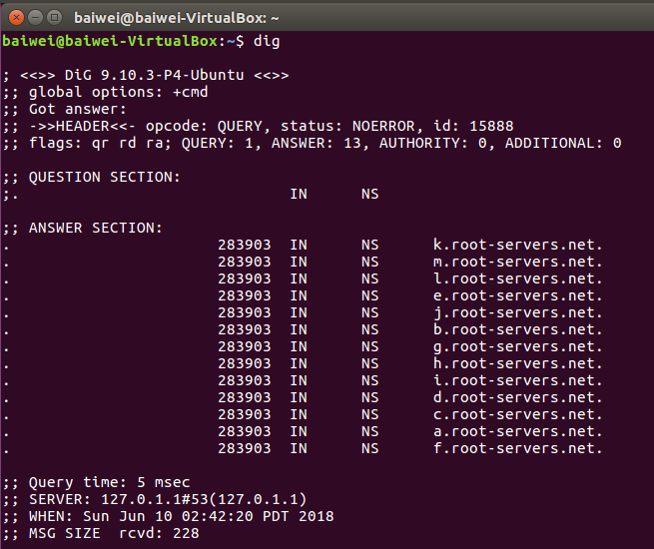
  + **Lookup A record of www.pdx.edu and the MX record of pdx.edu using the appropriate type flag for dig**

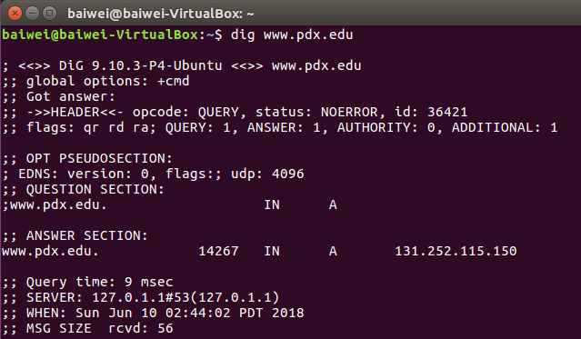

The type flag for MX record is: dig [pdx.edu](http://www.pdx.edu) MX

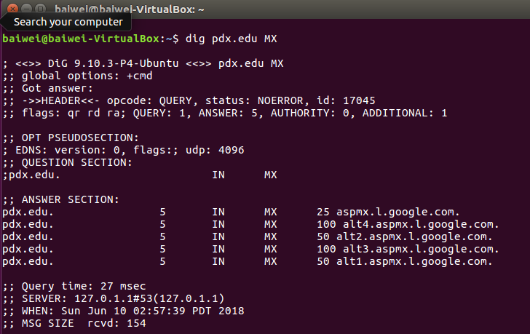

* + - **What do these records explain about how PSU's web/mail services are run?**

These records explains PSU’s web services are hosted on ip address 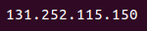, as well as mail services on the five different address below: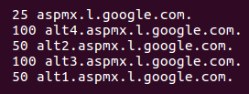

* + **Find the authoritative server (NS record type) for mashimaro.cs.pdx.edu**

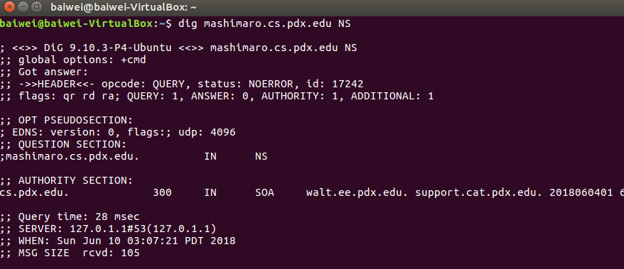

* + **and then query that server for the A record of mashimaro.cs.pdx.edu**

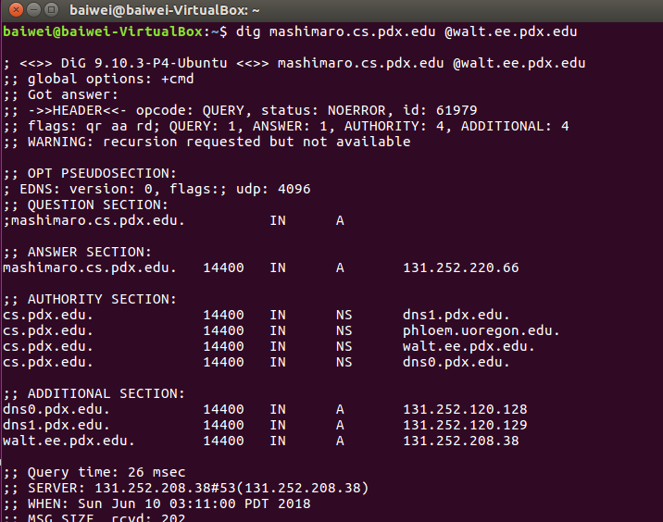

* + **Find the authoritative server for thefengs.com**

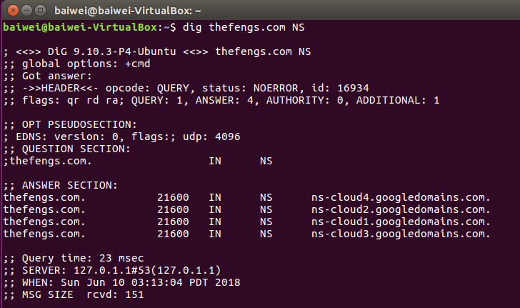

* + **and then query that server for the A record of thefengs.com**

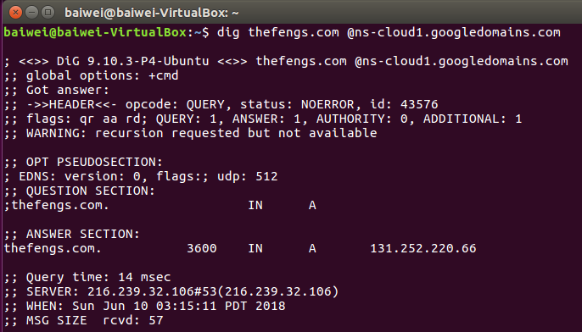

* + **When a web request hits port 80 of 131.252.220.66, how does the server know which site to serve from? (i.e. what protocol header)**

The Hypertext transfer protocol header will initiates bi-directional connection between the client and server, from which the layer protocol will analyze the URL contained in header lines. This is why the server knows which site to serve from.

# DNS Lab #2: Iterative lookup(Baiwei)

* **On a linuxlab machine, simulate the operation of a Local DNS server**

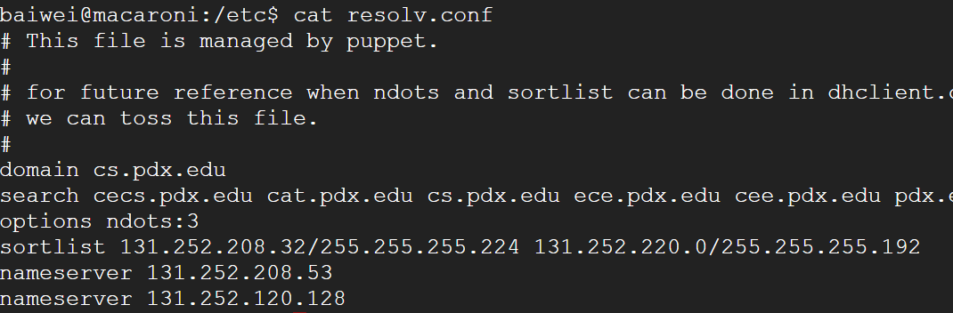

* + **Choose a DNS name containing at least 4 parts (e.g.**
    - **www.cs.pdx.edu , console.cloud.google.com ,**
    - **www.unsw.edu.au , www.amazon.co.uk )**

In this lab, I will pick: *console.cloud.google.com*

* + **Use the +norecurse flag to specify iterative queries and the +tcp flag to specify queries over TCP**
  + **Start your iterative querying at the F root server**

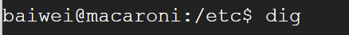

F foot is is here:



* + **Use the @ prefix to specify IP address of each DNS server to query**

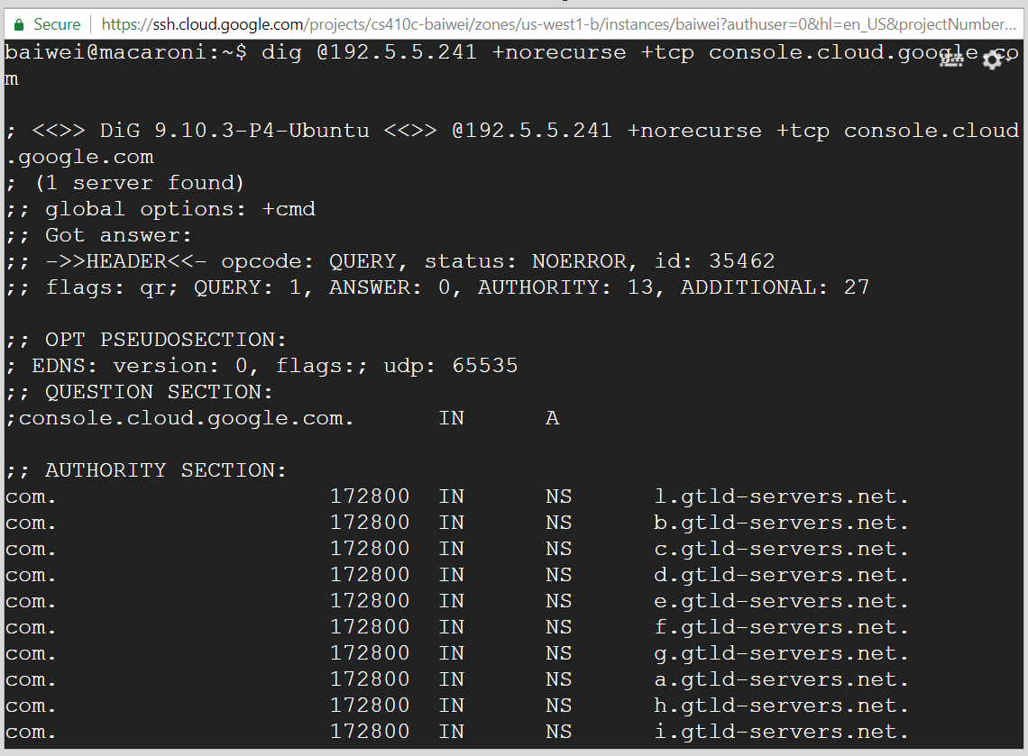

* + **Use the appropriate DNS record type to identify authoritative servers**

According to this DNS record type classification:

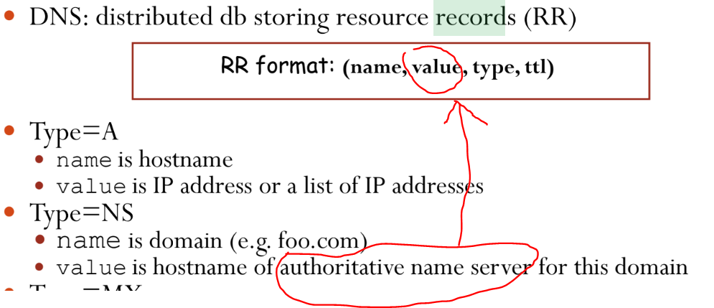

authoritative servers are:

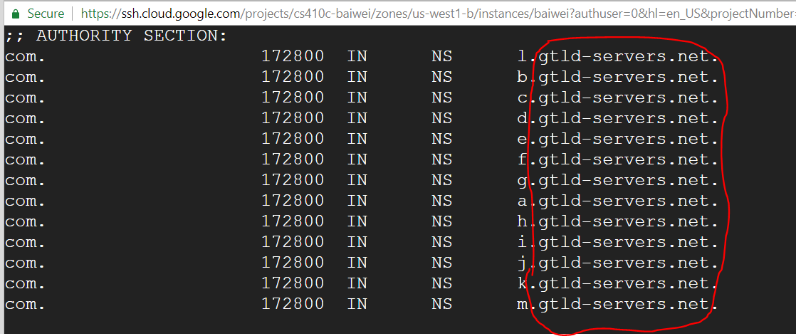

* **Shell (bash) preliminaries**
  + **Perform the following commands and examine the output to understand what egrep, awk, and the pipes (|) are doing**

ls -l /dev

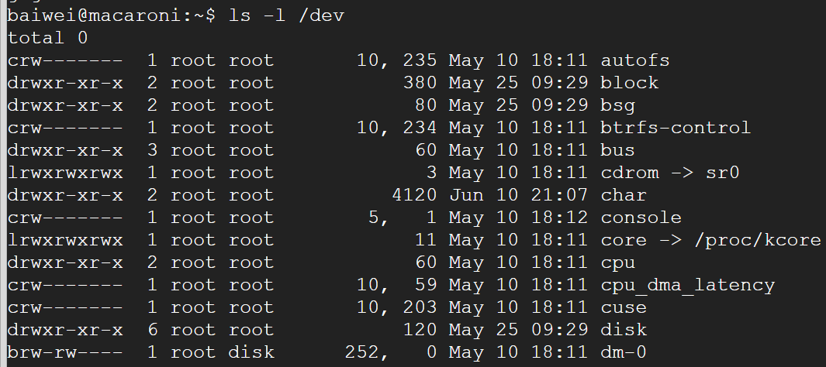

ls -l /dev | egrep sda

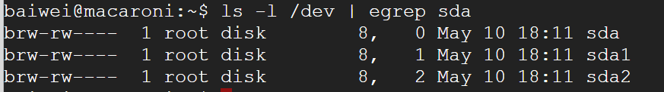

ls -l /dev | egrep sda | awk '{print $10}’

* + **You can save the standard output of a command and use it in subsequent command-line arguments. One way is to save it to an environment variable using back-ticks or $( )**

X=`ls -l /dev | egrep sda | awk '{print $10}'`

X=$(ls -l /dev | egrep sda | awk '{print $10}')

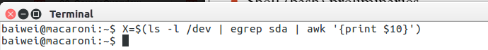

* + **Then, you can use a for loop in bash (or a foreach loop in zsh) to iterate over each value that is returned**

for i in `echo $X`

do

file /dev/$i

Done

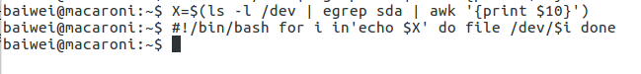

* **Finding aliases with dig and bash**
  + **Using a single command line, use dig, egrep, and awk, list all IP addresses that linuxlab.cs.pdx.edu points to**

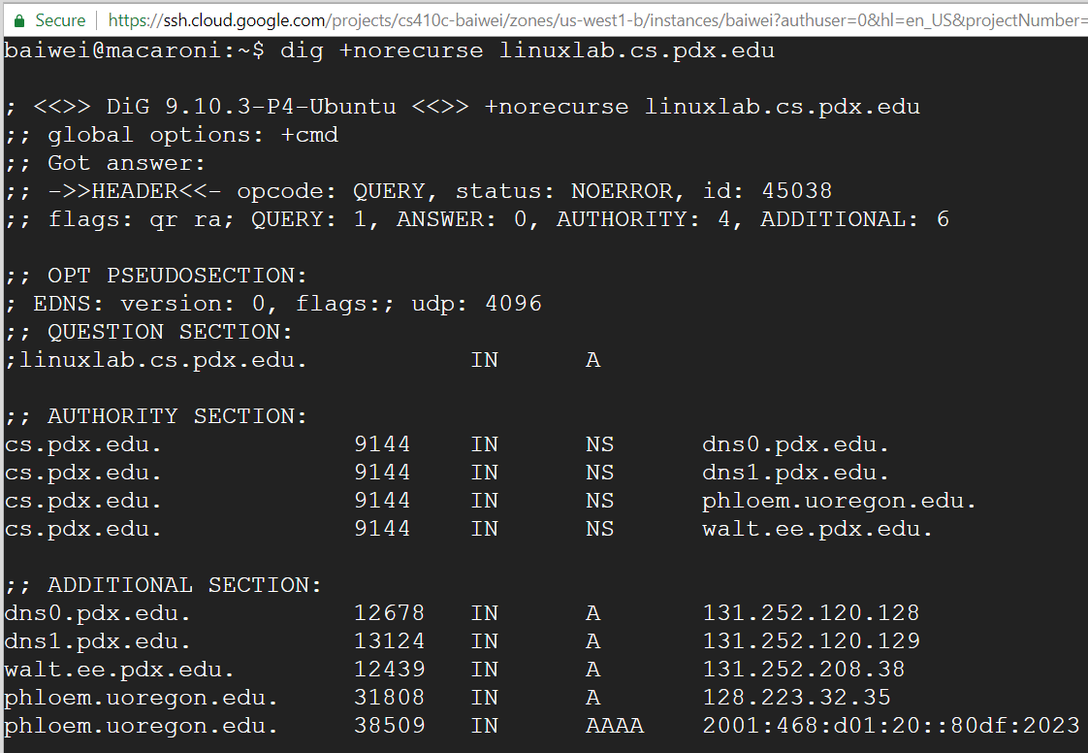

* + **Then, take that list and iterate over it in order to do a reverse lookup of each IP address**
    - **The command to perform a reverse-lookup given an IP address is dig –x**

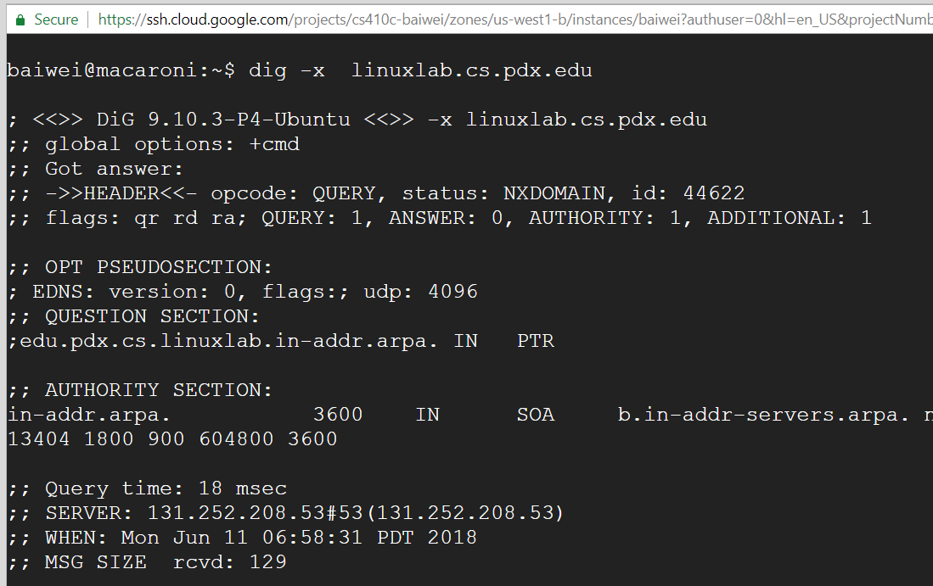

# DNS Lab #3: Names of hosts on a subnet(Baiwei)

* **In the shell, integer ranges specified via {<num1>..<num2>}**
* **Perform the following two commands to see how it works**

echo {0..2}{0..9}

for i in {1..20}

do

echo $i

Done

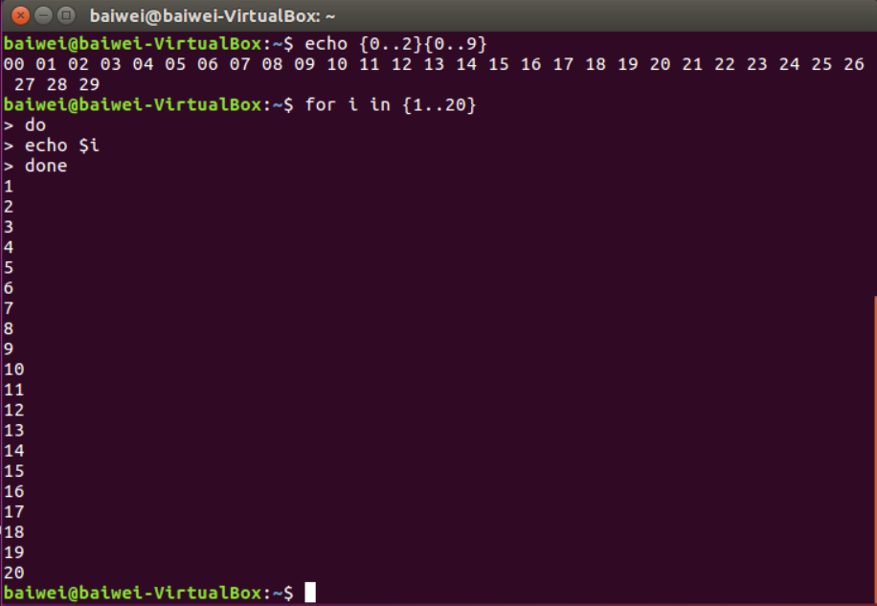

* **Using this mechanism, perform a reverse DNS lookup for each IP address on the 131.252.220.0/24 subnet**
  + **After the "done" keyword, before hitting return, pipe the standard output of the loop to egrep to list just the names of the hosts, and then redirect it to file called 220hosts.txt**

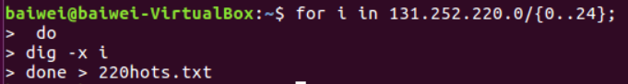

* + **Obtain the hosts between .30 and .50**
    - **head -50 220hosts.txt | tail -20**
    - **Numbers may be slightly off since some names will not resolve**

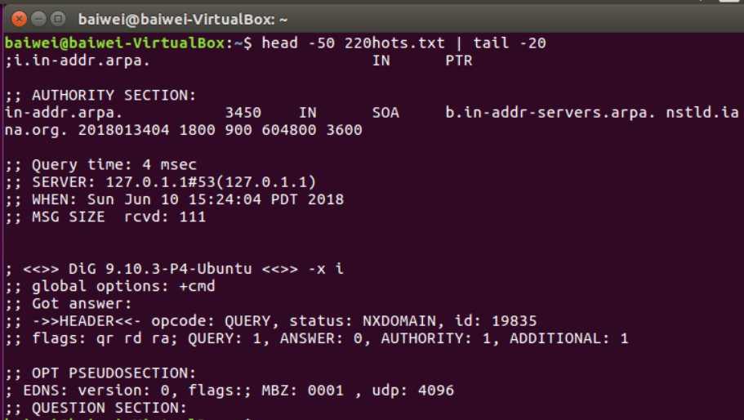

* + **Then, obtain the hosts between 58 and 70**

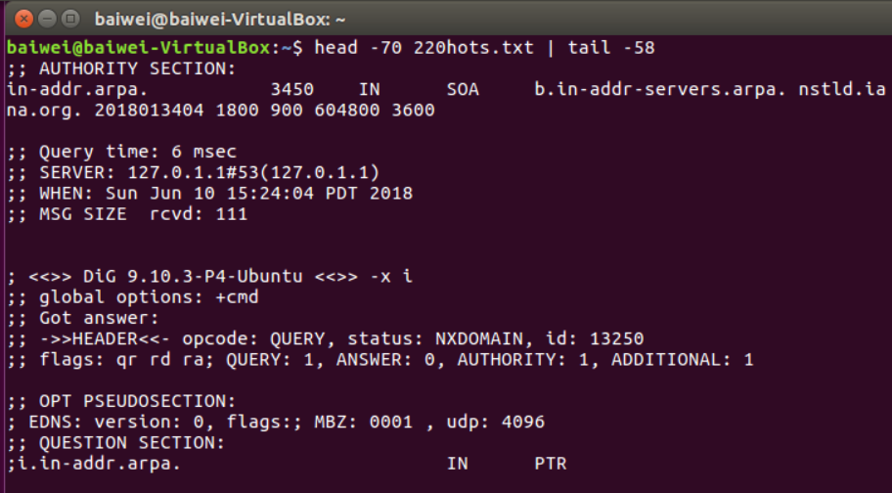

# Network Recap Lab #1: Full trace analysis(Baiwei)

* **Use ifconfig to find the IP address of the VM and the name of the local virtual ethernet interface** 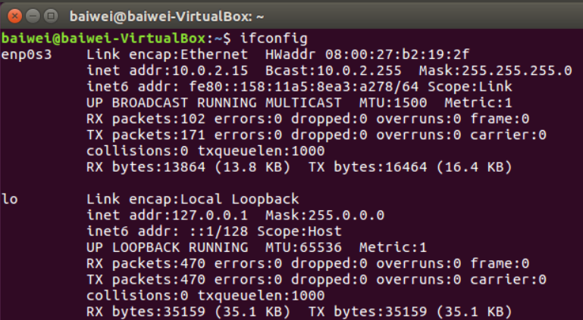
* **Use netstat to find the IP address of the default router**

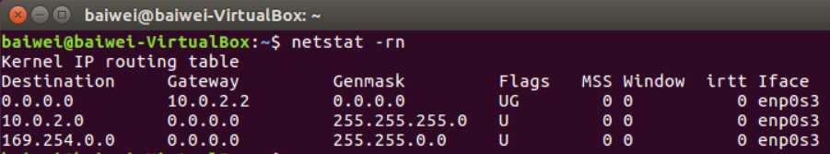

* **Temporarily change the default DNS server**
  + **sudo vim /etc/resolv.conf**

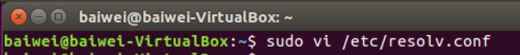

* + **Change to point to 1.1.1.1**

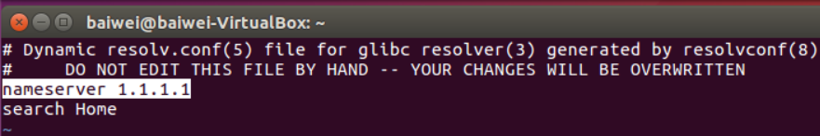

* + **Will be overwritten upon next DHCP renew**
  + **Perform a reverse DNS lookup on the DNS server to find its name**

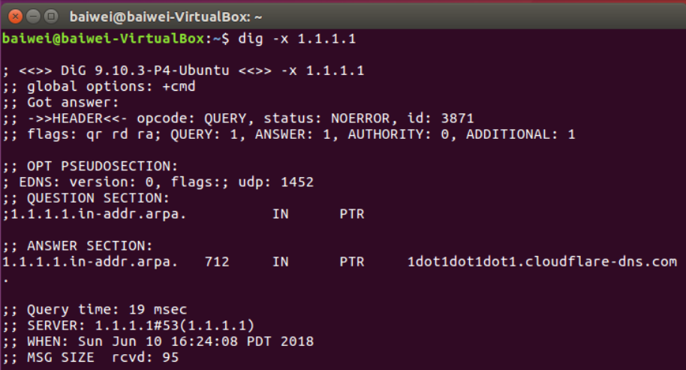

* **Parse the output arp -a using awk with specified delimiters**
  + **Type arp -a to see the format of its output**

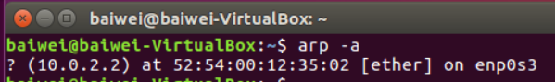

* + **Then**
    - arp -a | awk -F'[()]' '{print $2}' > arp_entries
    - **-F flag sets the delimiter to use, the square brackets specify a regexp that matches eith parentheses character for a delimiter, then the command prints out the 2nd field (the IP address) and outputs the result a file (arp_entries)**





* **Then, sudo wireshark**
  + **Begin capture on the virtual ethernet interface found earlier**

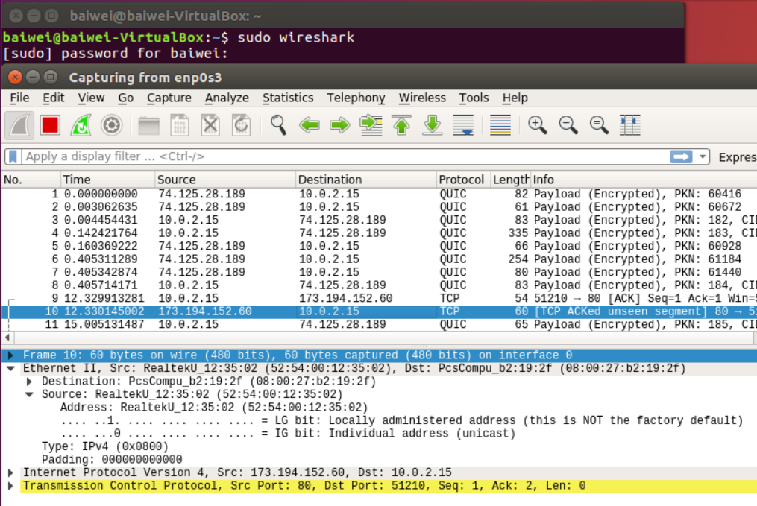

* + **Delete all arp entries using a for loop in the shell and then immediately retrieve http://<OdinId>.oregonctf.org**

for i in $(cat arp_entries)

do

sudo arp -d $i

done ; wget http://<OdinId>.oregonctf.org

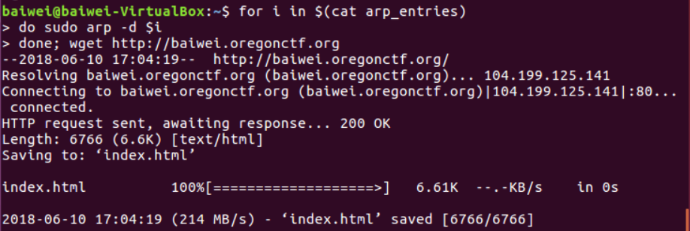

* **Stop the packet capture and inspect it**
  + **Ensure the arp packets and DNS request and response packet s for the request show up in the trace.**
  + **If not, you are using a cached lookup. Run the lab again using random characters to the DNS name you are fetching**

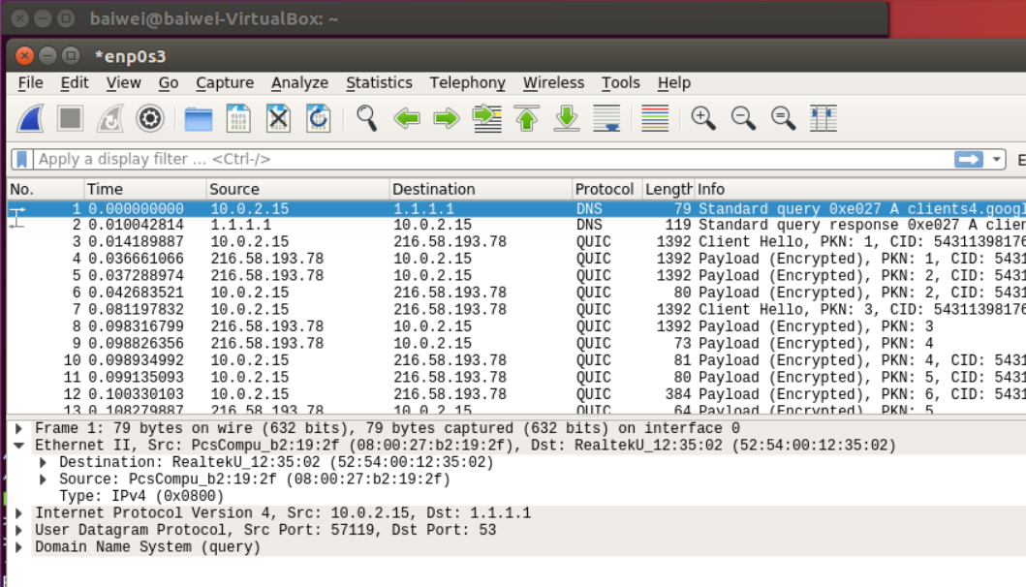

* **Within Wireshark, annotate the packets in the trace to explain the purpose of each of the packets being exchanged**
* **Answer the following questions**
  + **How many DNS requests are made?** 10

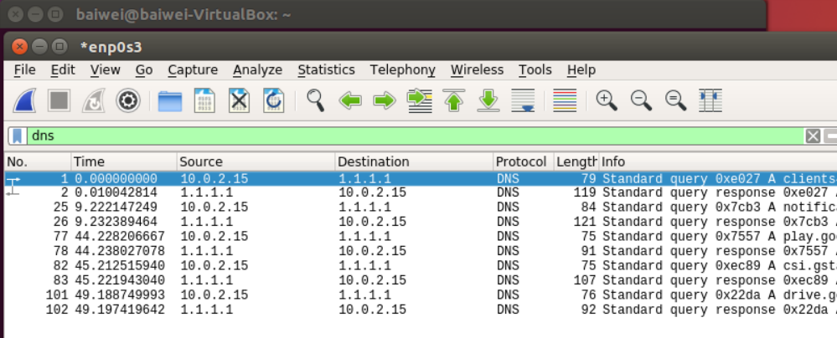

* + **How many TCP connections does the browser initiate simultaneously to the site?** 16

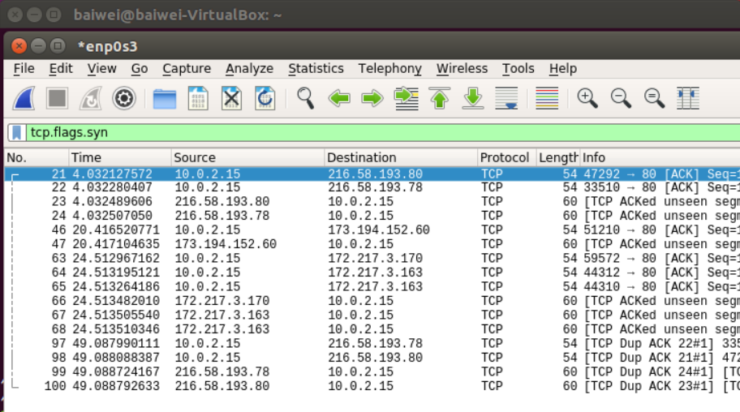

* + **How many HTTP GET requests are there for embedded objects?**

Maybe I’m wrong, I didn’t see any

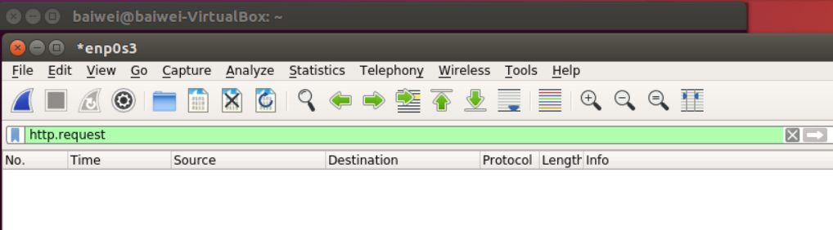

* + **Some helpful display filters include dns, tcp.flags.syn, and http.request**

# CDN Lab #1: Geographic DNS (Baiwei)

* **Based on the location of the local name server performing a name resolution, most sites served by a CDN attempt to resolve their names to the IP address of the nearest server that hosts it**
* **Using dig, we will resolve www.google.com from different local name servers to see how resolution differs from different locations**
  + **Lookup geographic locations of the following DNS servers via https://www.iplocation.net/**
    - **131.252.208.53 (PSU)**

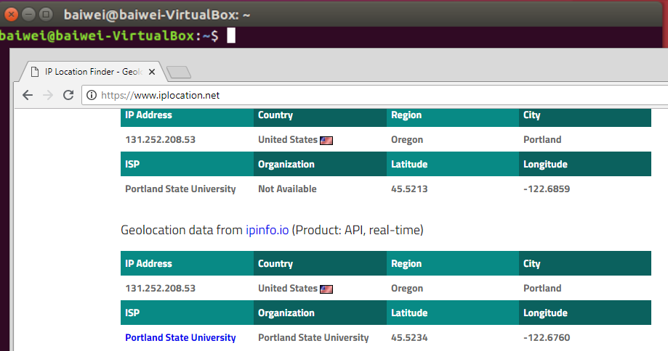

* + - **198.82.247.66 (Virginia Tech)**

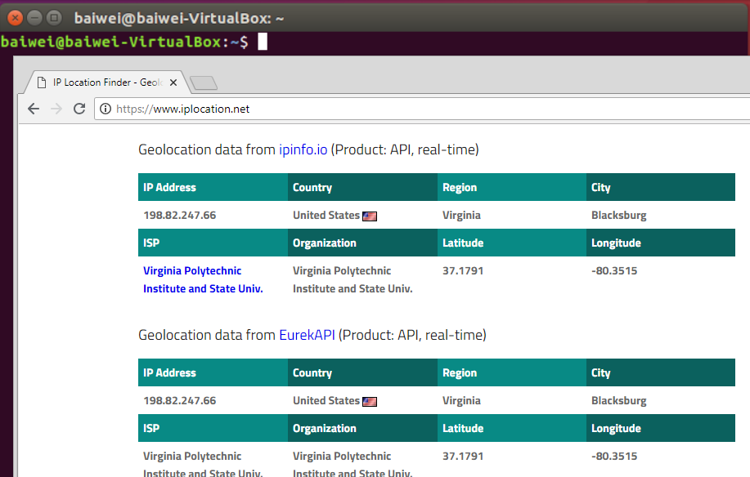

* + **Then, using dig, resolve www.google.com**

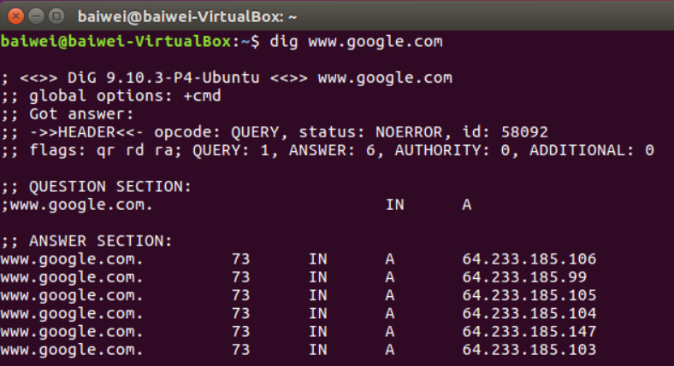

* + **from each of the DNS servers and record each result**
    - 64.233.185.106

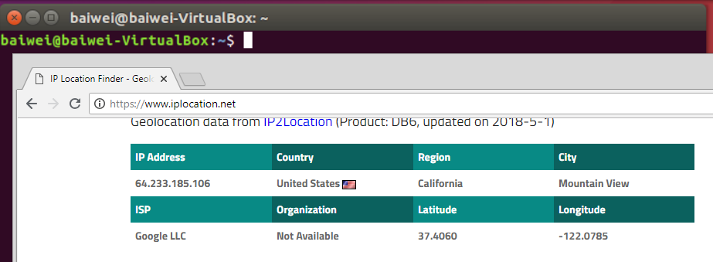

* + - 64.233.185.99

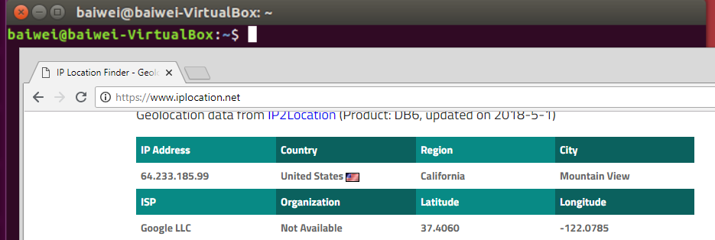

* + - 64.233.185.105

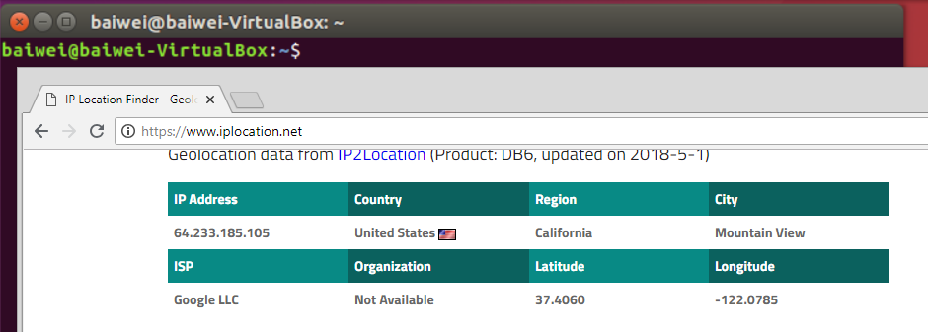

* + - 64.233.185.104

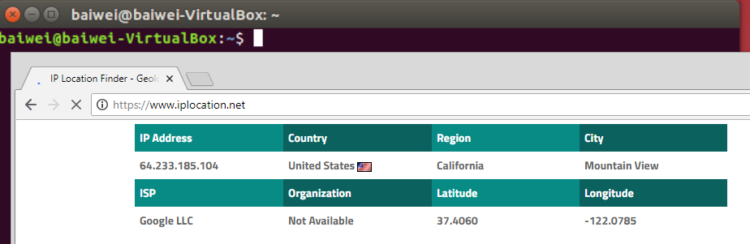

* + - 64.233.185.147

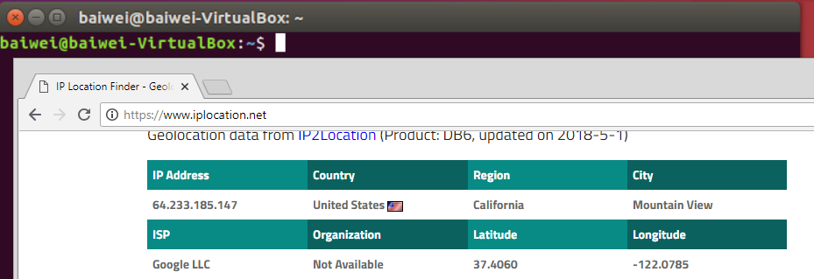

* + - 64.233.185.103

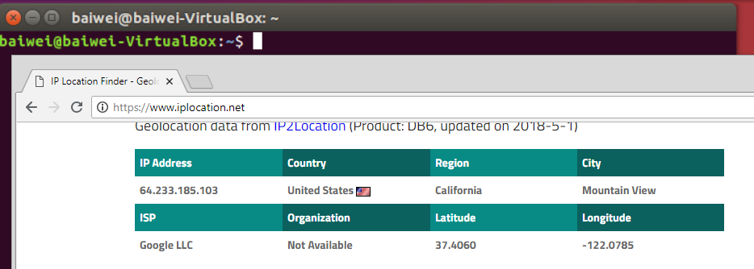

* + **Lookup up geographic locations for each that do not give Google's Mountain View headquarters as the result**
    - **What is the geographic distance between the DNS server and web server?**

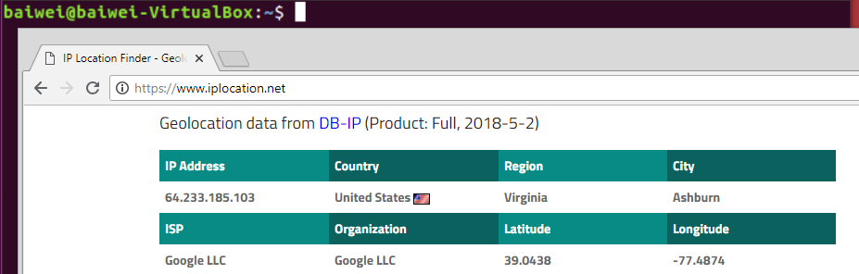

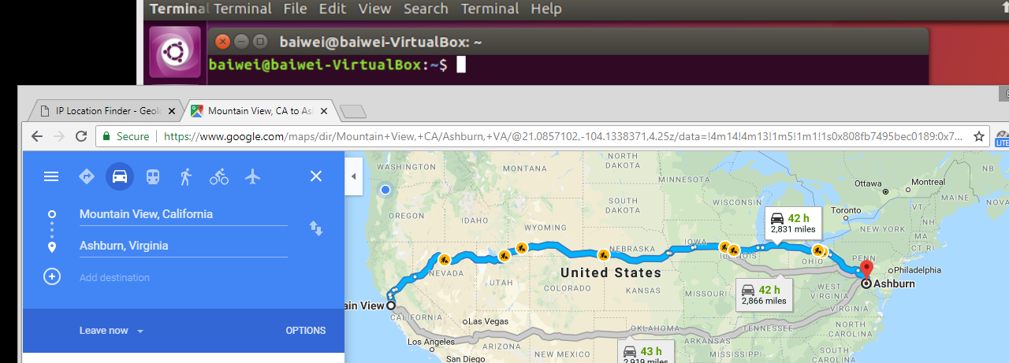

(Ashburn, VA is 2,831 miles away from Mountain view, CA)

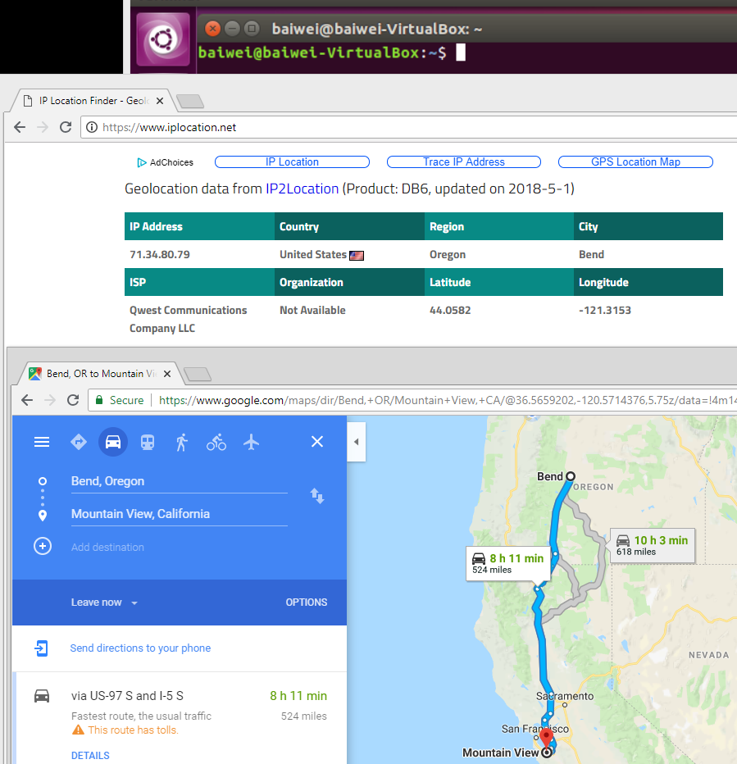

(Bend, OR is 524 miles away from Mountain View, CA)

* + **Perform a traceroute to each of the addresses**
    - **Do the routes reveal any information on the accuracy of the geographic locations given? Answer might be no.**

1. traceroute 64.233.15.103 (Virginia address) No geographic location is given.

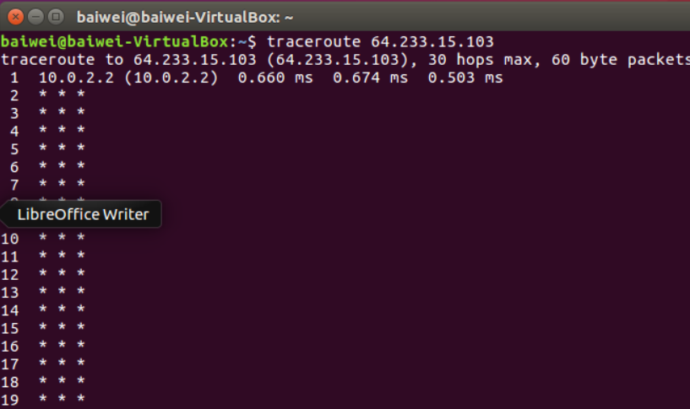

1. Traceroute 71.34.80.79 (Bend, OR address) No geographic address is given, either.

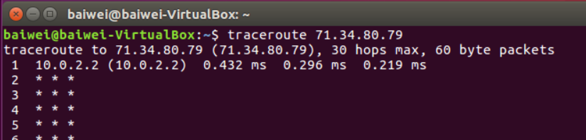

# CDN Lab #2: HTTP load balancing(Baiwei)

* **Launch Cloud Shell and copy files from lab’s bucket on Google Cloud Storage (similar to AWS S3 buckets)**

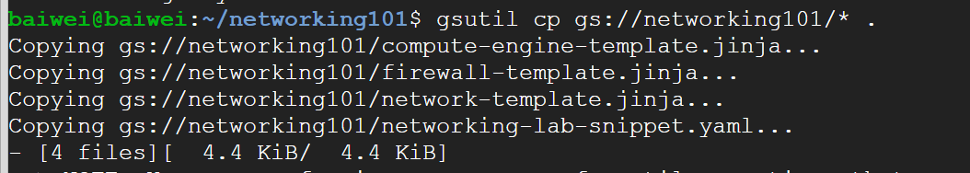

* **Cloud Deployment Manager**
  + **Allow one to specify and deploy collections of VMs**
  + **For lab, configuration include in files copied via YAML and Jinja files (more on Jinja later)**

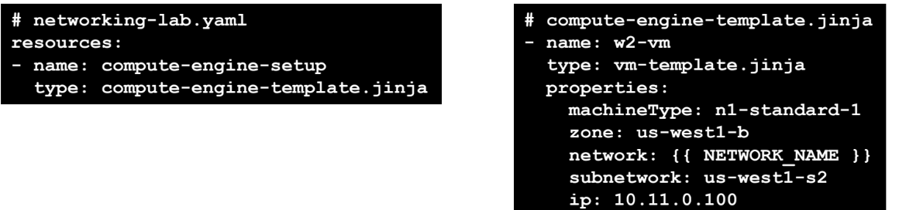

* **Launch the configuration to instantiate the network on GCP**
  + **Will need to enable the Deployment Manager API**
  + **Grab some coffee (takes a while to instantiate)**



* **Show the machines running within Cloud Shell and Compute Engine UI**
* **Note: If ssh works on Step 3, you may skip Step 4 (read through it anyway just for fun) Launch an ssh session on each VM to perform Step 5 and 6**
  + **For Step 6, repeat the pair-wise ping table from the various VMs**
  + **Pinging external hosts step optional**
* **Step 8: Set up network to allow HTTP traffic to all instances (name the rule http-server)**
  + **Done either via gcloud command-line or via Console UI**

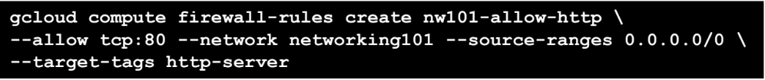

* **Note: "Networking" via the Menu is now labeled "VPC Network"**
* **Step 9: Managed Instance Groups**
  + **In Compute Engine, "Instance Templates" are recipes for creating identical VMs in a group (Instance Groups)**
  + **Group is managed by a policy**
    - **e.g. Maximum 5, Minimum 1, add a node when avg load > 0.8, subtract a node when avg load < 0.8**
  + **Creation via command line with a startup script taken from a different bucket**
    - **Example template creation command for machines residing in us- east1 (Sets subnet and region, associate http-server tag to allow HTTP traffic)**
    - **Run startup script at gs://networking101-lab/startup.sh**

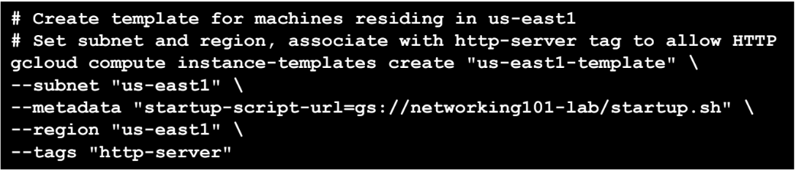

* **Startup script installs Apache2 and PHP, then updates index files to list region**
  + **Recall awk, $(), `` from previous lab**
  + **sed : Unix stream editor for filtering and transforming text (via regexp)**
    - **o substitutes the string "region-here" with environment variable**

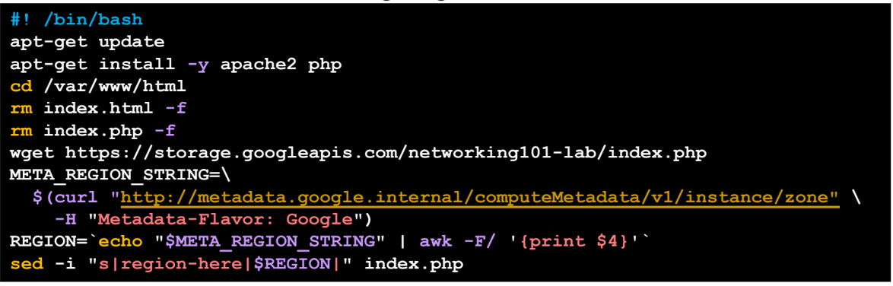

* **In Console UI, instantiate managed instance group from templates for both regions (note the configurations are different)**
  + **us-east-1 dynamic from 1 to 5 nodes**
  + **europe-west1 static 3 nodes**

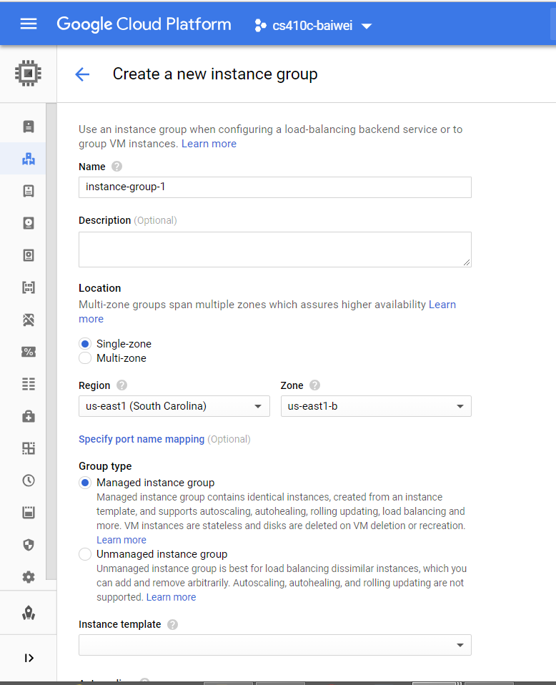

* **Hit the web page of one of the instance http://<Instance_IP>**
  + **If request fails, you may need to check your HTTP firewall rule and restart instances with the traffic enabled**
* **Step 10: Now at Network Services => Load balancing**
  + **Start configuration and specify backend configuration (e.g. a backend service implemented via the VMs in the instance groups)**

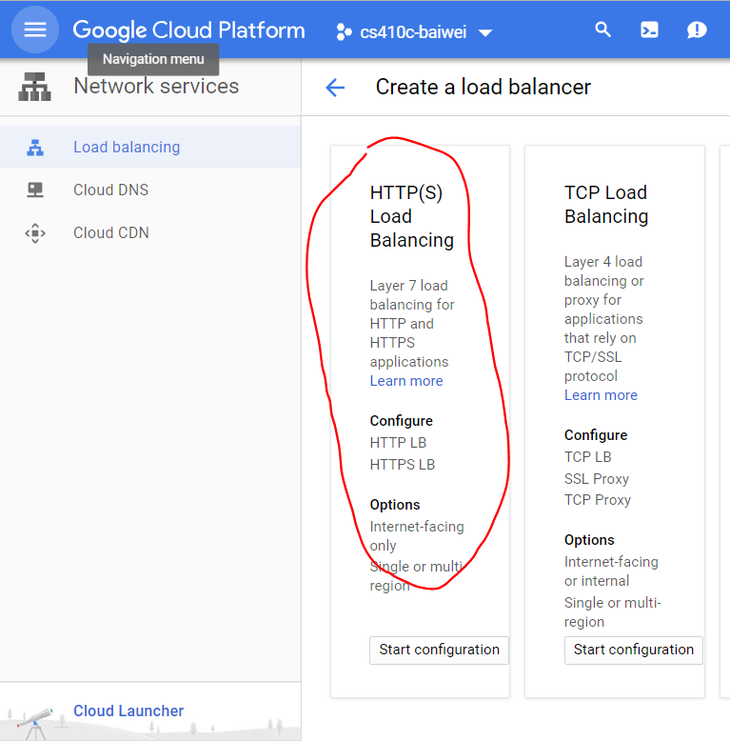

* **Go through *entire* configuration and then Create**

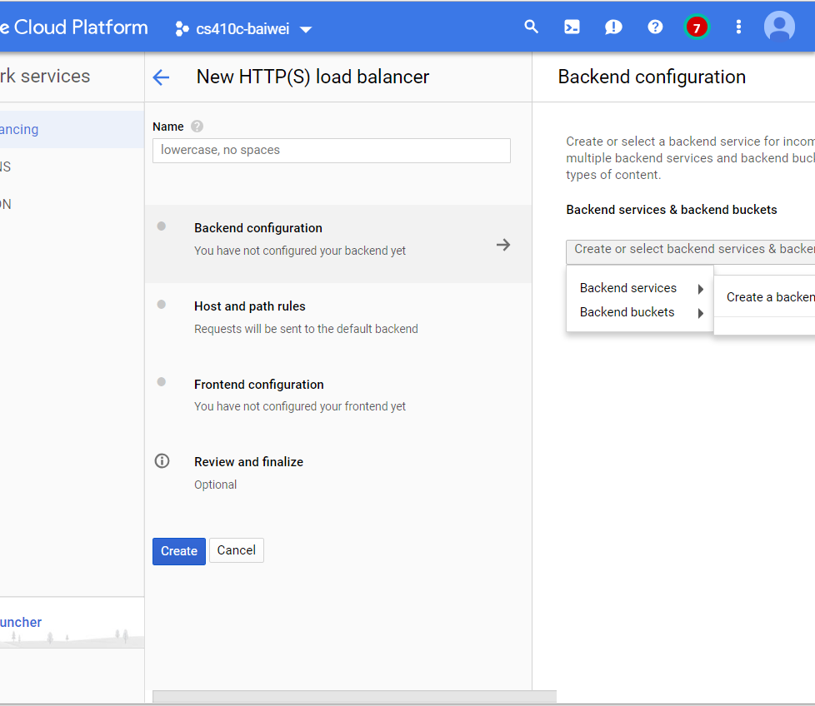

**Place the site under siege, from w1-vm**



**Show the autoscaling turning on for us-east1 instance group**

* **Perform optional steps 12-13, skip 14**
  + **Perform traceroutes from VMs to pdx.edu**
  + **Skip MTR section**

# Databases Lab #1(Baiwei)

* **Do this quiz**
  + [**http://www.w3schools.com/sql/sql_quiz.asp**](http://www.w3schools.com/sql/sql_quiz.asp)

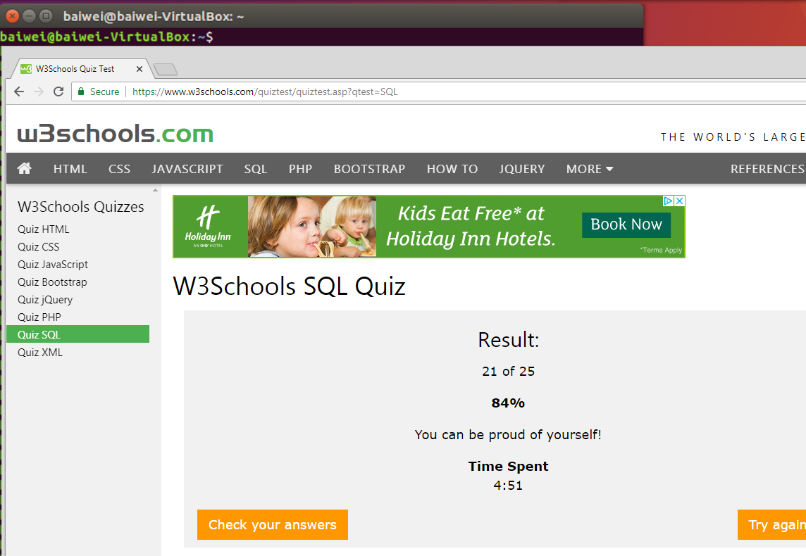

* + **Screenshot of "Check your answers"**

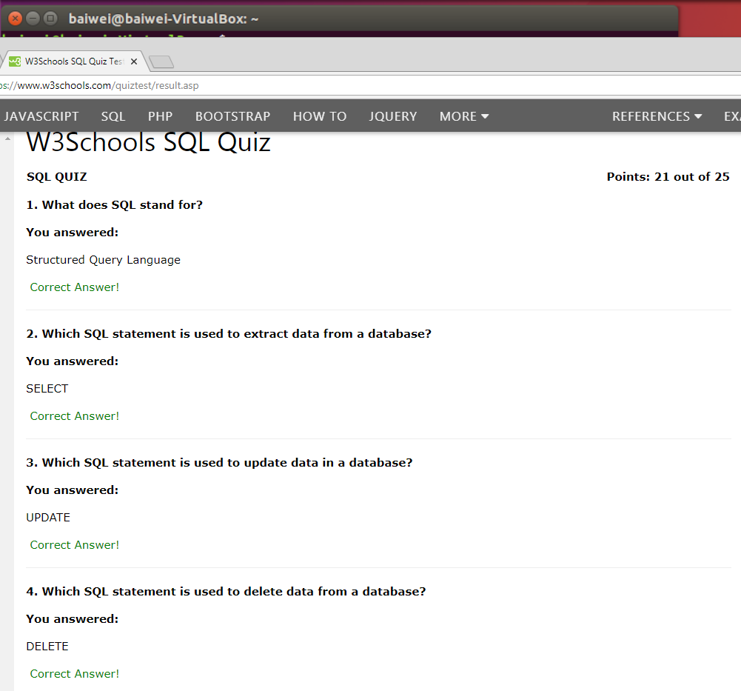

* + **Does not have to be perfect (mine wasn't), but check the ones you got incorrect**

# Databases Lab #2 (Cloud SQL)(Baiwei)

* **Setup**



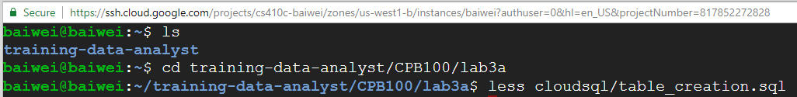

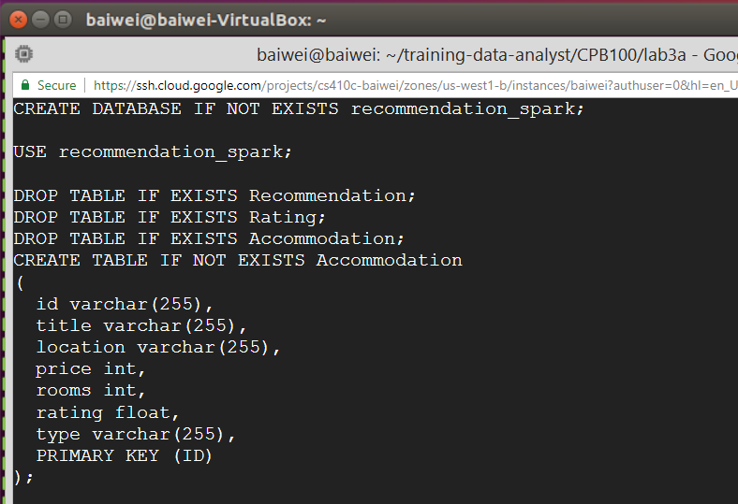

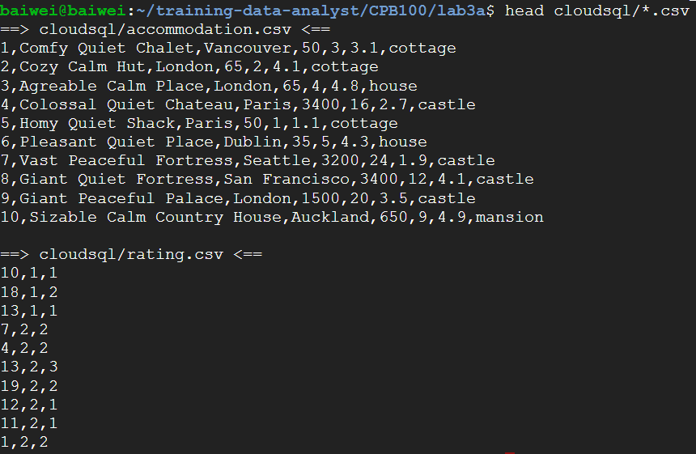

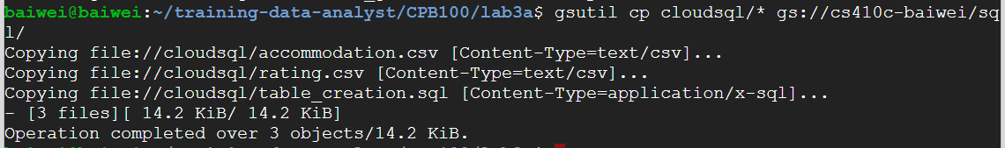

* **Create new Cloud SQL instance**

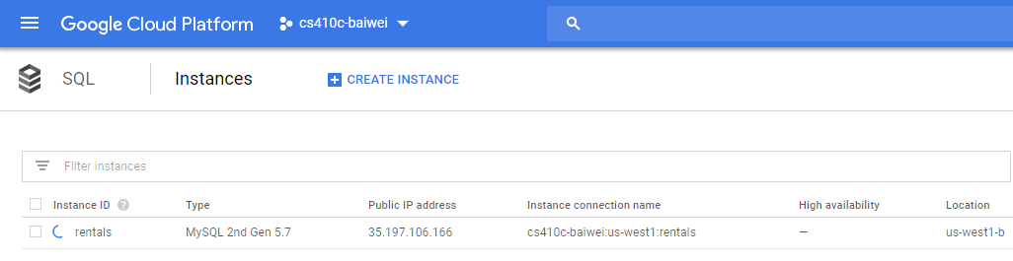

* **Configure access to instance from Cloud Shell**

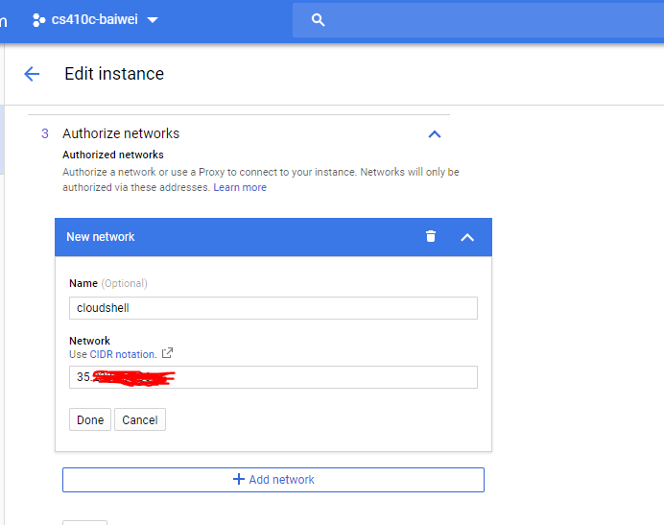

* **Import table definitions and tables**

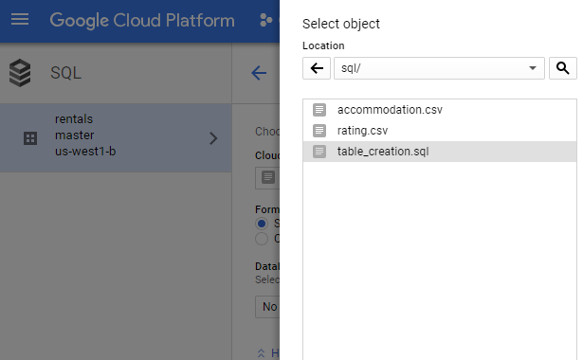

* **Populate tables**

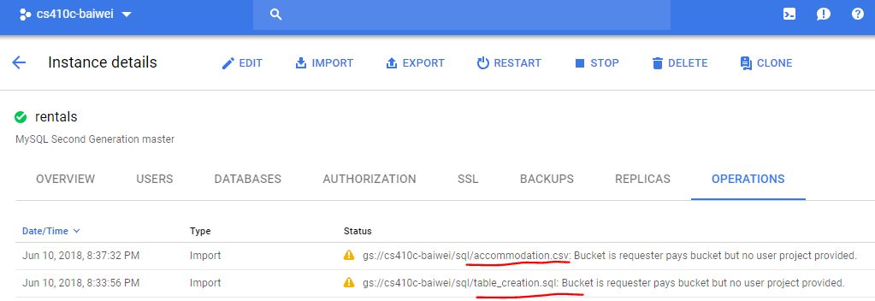

* **Use Cloud SQL**

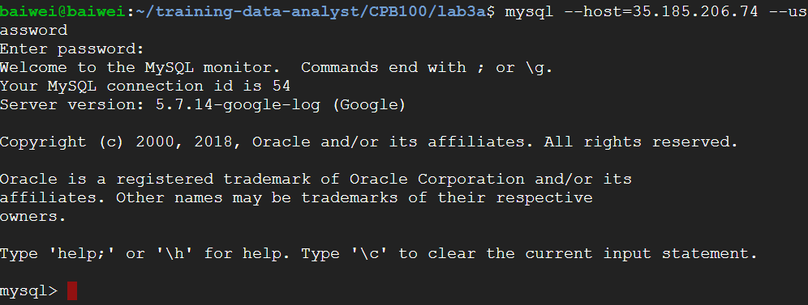



(At the final step, I encounter a little error when pulling the table on mysql. Most likely there’s some setup issue prior to importing the database on Cloud. But to me more importantly, I’ve handled how to implement SQL in Google Cloud, and used it on my homework.)

Here’s the error showing...



# Container Lab #1(Taisheng)

* **On your Ubuntu 16.04 VM on Google Compute Engine**
  + **Clone the repository if you haven't already, then goto the Container Lab**
    - git clone https://bitbucket.org/wuchangfeng/cs410c-src
    - cd cs410c-src/Container_Lab
  + **Examine the Python/Flask application in** app.py **and** Dockerfile.ubuntu **to see what they do**
    - app.py listen on port 8000 and return ‘Hello world!’ in text.
    - 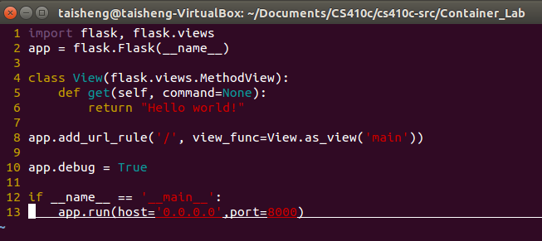
    - Dockerfile.ubuntu use ubuntu16.04 as base, and install python-pip on it. Then copy everything from to current local directory to a new directory call /app. Then set the working directory as /app, and install the packages in the requirements.txt. Finally expose port 8000 and run the python command to run the program.
    - 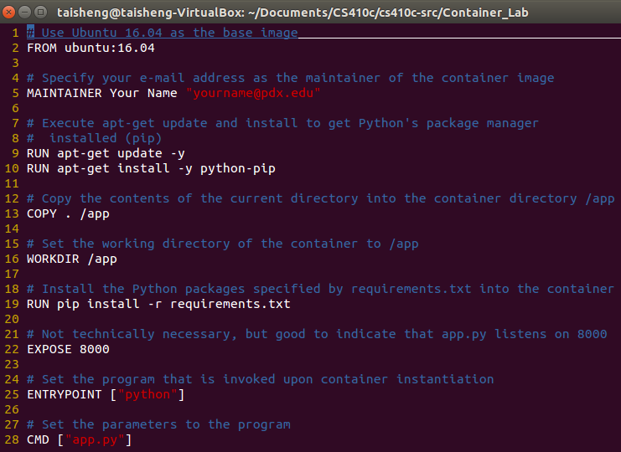
  + **Build a container for the app called** helloubuntu **with Ubuntu 16.04 as a base**
    - docker build –f Dockerfile.ubuntu –t helloubuntu .
    - 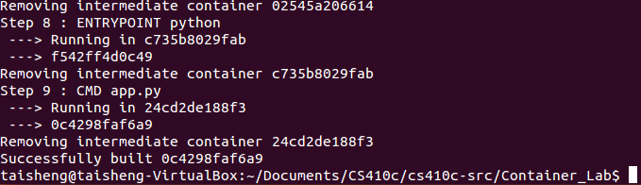
  + **Examine the image used to instantiate the container and list the size of the image created**
    - docker images
    - 
  + **Run the container in detached mode, mapping the host's port 8000 to the container's port 8000**
    - docker run –p 8000:8000 –di helloubuntu
    - 
  + **Test the container by retrieving** [**http://127.0.0.1:8000/**](http://127.0.0.1:8000/) **using a browser,** wget **or** curl
    - 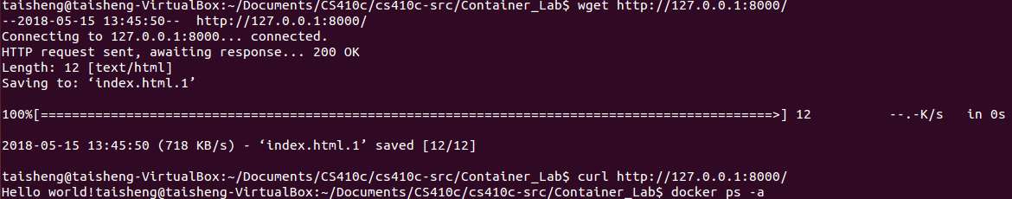
  + **List the running container to find its name under the "NAMES" column. The container will be named with two words separated by an underscore (e.g. stupefied_wiles)**
    - docker ps -a
    - 
* **Stop the running container via its name, for a container called "stupefied_wiles", the command is**
  + - docker stop stupefied_wiles
    - 
* **See that it is no longer running via**
  + - docker ps –a
    - 
* **Start the container via its name**
  + - docker start stupefied_wiles
    - Note that this only starts the container, but doesn't give you a session on it.
    - 
* **Now, execute an interactive shell on the container**
  + - docker exec -it stupefied_wiles /bin/bash
    - Do an ls and a ps –ef to show the filesystem and processes running in the container
    - Exit out of the container
    - 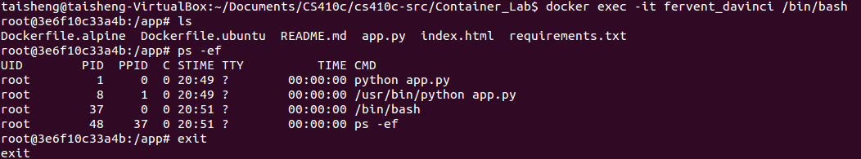
* **Publish the container to your Docker Hub account**
* **Login to Docker Hub using account from Homework #1**
  + - docker login
    - 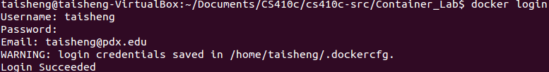
* **Tag image to your Docker Hub repo**
  + - docker tag helloubuntu <dockerhub_id>/helloubuntu
    - 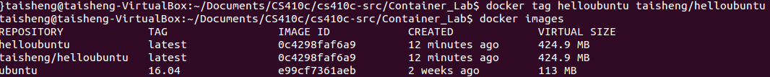
* **Push image to your Docker Hub repo**
  + - docker push <dockerhub_id>/helloubuntu
    - 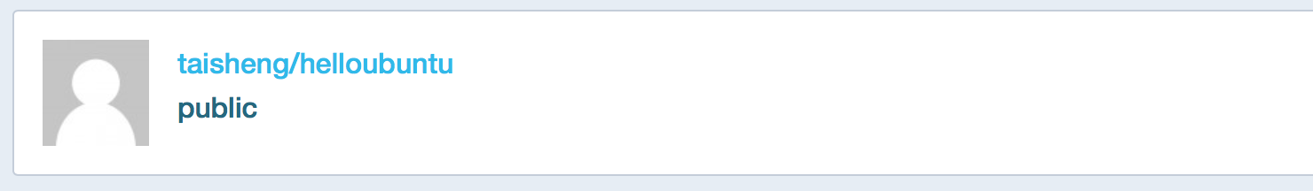
    - 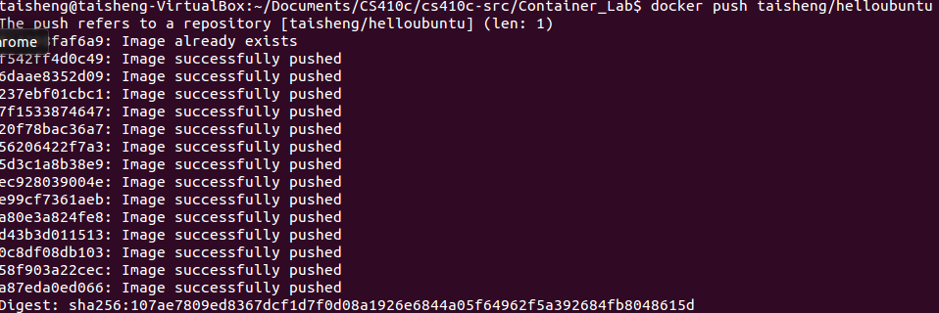
* **Now, stop and remove the local container**
  + - docker stop stupefied_wiles
    - docker rm stupefied_wiles
    - Note that while this removes the container, it does not remove the container image it was derived from (i.e. helloubuntu).
    - 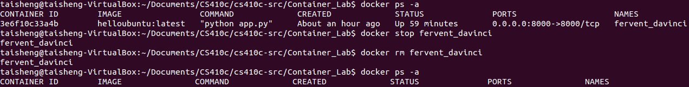
* **Now, remove both container images from your local machine**
  + - docker rmi helloubuntu <dockerhub_id>/helloubuntu
    - 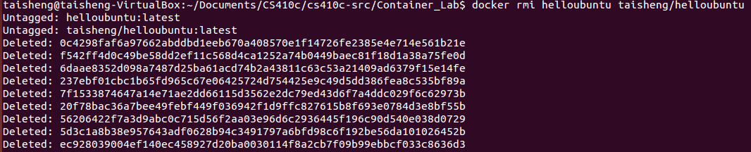
* **Run the image directly from Docker Hub**
  + - docker run -di -p 8000:8000 <dockerhub_id>/helloubuntu
    - 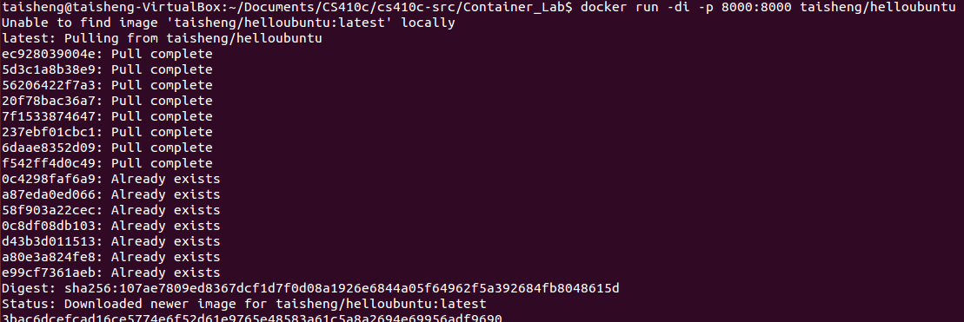
* **Validate that the container works by retrieving** [**http://127.0.0.1:8000/**](http://127.0.0.1:8000/) **using a browser, wget or curl**
  + 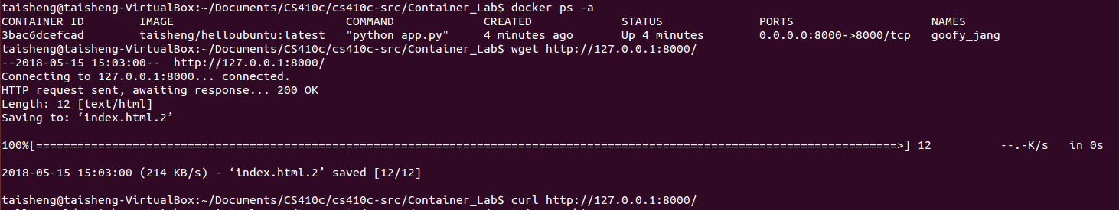
* **Show the container image on Docker Hub**
  + 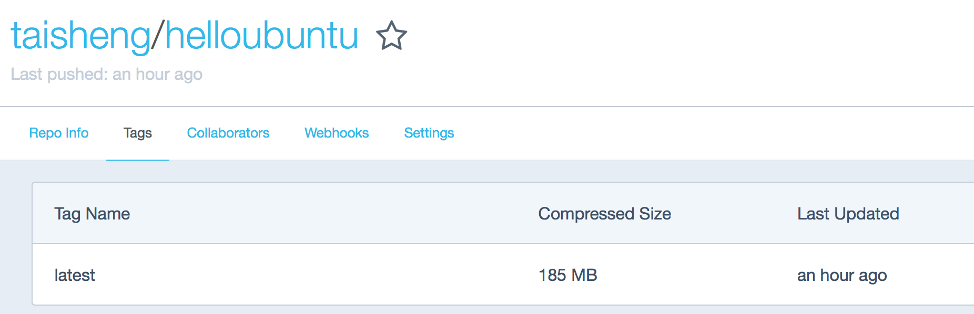

# 

# Container Lab #2(Taisheng)

* **Build a container for the application with Python Alpine as a base**
  + **Repeat the same steps used in the Ubuntu container helloubuntu, but with Dockerfile.alpine to create a local container helloalpine and a Docker Hub container <dockerhub_id>/helloalpine**
    - 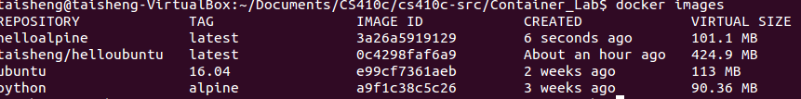
  + **For the the docker exec command, what is its output?**
    - 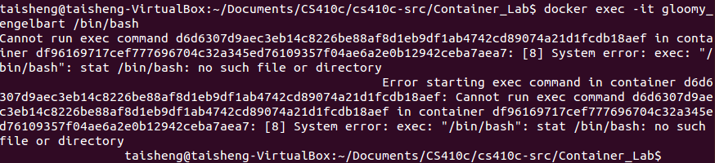
    - **What happens when you replace /bin/bash with /bin/sh in the docker exec command?**
    - 
  + **Repeat all other steps including pushing the container image to your Docker Hub account**
  + 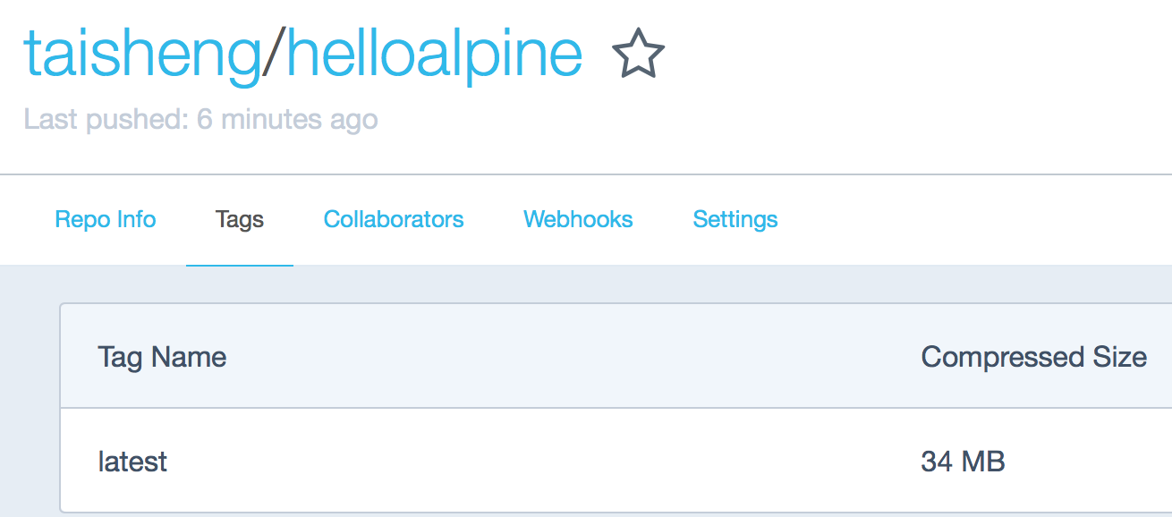

# Container Lab #3 (Taisheng)

* **Running containers in Google Cloud (UbuntuVM)**
* **Create VM on Google Cloud's Compute Engine**
  + Create instance
  + Place in zone us-west1-b
  + Select Ubuntu 16.04 LTS as a boot disk
  + Click on Allow HTTP Traffic
  + Click on Create
  + 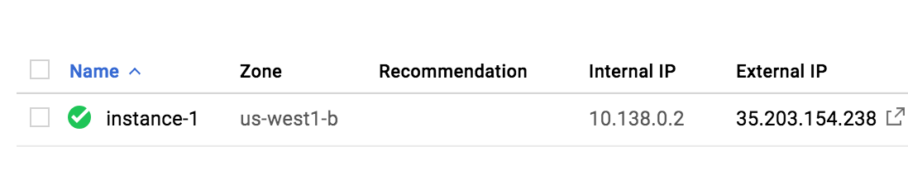
* **Install docker on the VM and add your username to its group**
  + sudo apt-get update
  + sudo apt-get install -y docker.io
  + sudo usermod -a -G docker $(whoami)
  + Then, logout and log back in
  + 
* **Run the helloalpine container, but map the host's port 80 to the guest's port 8000**
  + docker login
  + docker run -di -p 80:8000 <dockerhub_id>/helloalpine
  + 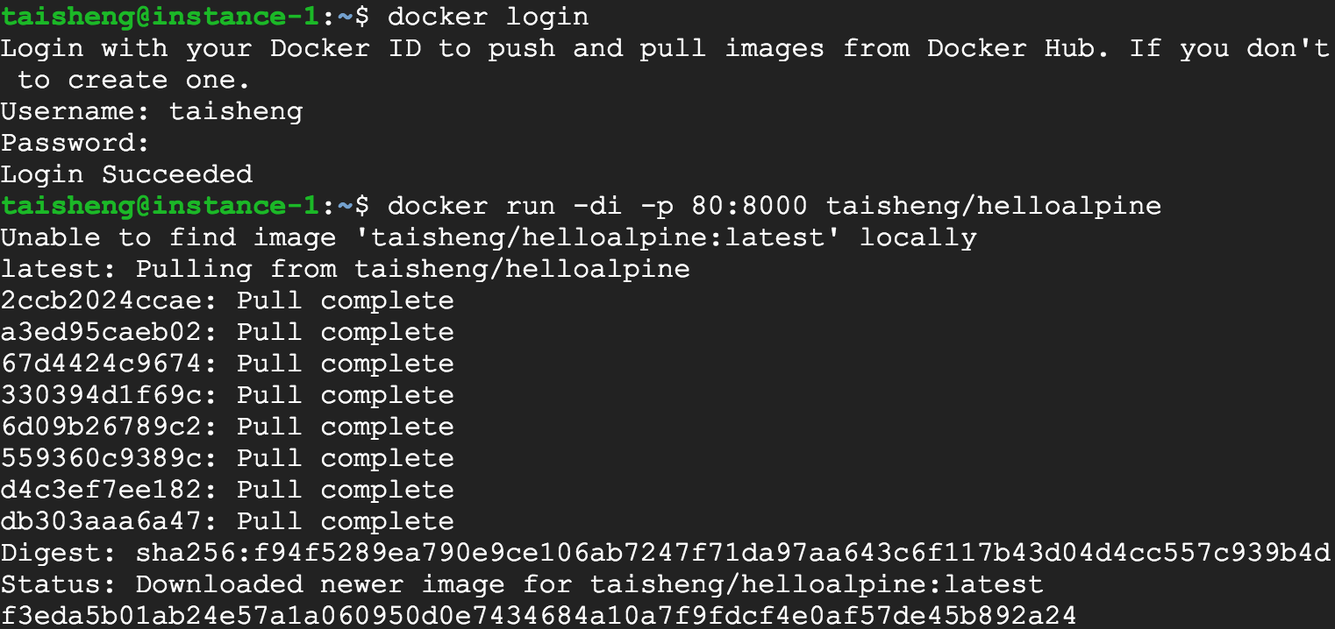
  + 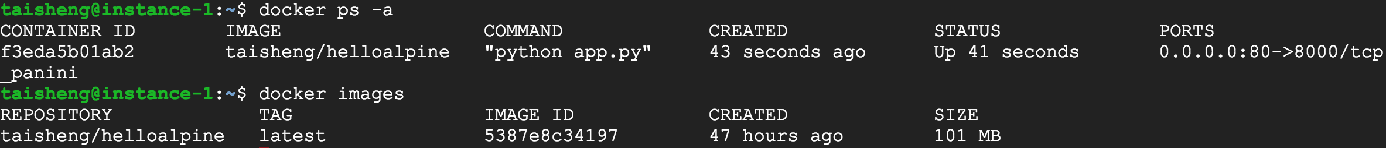
* **Go to a web browser and point it to the External IP address of the VM**
  + **Can be done by clicking on the IP address from the Compute Engine console**
  + **Show the output**
  + 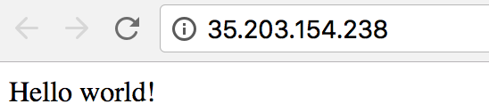

# Container Lab #4 (Taisheng)

* **Running containers directly in Google Cloud (ContainerOSVM)**
* **We will run our container in the previous labs on port 8000 and deploy it directly on a Compute Engine instance**
* **First, we need to create a VPC firewall rule to allow the port your container exposes by default (8000)**
* **Name the rule something descriptive**
* **Set its tag name to http-8000 (Rules applied based on tag name)**
* **Specify allow on match, ingress filtering, all source IP addresses, TCP port 8000**
* **Create the rule**
  + 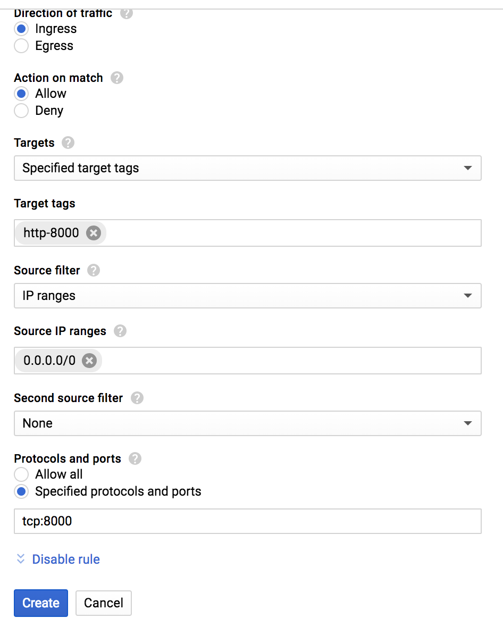
* **Create a VM to deploy your container on**
  + **Specify container image name (e.g. your Docker Hub image name for your web app)**
* **Boot disk will be set to Google's Container OS**
  + 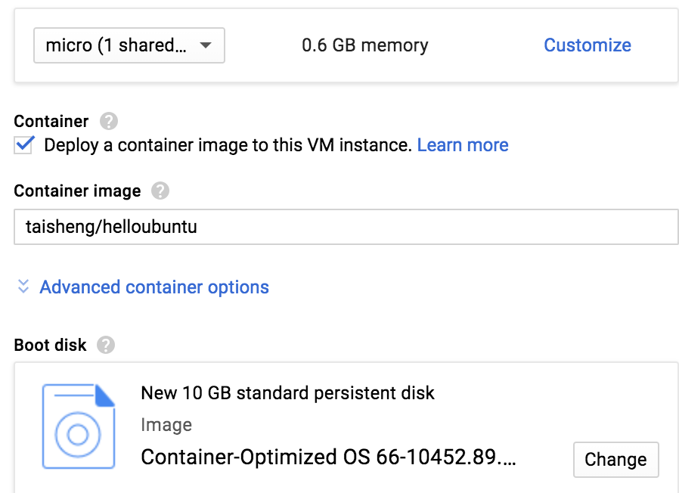
  + **Apply the tag you created**
  + 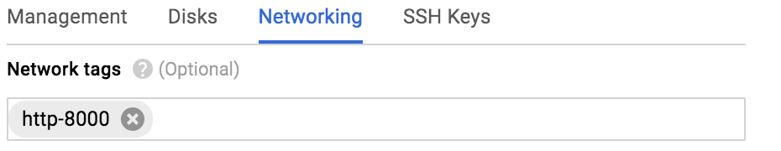
* **Create the VM**
* **ssh into the VM via console**
  + **Wait until the container comes fully up**
  + **Fetch http://localhost:8000 to ensure the container is running and serving up your web app**
  + 
  + 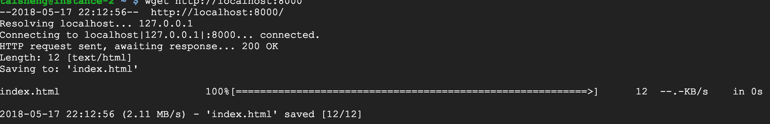
* **Find its external IP address in Compute Engine**
* **Visit http://<external_IP_address>:8000**
  + **Show screenshot of your web app running**
  + **Note, we did this through a GUI, but we will eventually deploy containers via command-line or via a YAML file**
  + 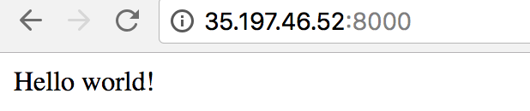

# Cloud Storage Lab #1 (Baiwei)

* **Step 1 - go to directory lab2b**



* **Step 2 - interact with USGS data**





* **Step 3 - install required files**









* **Step 4 - get the image**

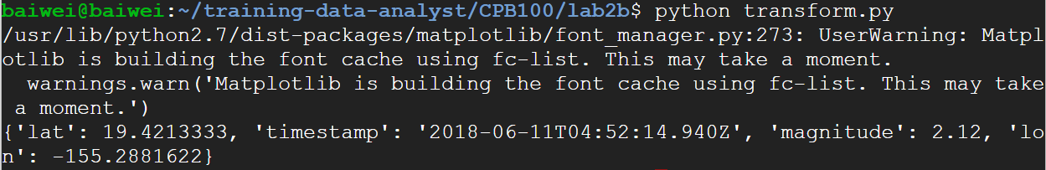

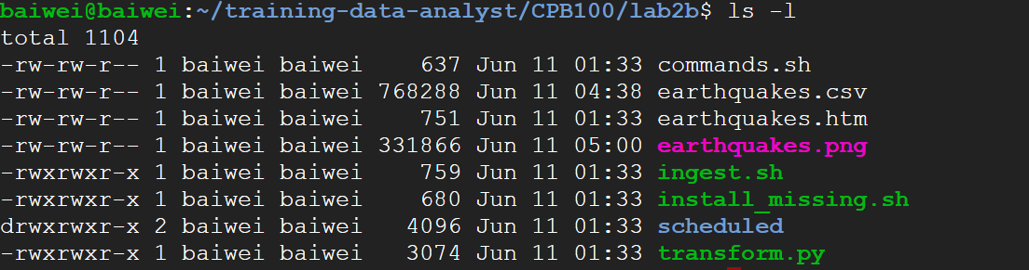

* **Step 5 - copy output file to bucket**

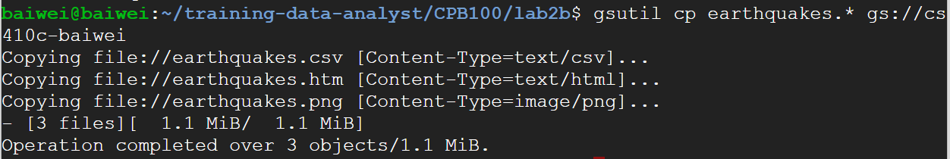

* **Step 5 - make files to public**

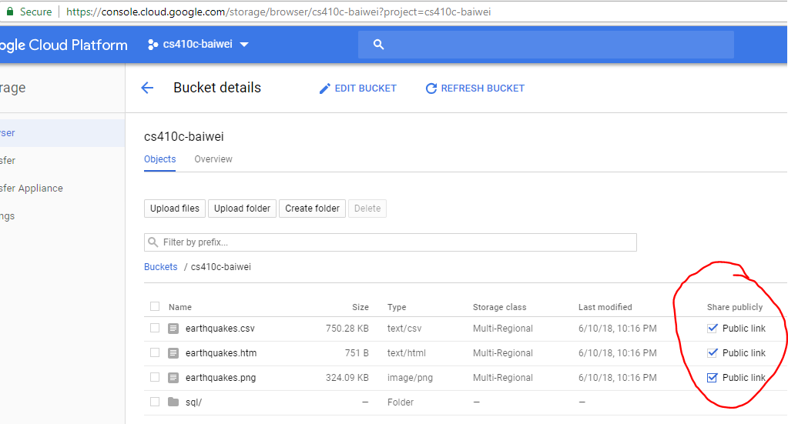

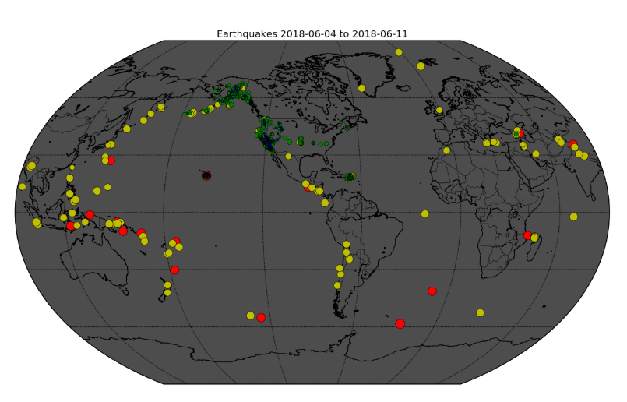

# IAM Lab #1 (Taisheng)

* **Create a Google group at** [**https://groups.google.com**](https://groups.google.com) **called cs410-OdinID**
  + 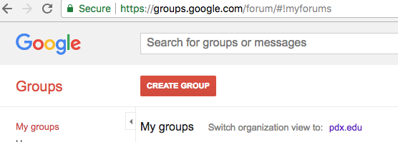
* **Add yourself, me (wuchang@pdx.edu), and your partner (if working in a group)**
  + 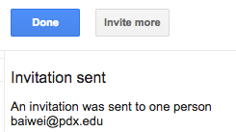
* **In IAM, add the group to project permissions (Project=>Viewer)**
  + 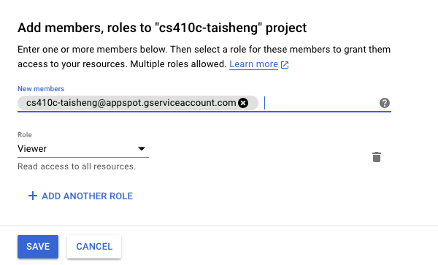
* **Test with your partner or with me (if you do not have a partner)**
* **For help only**
* [**https://cloud.google.com/iam/docs/quickstart**](https://cloud.google.com/iam/docs/quickstart)

# Google Cloud Storage Lab #2 (Baiwei)

* **Step 1 - Create GCP project**

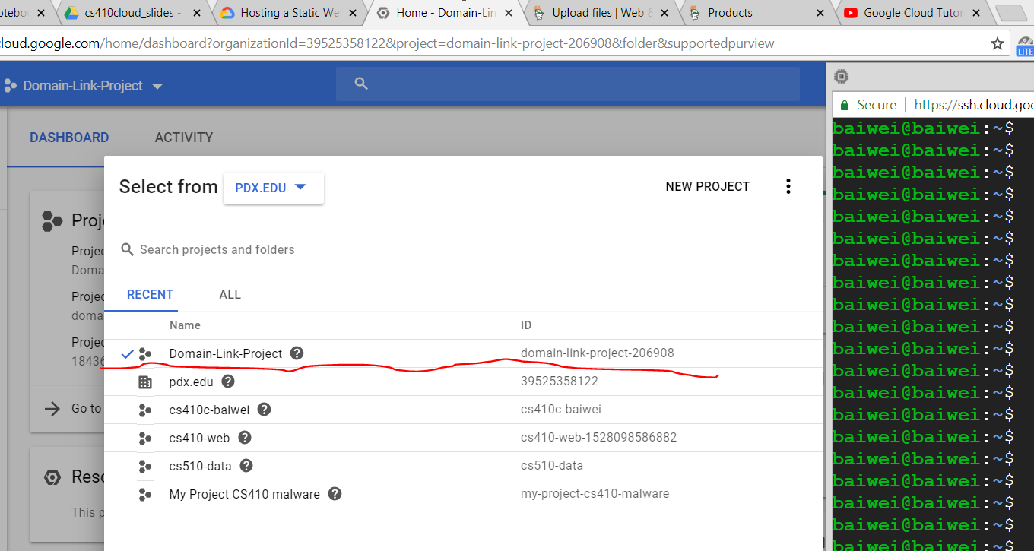

* **Step 2 - have a domain that you own or manage**

I just bought a domain from GoDaddy: [*www.baiwei.co*](http://www.baiwei.co)

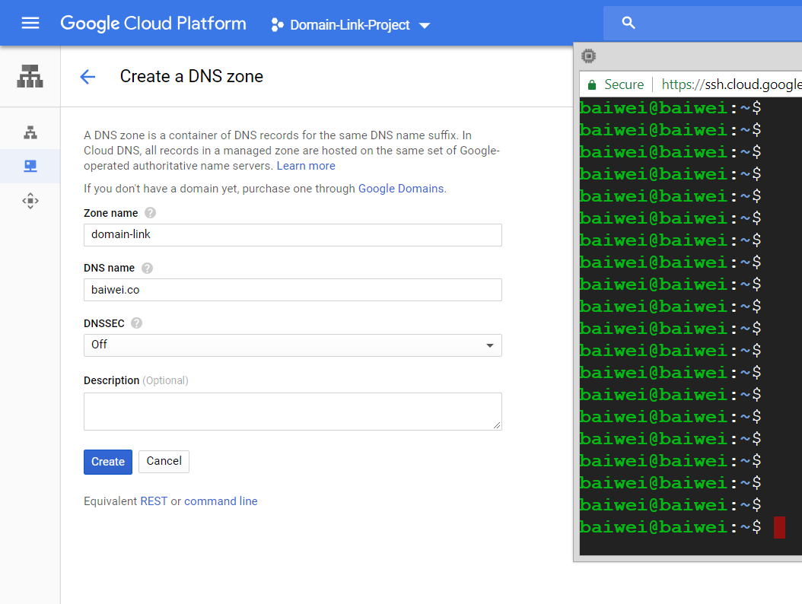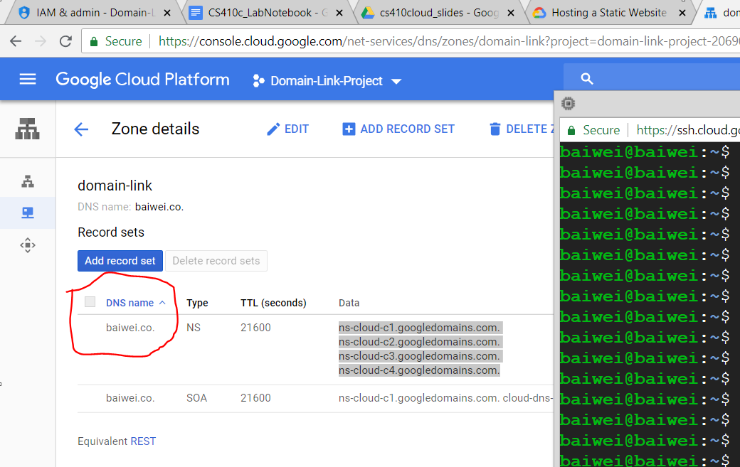

* **Step 3 - Setup my DNS at GoDaddy**

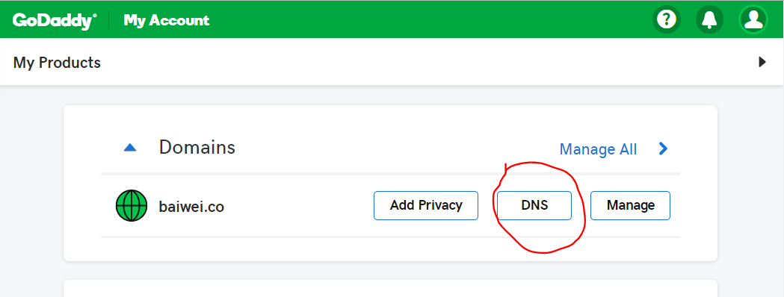

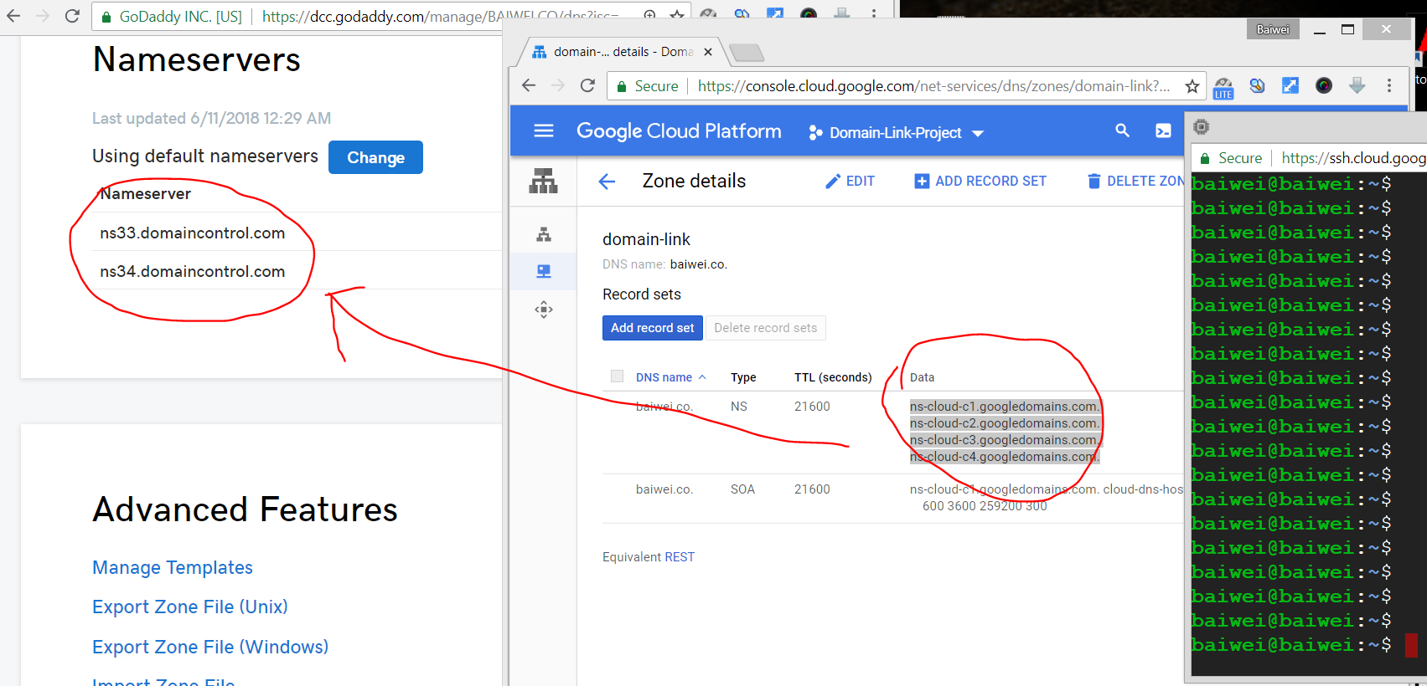

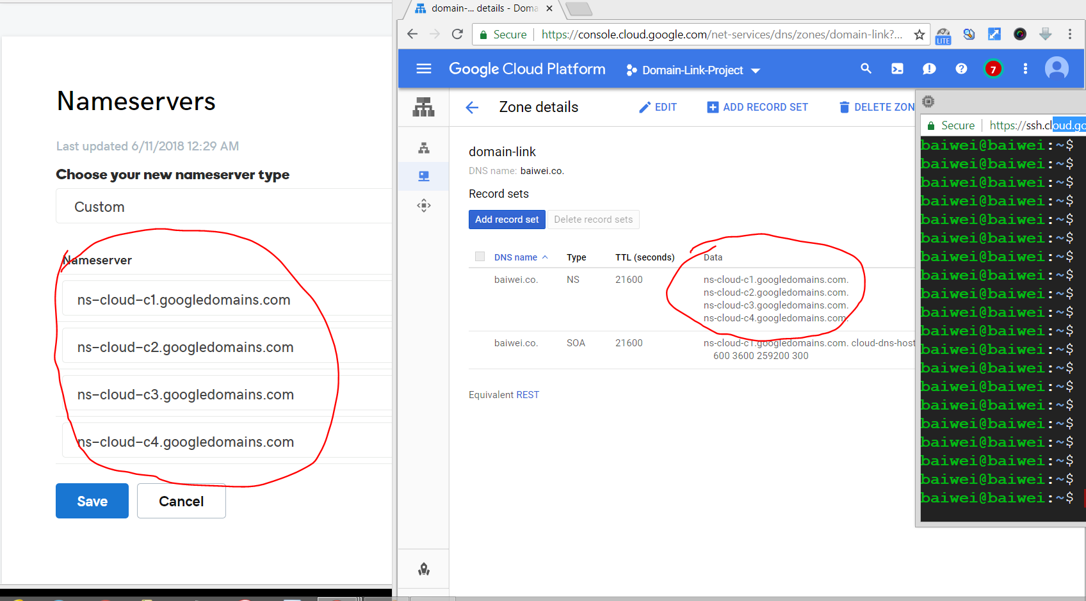

(Now my domain: *baiwei.co* has been linked to Google Cloud server. )

* **Step 4 - Verify ownership of GoDaddy domain name on GCS (a must before creating bucket)**

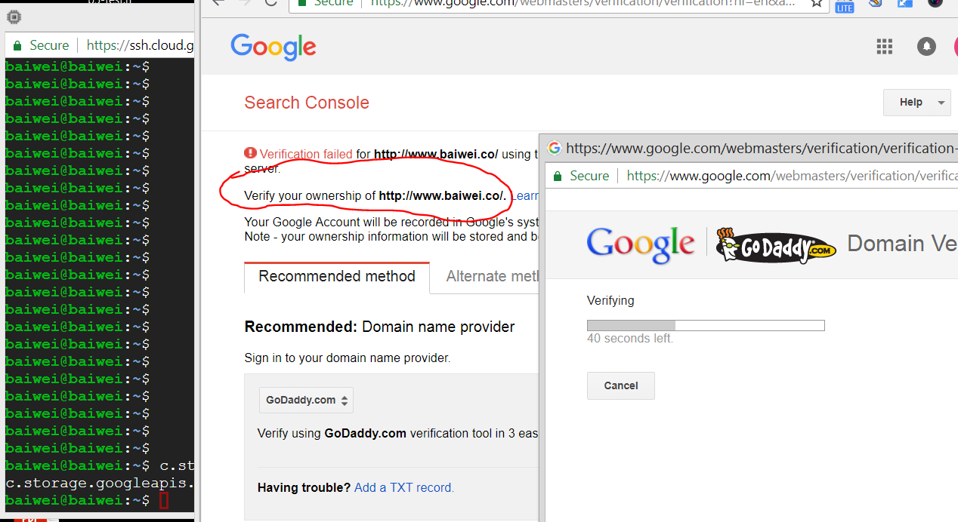

(*baiwei.co* is successfully added to bucket !!)

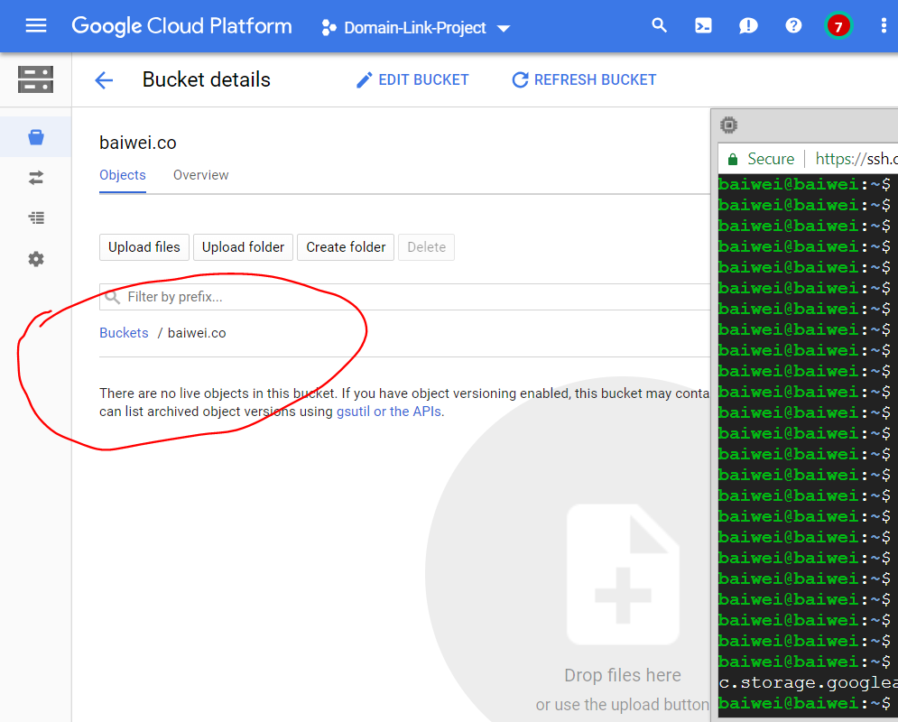

* **Step 5 - upload files (html, css, js and so on) to bucket**

Prior to this class, I’ve built my personal webpage. So I decide to upload the webpage file to the GSC.

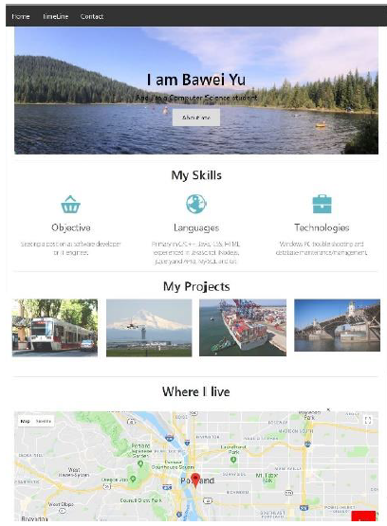

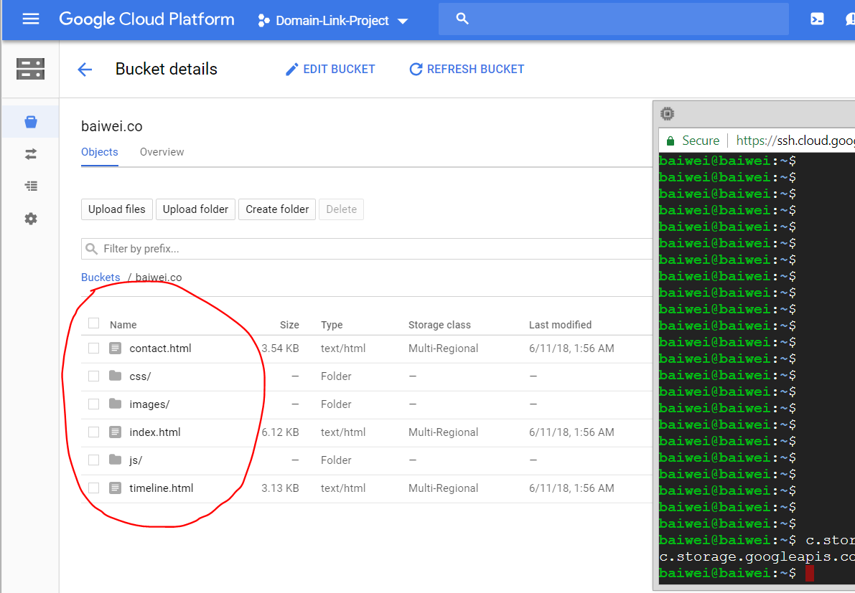

* **Step 6 - make the webpage public**

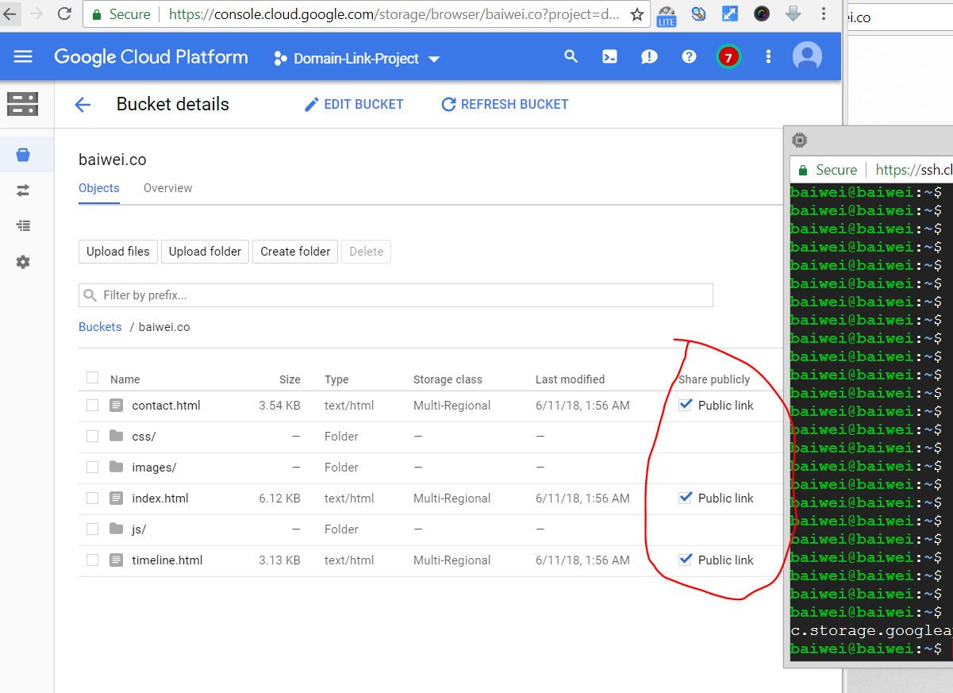

(Now, my website is ready to go!)

# Compute Engine Lab #1 (Taisheng)

* **Compute the Cosmos (54 min)**
* **Demo multiple ways of accessing Compute Engine (command-line, programmatically in Python)**
* **Then, perform a large computation**
* **Note: You can re-use your course project for this lab**
* **Set zone to us-west1-b**
  + 
* **Add Custom VM Image to Project**
* **Run the following command to add a custom VM Image to your project named "codelab-image"**
  + 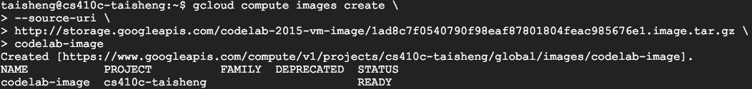
* **May take a few minutes**
* **List image**
  + 
* **Create a persistent disk and use it to build codelab VM**
  + 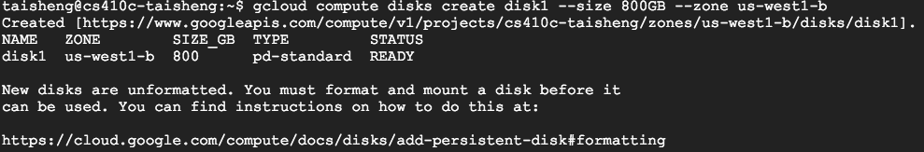
* **Note that VM image and disk must be in same zone**
  + 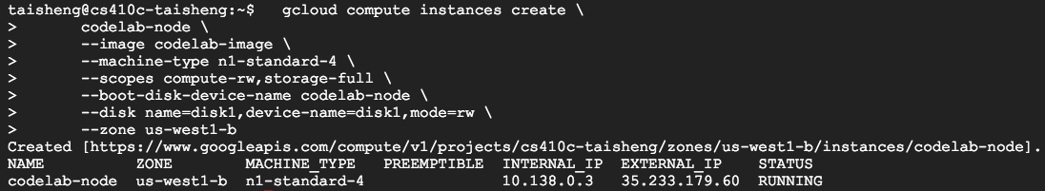
* **Programmatically list VM instances in your project**
* **ssh into your VM instance via the console or via**
* **Create a simple program helloworld.py with the following imports**
* **Then set credentials**
  + 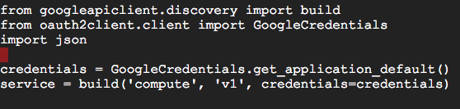
* **Then enter the following in to the file, filling in PROJECT_ID with your own**
  + 
* **Save the file and run it from the command line**
* **Show the JSON that is returned**
  + 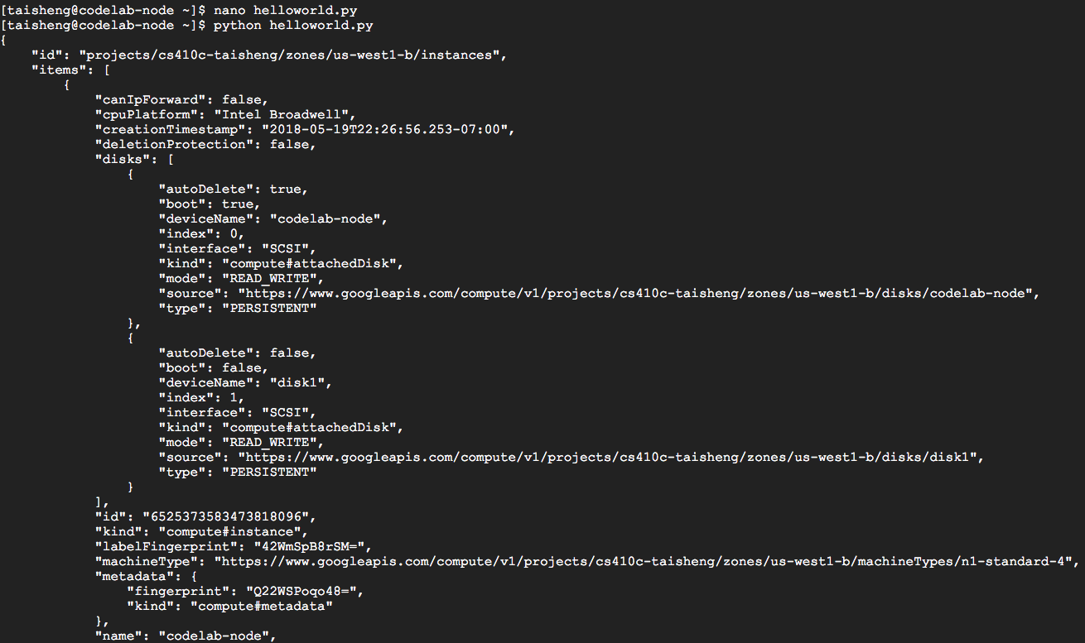
* **Find all images that cover one part of the sky**
* **Align and stack them to create a deeper view**
* **Create a mount point for disk, find persistent disk's ID**
* **from previous step, format it, mount it, set it to rwx**
  + 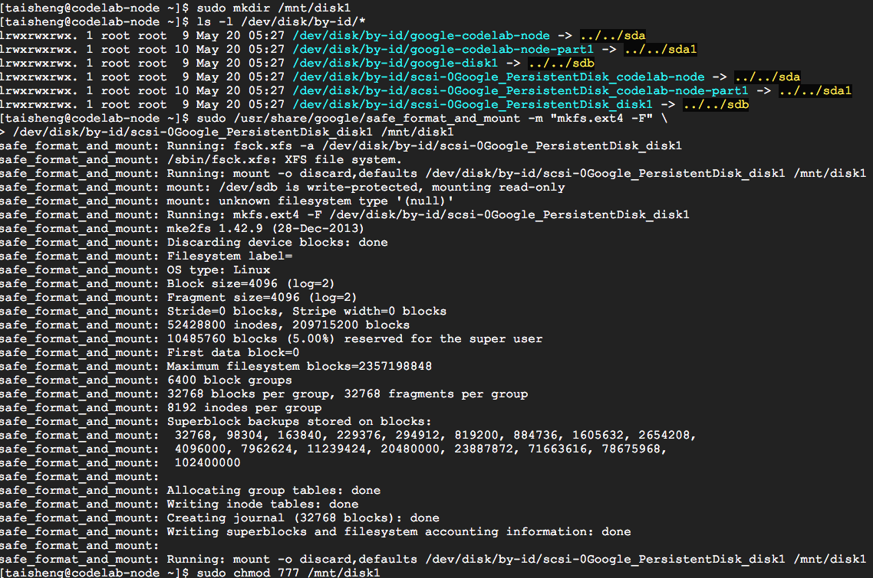
* **Check disk contents (~800GB available)**
  + 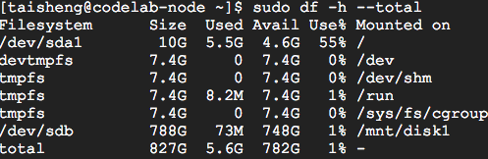
* **Then change directories into it**
  + 
* **Run the following command to get a tile assignment**
  + 
* **Confirm that your tile assignment is valid.**
  + 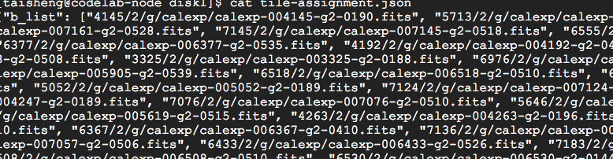
* **File contains JSON object with URLs to .fits files.**
* **Using JSON Pretty Print try running this command**
  + 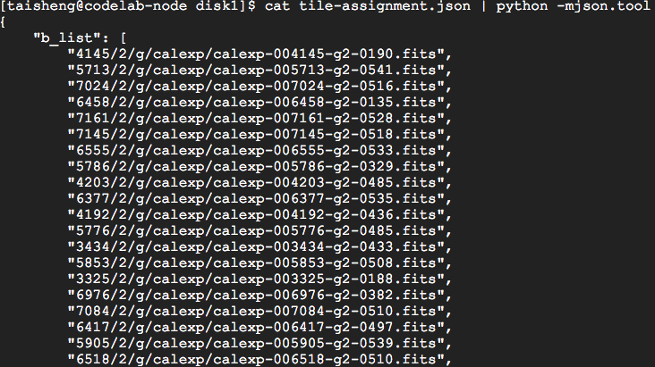
* **If you did not get a valid JSON response, try to request another assignment.**
* **Initialize the LSST Software Stack for astronomical image processing (Large Synoptic Survey Telescope)**
* **Download the Python processing script and other input files.**
* **Change your present directory to the location of LSST Software Stack.**
  + 
* **Initialize LSST software for usage.**
  + 
* **Setup the LSST afw Python library.**
  + 
* **Download makeCoaddCloud.py provided by University of Washington and other input files from Google Cloud Storage to the mounted Persistent Disk.**
  + 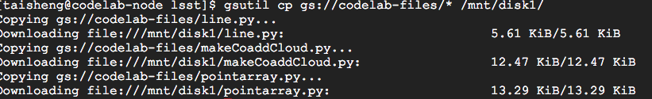
* **Change directory back to mounted Persistent Disk.**
  + 
* **Execute the makeCoaddCloud.py script to process the JSON in our tile assignment and generate an image.**
* **Note: Start with --maxImages=20, increasing by 5 until it successfully completes, if it still fails abandon this tile and go back to the previous step titled "Assigning yourself part of the Universe" to get assigned a new tile.**
* **If you want to include all images associated with your tile assignment you can run the command without the -- maxImages flag but be aware that this will require more time for processing.**
* **Find out the image filename for your newly created image by listing the contents of your current directory.**
  + 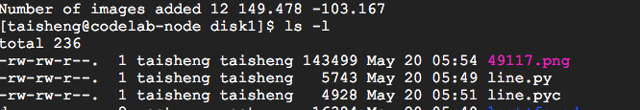
* **Create a Google Cloud Storage bucket in your project to host your image for viewing in a web browser.**
  + 
* **Copy the composite image file you just created to a Google Cloud Storage bucket in your project.**
  + 
* **Make the image public (done via GUI previously)**
  + 
* **View image in a browser**
  + 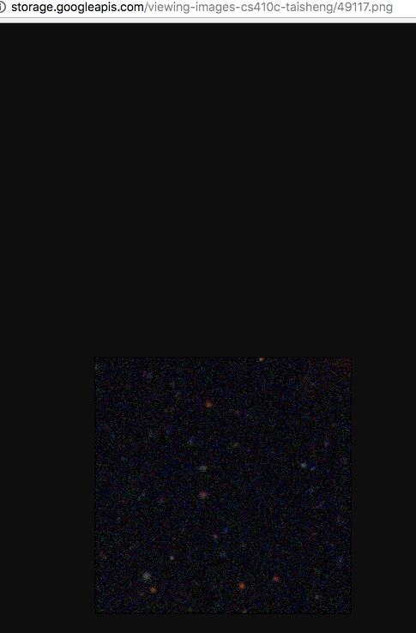

# App Engine Lab #1 (Taisheng)

* **In Google Cloud Shell**
* **Create app directory**
  + 
* **Create app in helloworld.py**
  + 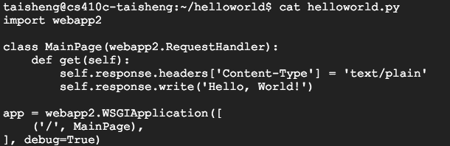
* **Configure deployment using app.yaml YAML specification file**
  + 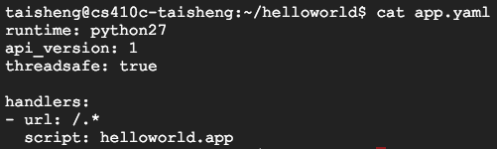
* **Start a deployment instance of the application server**
  + 
* **Click on Web Preview Icon**
  + 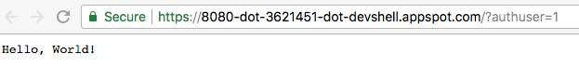
* **Leave the web server running, open a new Cloud Shell session with the +, and change the helloworld.py file.**
* **Change the message while app is running**
  + 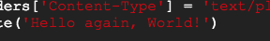
* **Reload the browser tab and see that the output has changed.**
  + 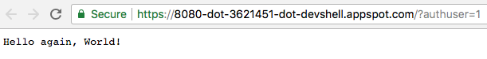
* **Shutdown the dev_appserver**
  + 
* **Via Cloud Shell**
* **Place in us-central**
  + 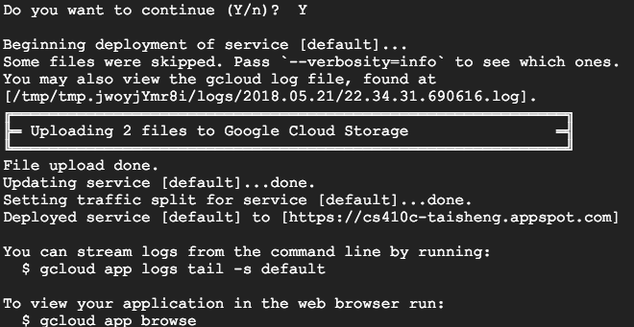
* **After the application is deployed, visit it by opening the URL in your web browser:**
* **Take a screenshot**
  + 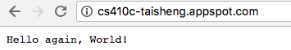
* **View the app and instance in the App Engine dashboard to see how many resources it consumes**
* **Go to App Engine instances, select instance, then**
* **Delete**
  + 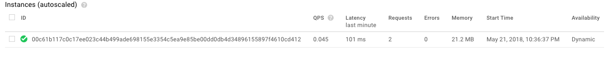

# App Engine Lab #2 (Taisheng)

* **Python Flask on App Engine Standard Environment**
* **Test app locally in your Ubuntu VM**
  + 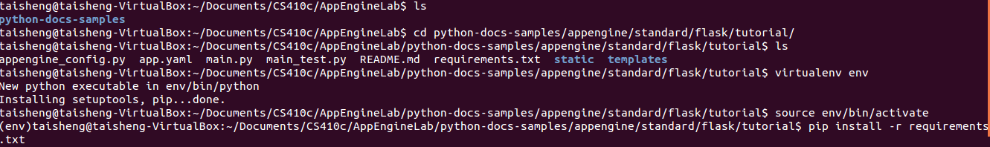
* **Then, edit main.py and place the following code at the bottom (app-engine code not meant for interactive startup)**
  + 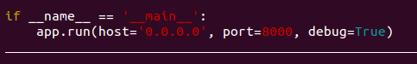
* **Then, run the app**
  + 
* **Visit the app and submit a form to see that it works**
  + 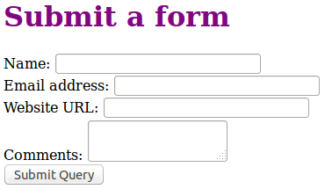
* **Examine source code (main.py)**
  + 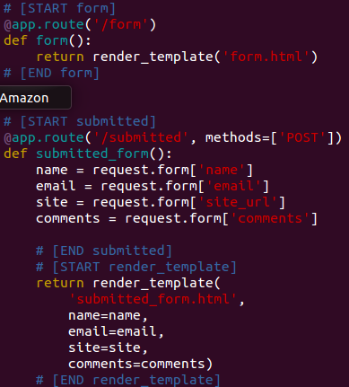
* **Examine source code (form.html)**
  + 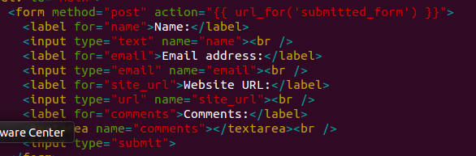
* **Examine source code (submitted_form.html)**
  + 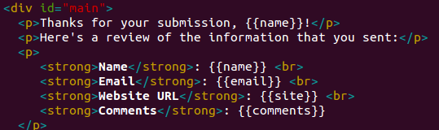
* **Note the style.css file in static/ directory**
  + 
* **Specified in App Engine so that it may be served via the web server**
* **See python/uwsgi/nginx discussion**
* **Goto Google Cloud Shell**
* **Repeat install, but now, packages will be installed in lib directory now**
  + 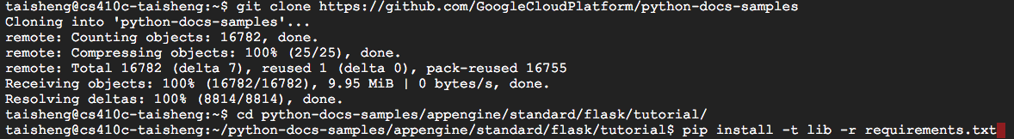
* **Examine source code specific to App Engine**
* **Add path to libraries**
  + 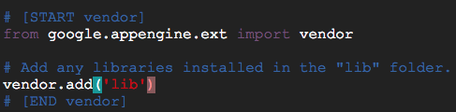
* **Add application configuration to App Engine YAML configuration file**
  + 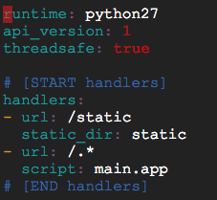
* **Run the app using the dev_appserver**
* **Wait in console for server to boot up**
  + 
* **Note the three ports being listened**
  + **API server**
  + **Your app on 8080**
  + **Admin console on 8000**
* **Visit the admin server, by going to "Web Preview" and changing the port to 8000, then launch**
* **View the information on your deployed application**
* **May come in handy for your homeworks**
  + 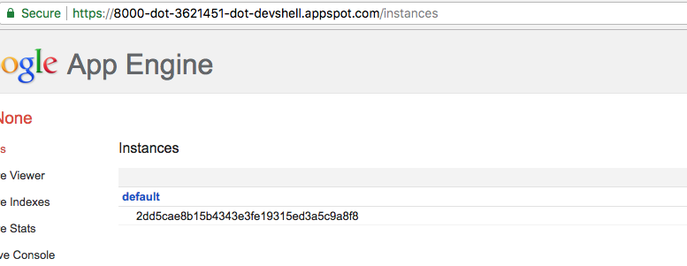
* **Visit your app, by going to the Web Preview and**
* **changing the port back to the app (8080)**
  + 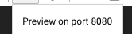
* **Note: There is no route on / in the app**
  + 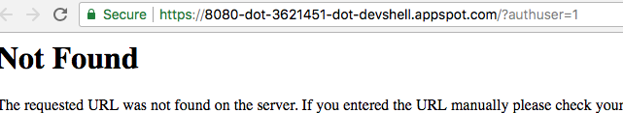
* **Go to /form**
  + 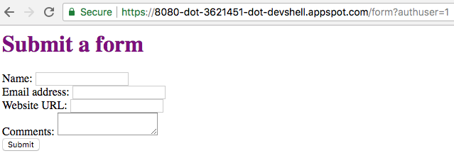
* **Deploy the app**
  + 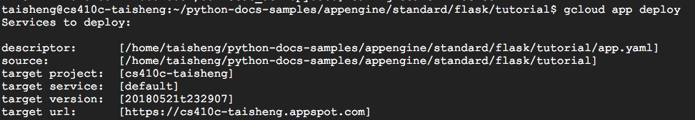
* **Show the site up at the registered URL**
  + 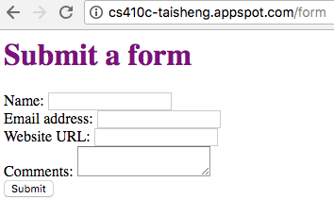

# Cloud Datastore Lab #1(Taisheng)

* **Bookshelf Python/Flask app running on App Engine via managed, DBaaS NoSQL backend (Cloud Datastore) (45 min)**
* **Run within your class project (not cp100)**
* **On, navigation pane go straight to “Source Repositories => Repositories"**
* **Create a new repository named "default"**
  + 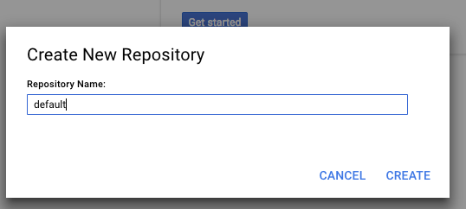
  + 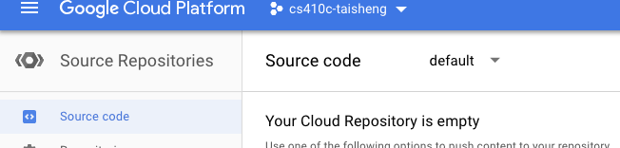
* **Note the options for populating your repository**
* **We will be doing this via command-line**
* **In Cloud Shell, populate the repository**
  + 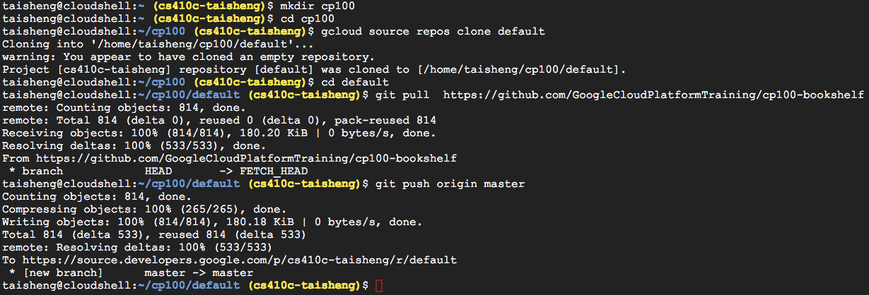
* **Then go back to Web UI and view the files in "Source Repositories"**
  + 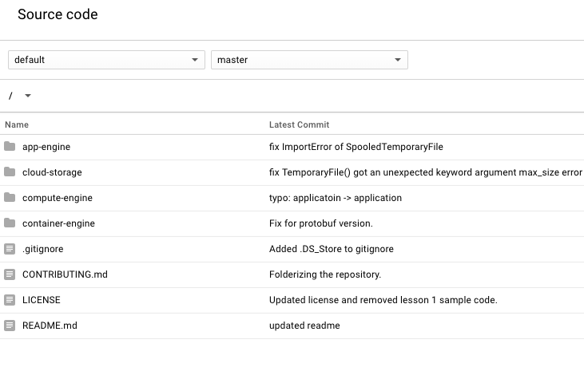
* **Bookshelf code**
* **Has versions for multiple cloud architectures**
  + **app-engine**
  + **PaaS (App Engine)**
  + **cloud-storage**
  + **PaaS with static content (App Engine w/ Cloud Storage)**
  + **compute-engine**
  + **IaaS (Compute Engine)**
  + **container-engine**
  + **Containers (Container Engine)**
  + 
* **Done via simple MVC framework to separate model (database code) so that it is easily pluggable**
* **Within app-engine**
* **app.yaml configures app and routes requests to it**
* **All routes go to main.app**
  + 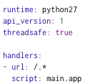
* **Database implementation**
* **Set in config.py**
  + 
* **main.py**
* **Code mostly in bookshelf class**
* **Imports config.py for model configuration**
* **Note that bookshelf is imported as a directory**
* **By default, Python will look for __init__.py for its implementation**
  + 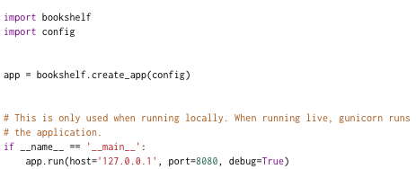
* **bookshelf/__init__.py**
* **Initializes app and configures model based on config**
* **(e.g. Cloud SQL vs Cloud Datastore)**
  + 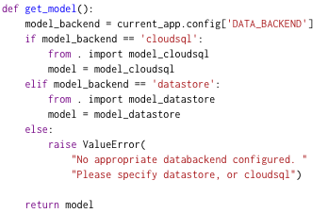
* **crud.py routes for**
* **list()-ing all books**
  + 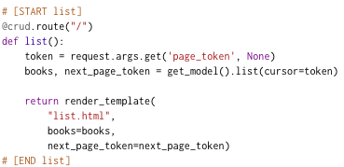
* **read()-ing a single book by ID**
  + 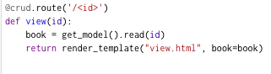
* **create()-ing a book**
  + 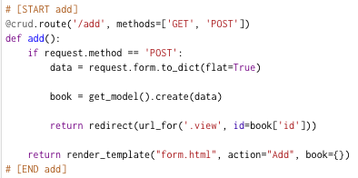
* **delete()-ing a book**
  + 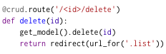
* **edit()-ing a book**
  + 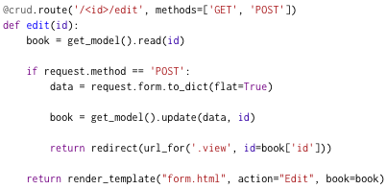
* **Note use of get_model() throughout to abstract out which backend database is used**
* **Each model implements same 5 methods**
* **Database implementation in model_datastore.py**
* **Implementation for managed NoSQL (Cloud Datastore)**
* **Recall key-value storage abstraction**
* **Key is a unique integer**
* **Google’s ndb Python client library for interfacing with Cloud Datastore**
* **Note the restricted interface to backend datastore**
  + **get()**
  + **put()**
  + **delete()**
* **Cloud Datastore model**
* **Kind = similar to table in SQL, categorizes entities for queries**
* **Entities = similar to a row in SQL, but not all entities of a Kind have the same properties. Has a unique key.**
* **Properties = similar to columns in SQL**
* **Alternate database implementation in model_cloudsql.py**
* **Implementation for managed SQL (Cloud SQL)**
* **SQLAlchemy (Python support for writing to SQL backends)**
  + 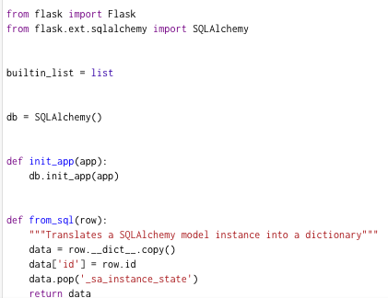
* **Bookshelf code**
* **Python modules specified in requirements.txt**
  + 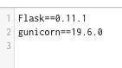
* **Install packages in requirements.txt in lib directory**
  + 
* **appengine_config.py then loads lib directory packages when app deployed**
  + 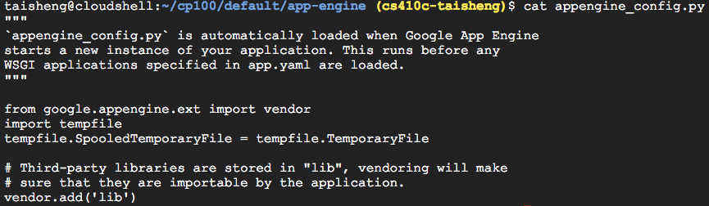
* **Then, deploy the app**
  + 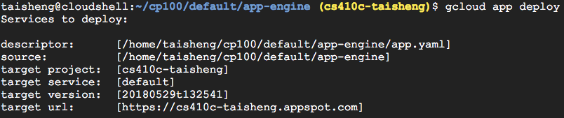
* **Visit the web application after deployed**
  + 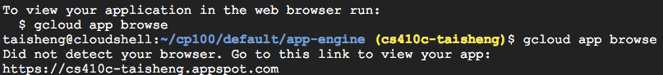
  + 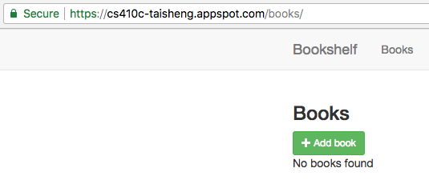
* **Add the book as described in the walkthrough**
  + 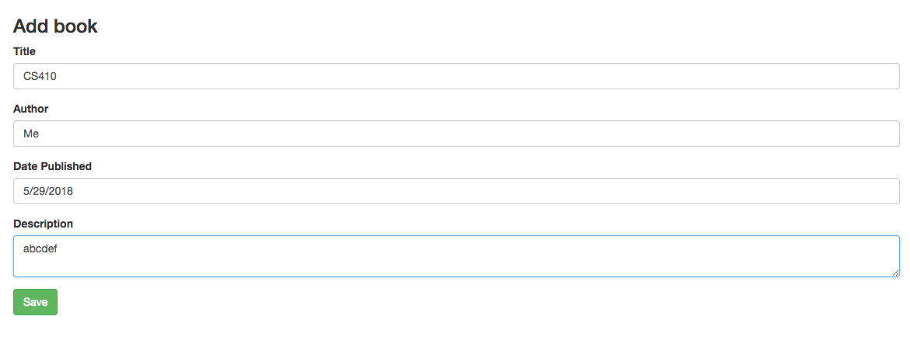
* **Turn in**
* **Submit a book to your app**
  + 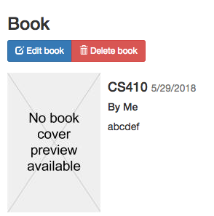
* **Then, go to Storage => Datastore => Entities to show the book added**
  + 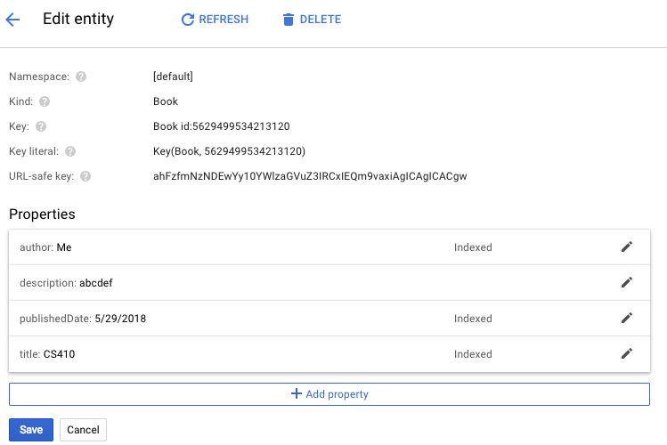
* **Add a book via this interface and return to the web app**
  + 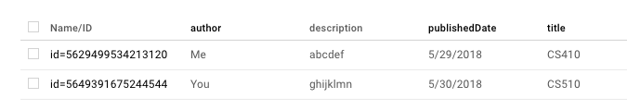
* **Show both books**
  + 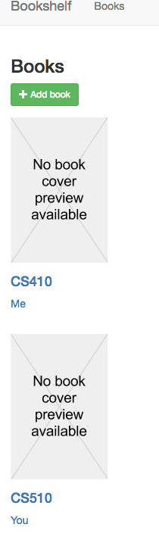
* **Remove the app from App Engine (see prior lab)**

# Spanner Lab #1(Taisheng)

* **Getting Started with Cloud Spanner in Python**
* **Uses multiple methods for accessing**
* **Enable API**
* **Use us-west1 region**
  + 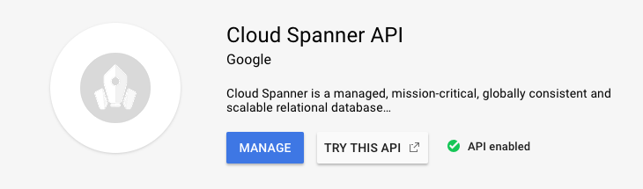
* **In Cloud Shell, set up authentication and authorization (if needed)**
* **Clone the sample app repository (not necessary)**
  + 
* **Set up a local Python virtual environment and install Spanner dependencies**
  + 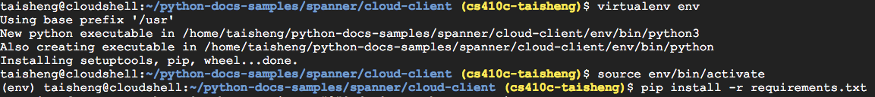
* **Create a 1-node Cloud Spanner instance in us-west1**
  + 
* **Python code for creating database (SQL)**
  + 
* **Client class used to interact with Spanner database**
* **Via a Batch object**
* **Container for mutation operations (create/insert, update, delete) to be applied atomically to a set of rows/tables**
* **Run snippets.py with insert_data as argument**
  + 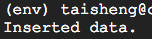
* **Via command line, execute arbitrary SQL on Spanner instance to read values columns from the Albums table**
* **Show the results**
  + 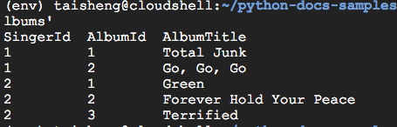
* **query_data to get album information via SQL**
* **Run snippets.py using the query_data argument**
* **Show results**
  + 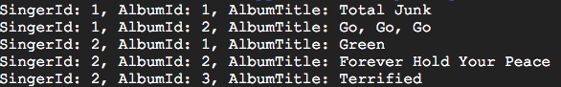
* **read_data to get album information via Spanner API**
* **Run script using the read_data argument**
* **Show results**
  + 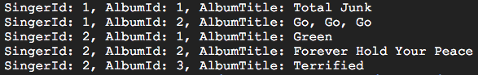
* **Only do the first two bullets of the walk-through https://cloud.google.com/spanner/docs/getting-started/python/**
* **Note, you may do the entire lab on Cloud Shell**
* **(i.e stop at "Update the database schema" section) Remember to delete everything when done**
* **$$$**

# Kubernetes Lab #1(Taisheng)

* **Bookshelf Kubernetes Engine + Cloud Datastore + Cloud Storage (30 min)**
* **2 nodes, 3 replicas of a single Docker container image**
* **Network load-balancer to route requests to the external IP address on port 80 to one of the three replicas**
* **Ensure Kubernetes API is enabled**
* **In web console, and select Go to APIs Overview**
* **Search for Google Kubernetes Engine and ensure it is enabled**
  + 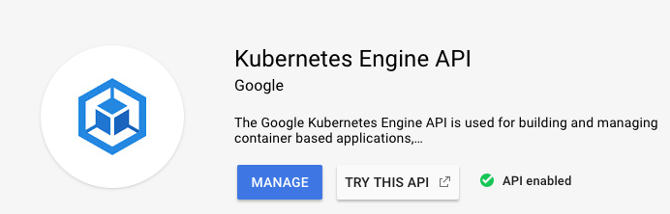
* **Launch Cloud Shell**
* **List Compute Engine zones (which will run your containers)**
  + 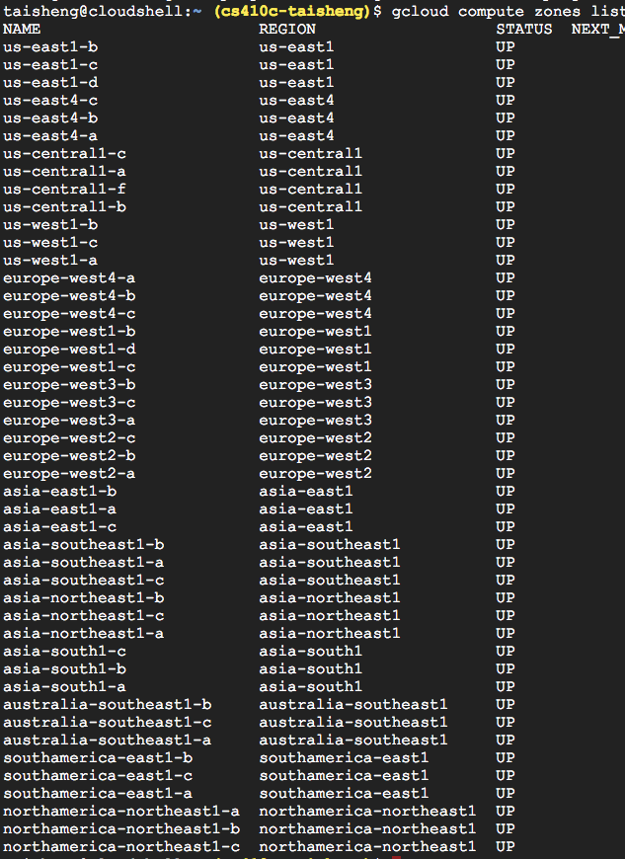
* **Set the region to the desired region:**
  + 
* **See configuration**
  + 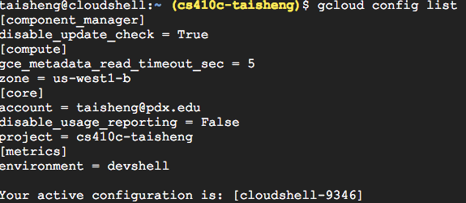
* **Create a bucket to hold images uploaded by web site users**
* **Via Google Cloud Shell**
  + **gsutil mb -l <location> gs://$DEVSHELL_PROJECT_ID**
* **gsutil (Google Cloud Storage utility) command**
* **mb = make bucket**
* **Use <location> of us-west1**
* **gs://**
* **URI for all buckets (must be globally unique)**
* **Use <Project ID> to uniquely label bucket**
* **Note: you can use any name that is unique but the instructions assume you’ve named your bucket after your project ID**
* **Get Project ID in Google Cloud Shell via**
  + **echo $DEVSHELL_PROJECT_ID**
  + 
* **Verify in console that bucket has been created**
* **Allow global read access to bucket**
  + 
* **Create cluster called bookshelf with two nodes**
* **Set scope to cloud-platform so it can access services such as Cloud Storage and Cloud Datastore**
  + 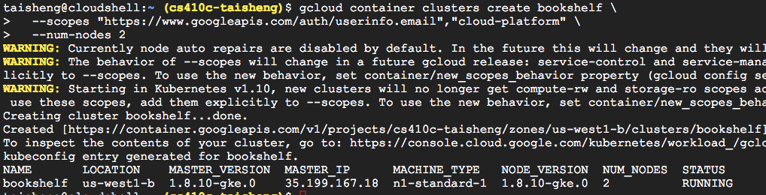
* **Examine code**
* **Source Repositories=>Source code=>container-engine**
* **Note: Alternative client libraries used to access Cloud Datastore for Container Engine version versus App Engine**
  + 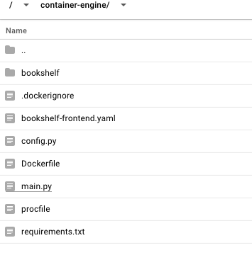
* **Update config.py and bookshelf-frontend.yaml with your project ID**
  + 
* **Set container cluster to previously created one**
  + 
* **Build Docker container from Dockerfile and code in current directory and register it in Google Cloud Registry**
  + 
  + 
* **Push it to the registry**
  + 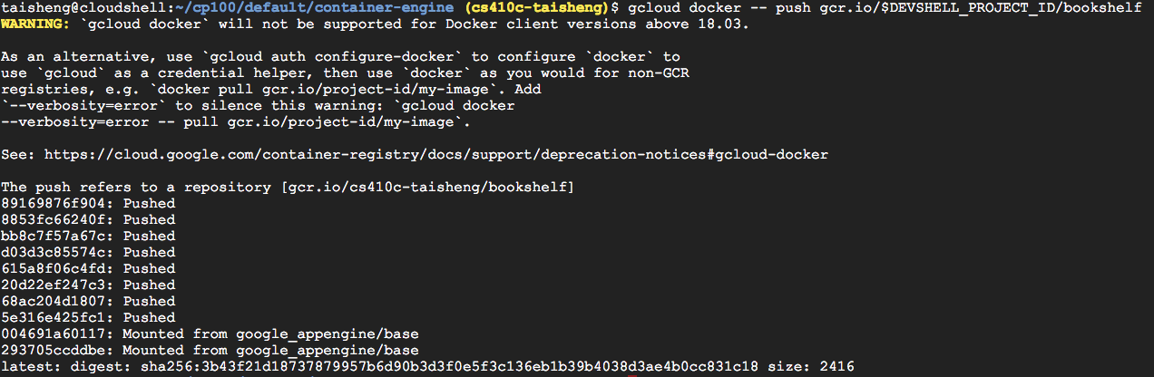
* **Kubernetes configuration (3 replicas, 1 service)**
* **Get credentials for kubectl**
  + 
* **Use Kubernetes kubectl to deploy and scale on GKE**
  + 
* **Note that all containers run on Compute Engine instances**
* **But, configuration file portable**
* **Can run on *any* other public cloud provider, locally on a laptop or on a private cloud, or even a hybrid cloud**
* **List pods**
  + 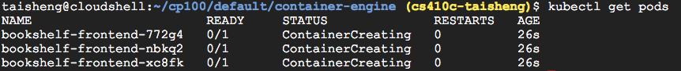
* **List services (with load-balancer)**
  + 
* **Visit site via external IP address**
  + 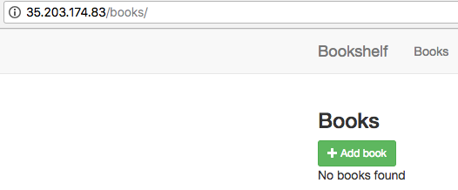
* **Add the book**
* **Screenshot of site after book CPB200 Google BigQuery for Data Analysts is added with image (as described in Section 5)**
  + 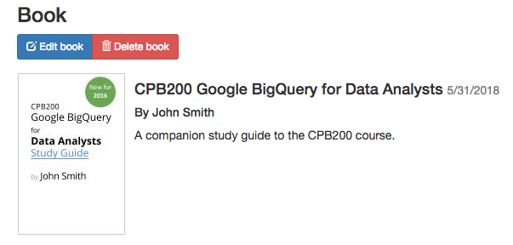
* **Show app in Container Engine**
  + 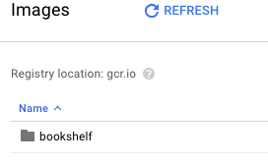
* **Show nodes in Compute Engine**
  + **VM instances**
    - 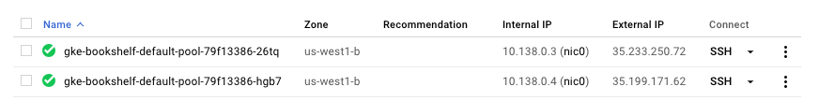
  + **Instance groups**
    - 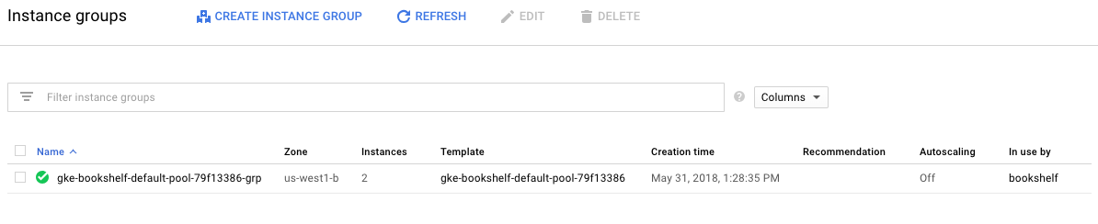
  + **Instance templates**
    - 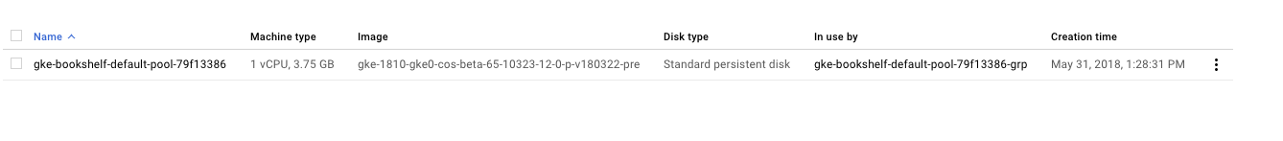
* **Show load balancer in Network Services**
  + 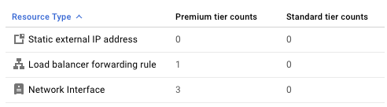
* **Show External IP addresses in VPC network**
  + 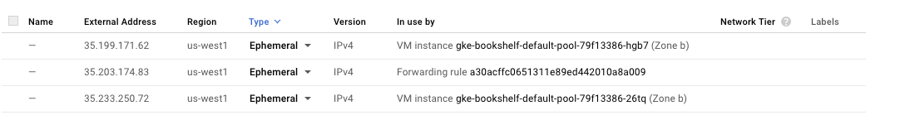
* **Show Docker image in Container Registry**
  + 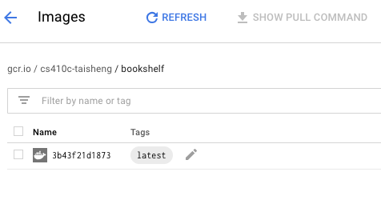
* **Clean up everything (to avoid charges)**

# Cloud Functions Lab #1(Taisheng)

https://cloud.google.com/functions/docs/tutorials/http#unix

* **Simple HTTP cloud function**
* **Enable Cloud Functions API in APIs & Services Dashboard**
  + 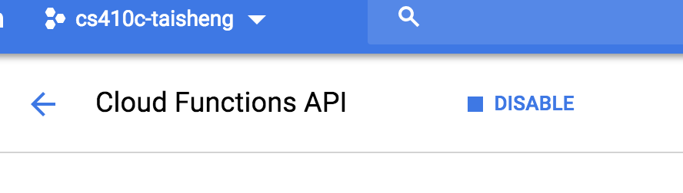
* **Create the function**
* **Create a folder on your local system called gcf_http.**
* **Create a file called index.js, with the following contents**
  + 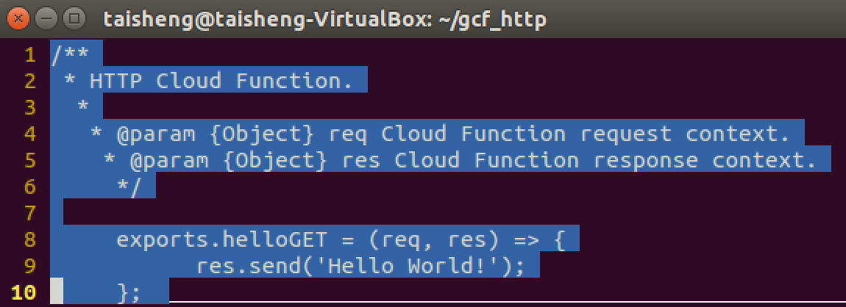
  + 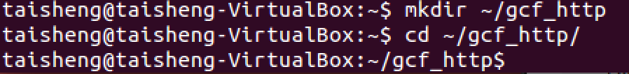
* **Deploy the application**
  + 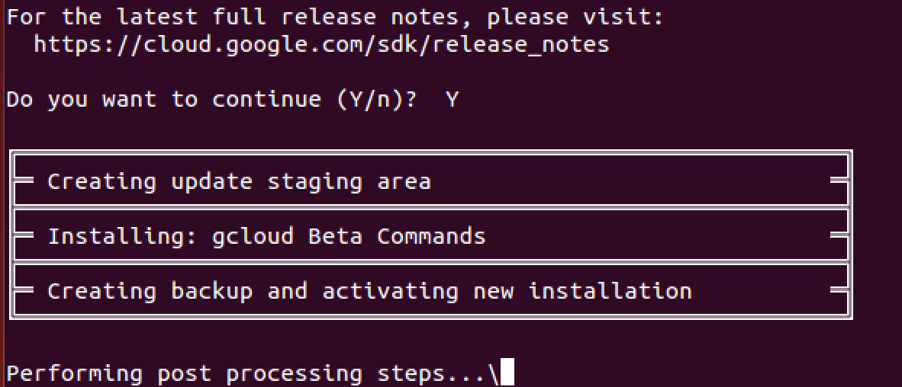
* **View the output to see the URL of your function**
  + 
* **It will have the format**
* **Make an HTTP request to the function to trigger it via**
* **curl and web browser**
  + 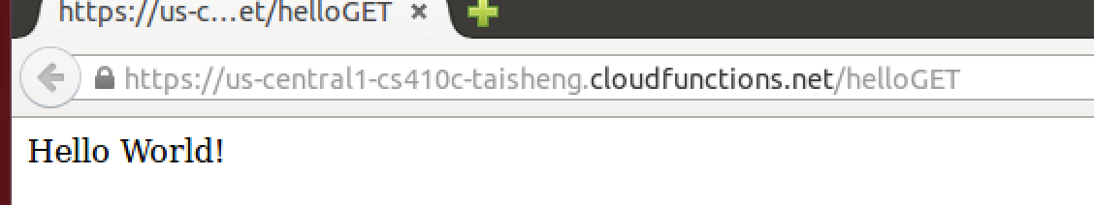
  + 
* **Delete the function**
  + 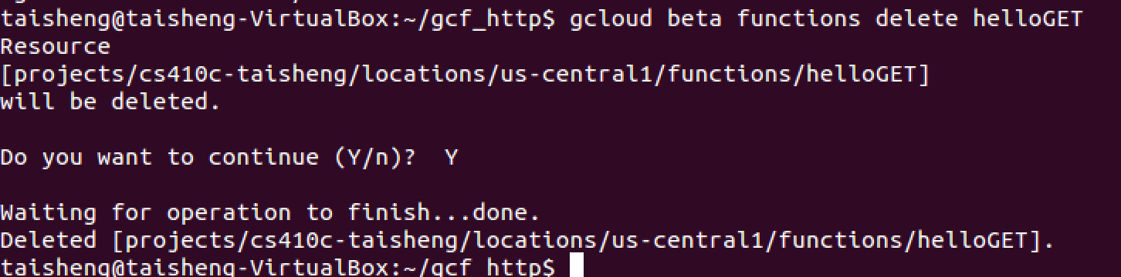
  + 

# Cloud Functions Lab #2(Taisheng)

* **Blurring offensive images uploaded to storage bucket**
* **Clone the repository in Cloud Shell**
  + 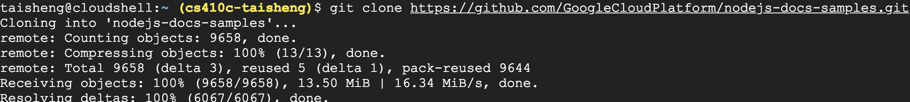
* **Create a Cloud Storage bucket for uploading images, with a globally unique bucket name:**
  + 
* 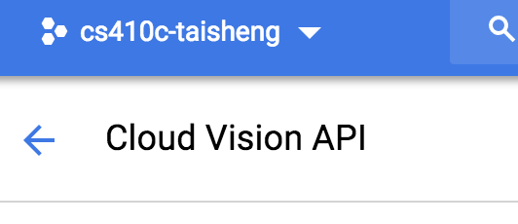
* **Include libraries**
* **Call Vision API with filePath of new object to do detection, then call blurImage() on file object if adult content or violence detected**
* **blurImage()**
* **Download image to a temporary file**
* **Call ImageMagick's convert utility to blur image wrapped in a promise for error handling**
* **blurImage()continued**
* **Upload back to bucket**
* **Remove temporary file (good practice)**
* **Register function and set trigger for its execution on storage bucket event.**
  + 
  + 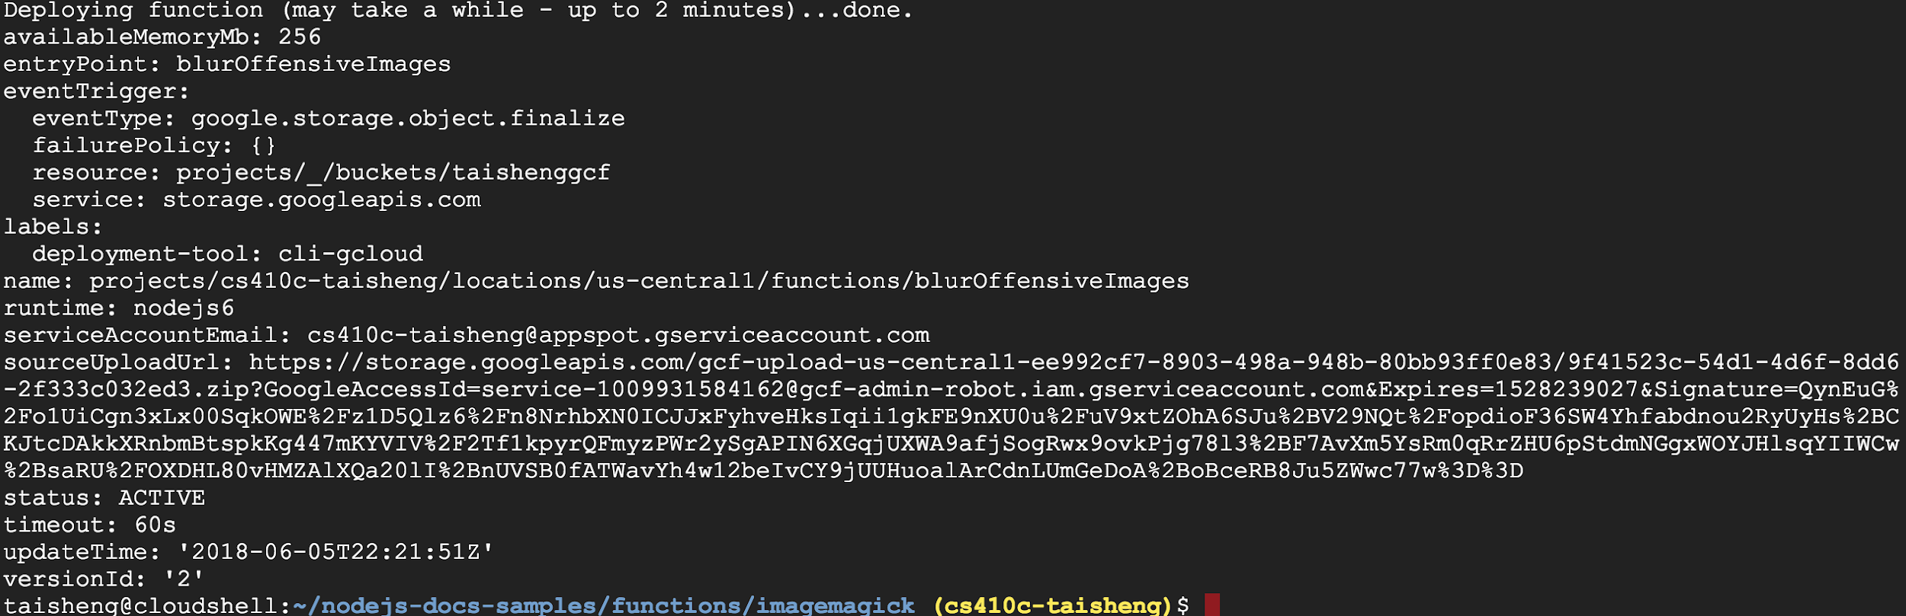
* **Find an offensive image**
* **e.g. a flesh-eating zombie at**
* [**https://cdn.pixabay.com/photo/2015/09/21/14/24/zombie-949916_1280.jpg**](https://cdn.pixabay.com/photo/2015/09/21/14/24/zombie-949916_1280.jpg)
* **Use wget to pull into Cloud Shell**
  + 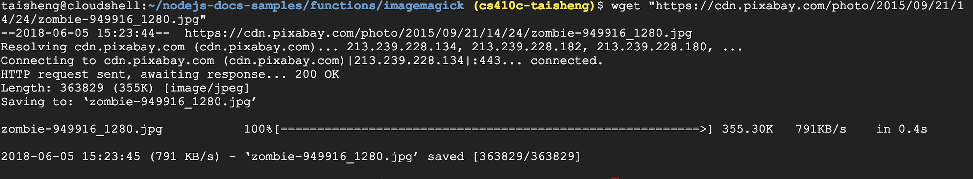
* **Upload image to bucket via console or command-line**
  + 
* **Function should automatically execute**
* **Then, upload two other images to the bucket**
  + [**https://images.pexels.com/photos/207962/pexels-photo-207962.jpeg**](https://images.pexels.com/photos/207962/pexels-photo-207962.jpeg)
  + 
  + 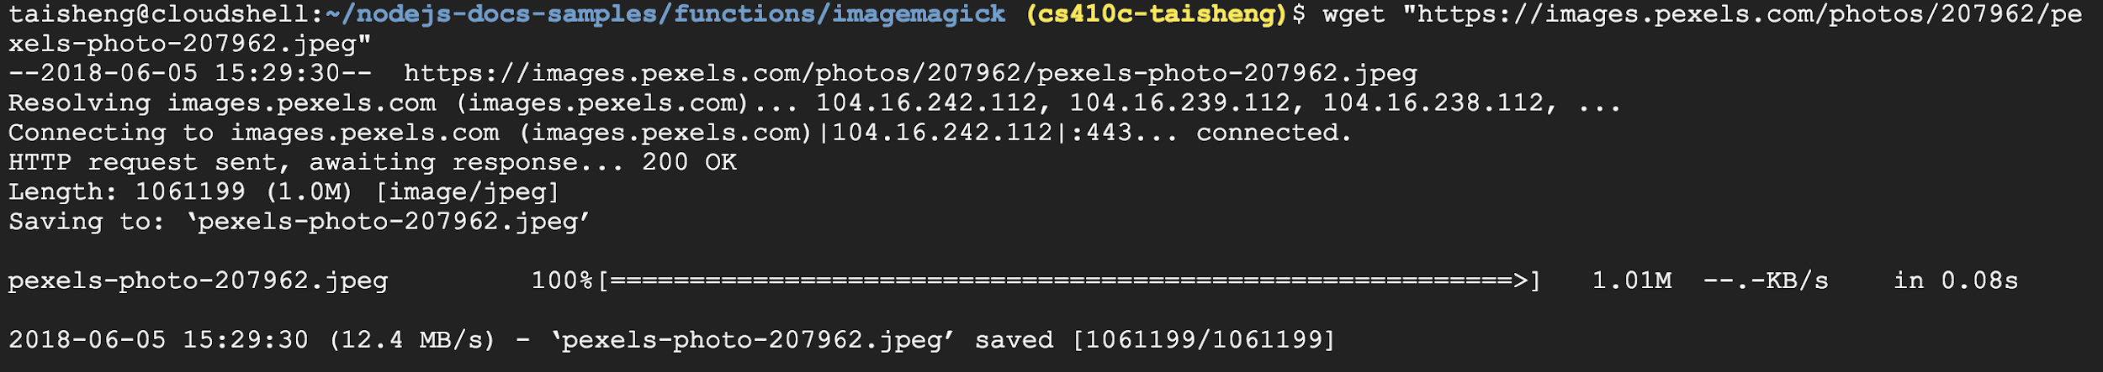
  + 
  + [**https://wpp.azureedge.net/sites/default/files/styles/gallery_main_image/public/hviofv7y64ywr2sk1ju5.jpg**](https://wpp.azureedge.net/sites/default/files/styles/gallery_main_image/public/hviofv7y64ywr2sk1ju5.jpg)
  + 
  + 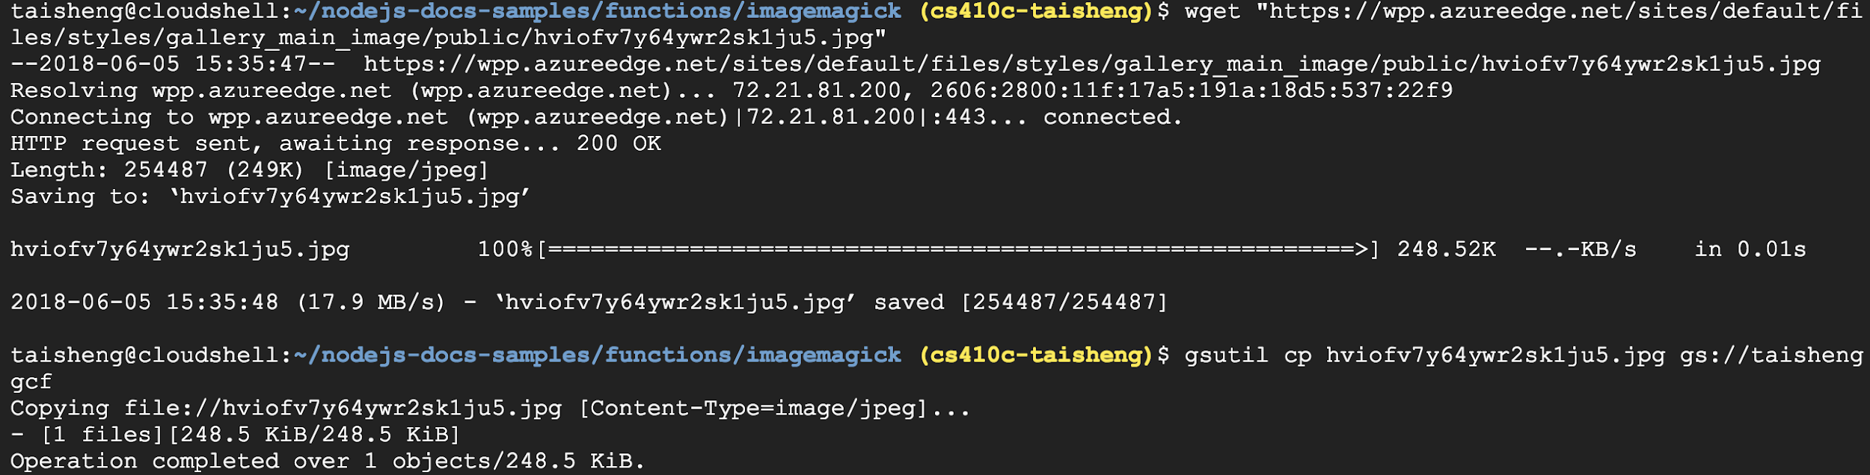
  + [**https://cdn.theatlantic.com/assets/media/img/mt/2018/03/Atacama/lead_960_540.jpg**](https://cdn.theatlantic.com/assets/media/img/mt/2018/03/Atacama/lead_960_540.jpg)
  + 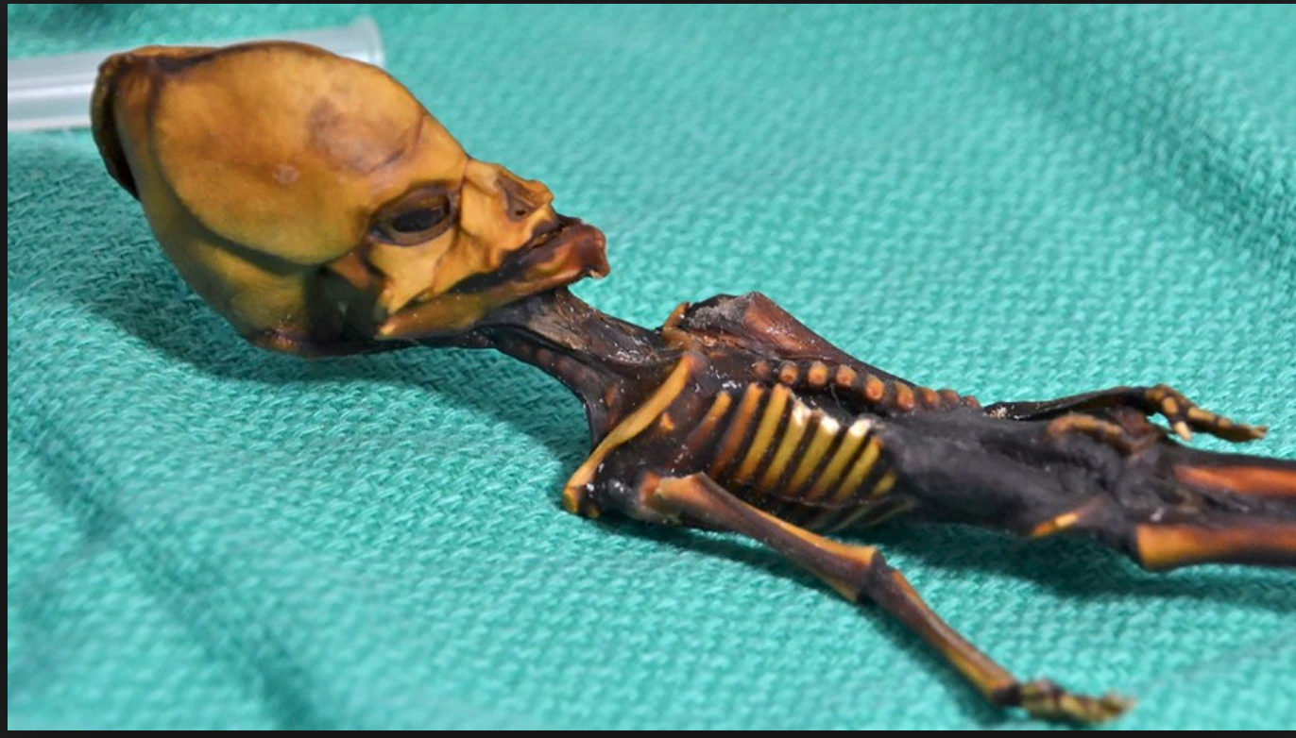
  + 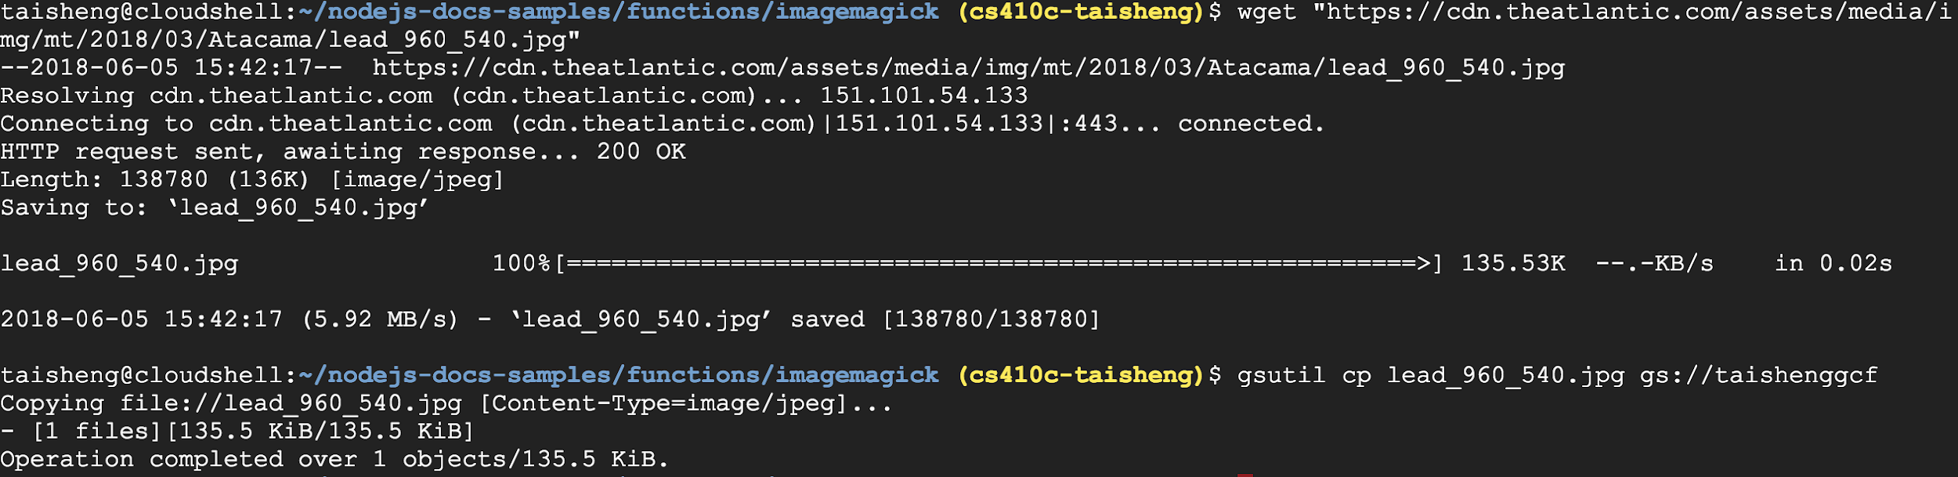
* **View the images in the Cloud Storage bucket you created earlier for uploading images.**
  + 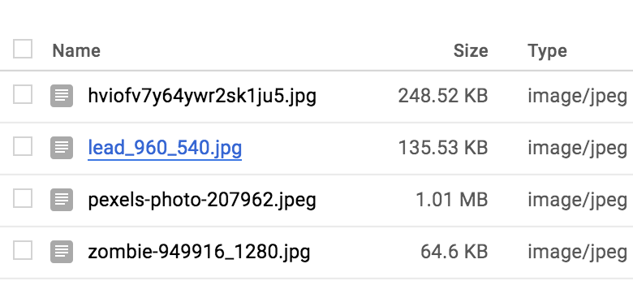
  + 
  + 
  + 
  + 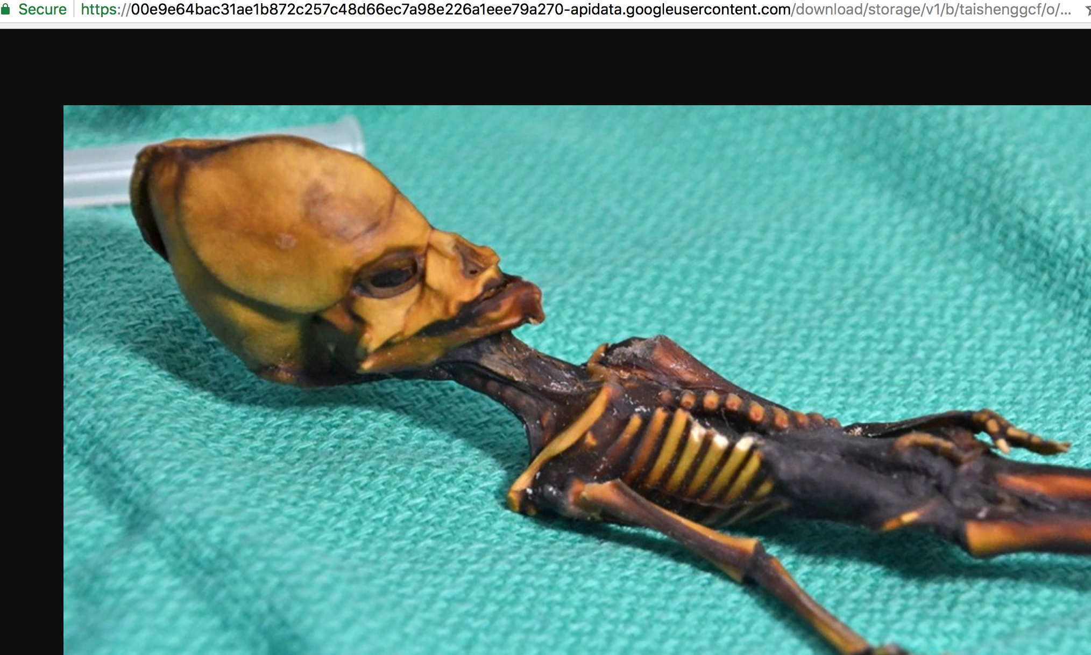
* **Output the logs showing function execution showing at least one image that has been blurred**
  + 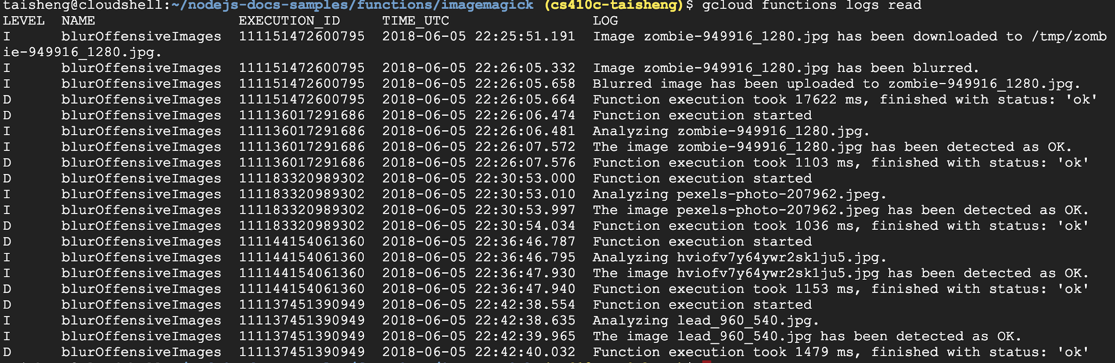
* **Clean-up**
* **Delete the function**
  + 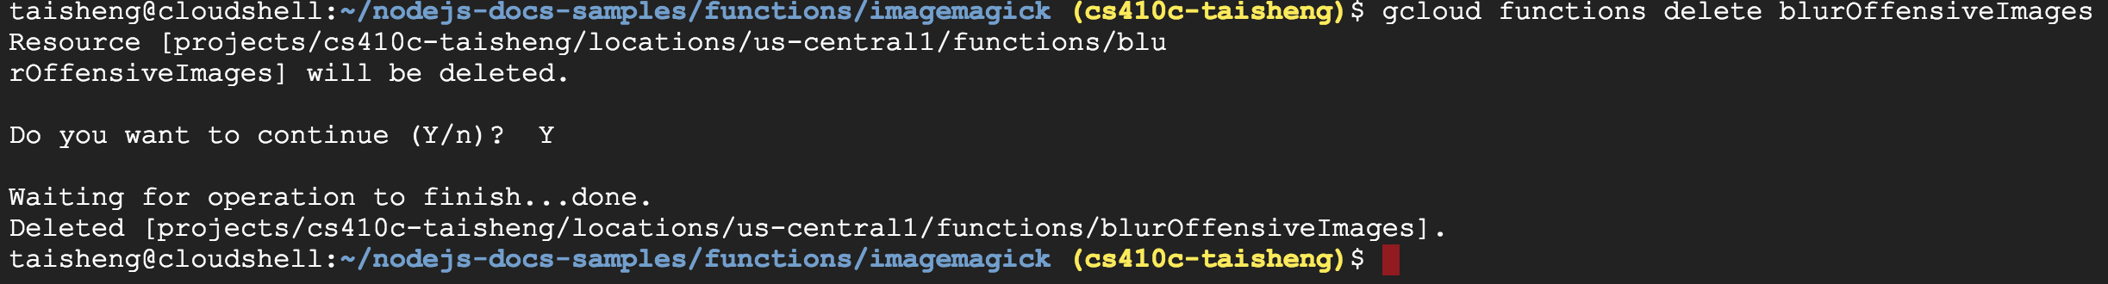

# Cloud Functions Lab #3(Taisheng)

* **Create a Slack app that queries Google's Knowledge Graph API on demand via Cloud Functions**
* **1. User executes the /kg <search_query> Slash Command**
* **2. Slack app sends the command payload to the Cloud Function's trigger endpoint along with its verification "token"**
* **3. Cloud Function verifies token, then sends a request with the user's search query to the Knowledge Graph API along with an API key**
* **4. Knowledge Graph API performs query and returns a matching result**
* **5. Cloud Function formats the response for Slack**
* **6. Sends it back.**
* **7. The user sees the formatted response in the Slack channel.**
* **Interface definition (Javascript)**
* **Slack app authenticates to Cloud Function via a shared token**
* **Generated by Slack app, then included in function**
* **Must be replaced with your own**
* **Call API (kgsearch)**
* **Cloud function authenticates to Knowledge Graph API via key**
* **Must be replaced with your own**
* **Format a response to Slack based on response from API**
  + 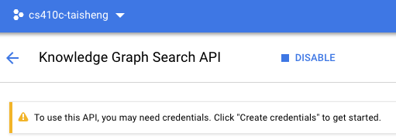
* **In console, APIs & services => Credentials**
* **Create credentials and then select API key.**
* **Keep tab with API key open so you can copy to function**
  + 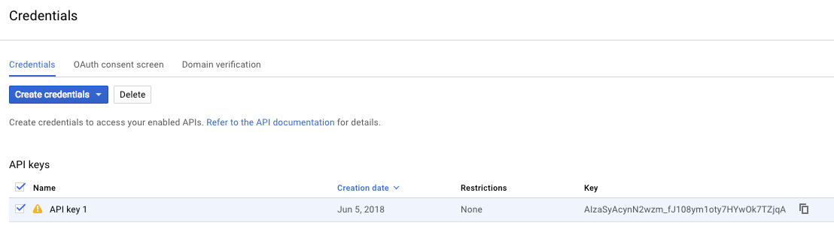
* **Create a Slack workspace**
* **Or use one you own**
  + 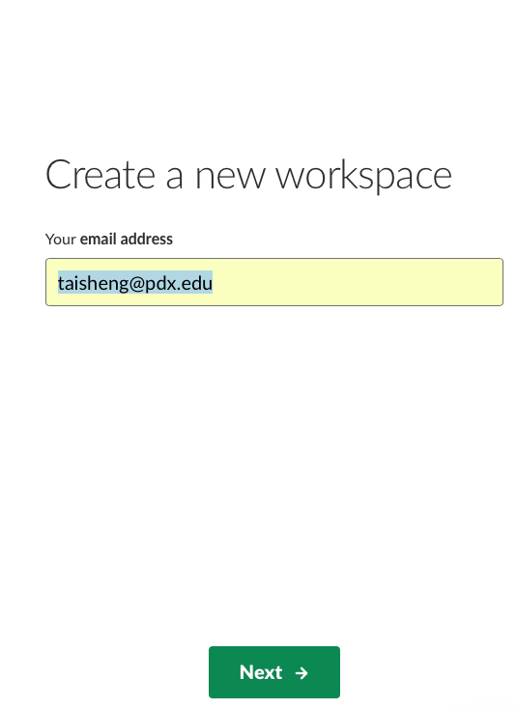
* **Create a Slack app**
* **https://api.slack.com/apps**
* **Used to host your Slack Slash command**
* **Associate it to workspace**
  + 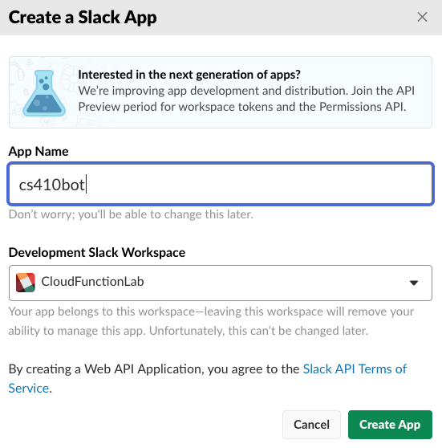
* **Shared secret that authenticates Slack app to your Cloud Function**
* **Automatically sent using the "token" field in HTTP cookie**
* **In Basic Information of app**
  + 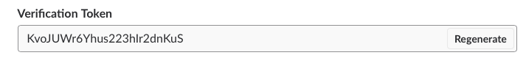
* **In Cloud Shell, clone repository**
  + 
* **Edit index.js**
* **Comment out line 19 (require no longer works)**
  + 
* **Replace config.SLACK_TOKEN in line 90 with verification token provided by Slack in the Basic information page of your app config (in double-quotes)**
  + 
* **Replace config.KG_API_KEY with API key you just created (in double-quotes)**
  + 
* **Deploying the Function**
* **Via**
  + 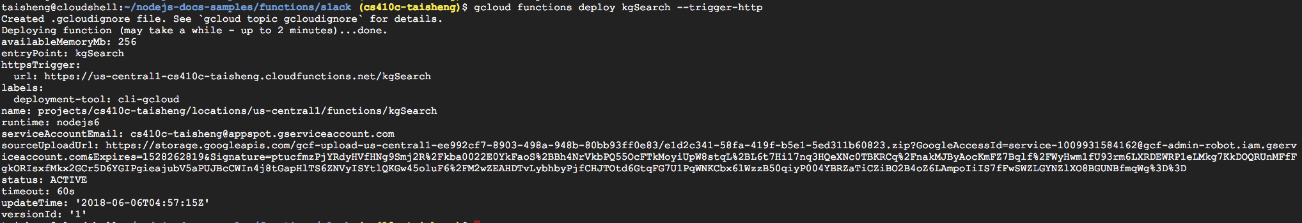
* **Note the URL of function**
  + 
* **Go to Slash commands and click the Create new command button.**
* **Configure command**
* **/kg as the name**
* **URL listed for function in previous step as Request URL** **https://[YOUR_REGION]-** **[YOUR_PROJECT_ID].cloudfunction s.net/kgSearch**
* **Then, save command**
  + 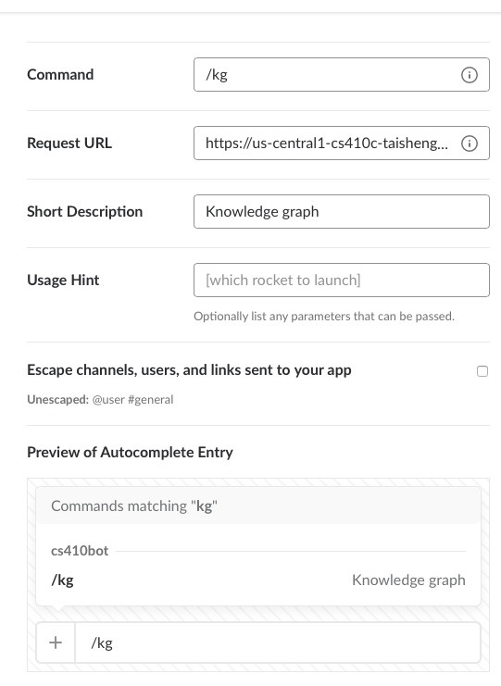
* **Install the App into the workspace**
  + 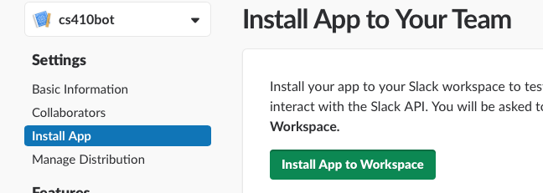
* **Authorize app**
  + 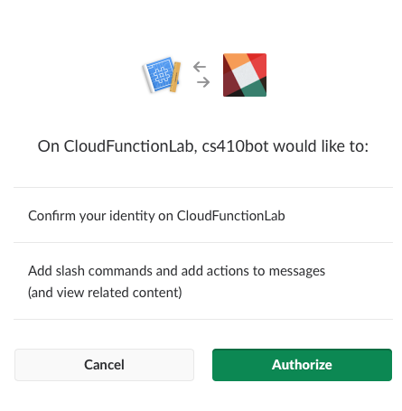
  + 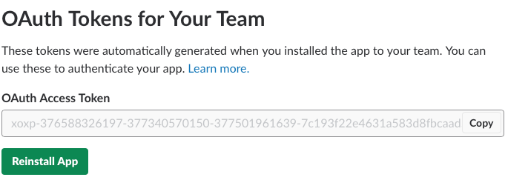
* **Test the command manually:**
  + 
* **Use URL given in creation of the Cloud Function containing the region the function is deployed and your project ID.**
* **[YOUR_SLACK_TOKEN] is the verification token provided by Slack in the Basic Information section (see earlier steps)**
* **Try it out in your Slack environment!**
  + 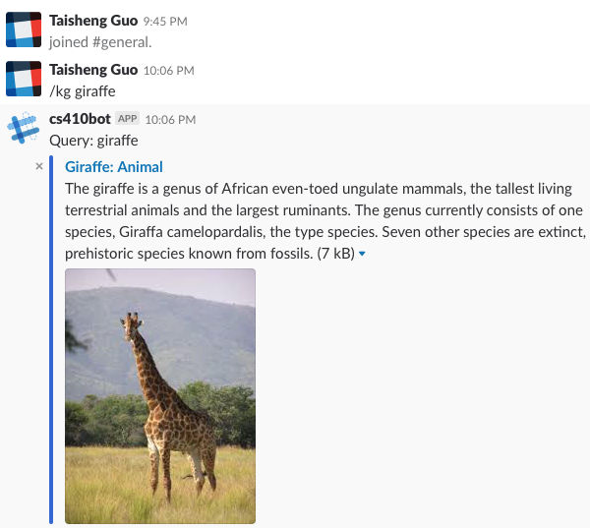
* **Watch the logs to be sure the executions have completed:**
  + 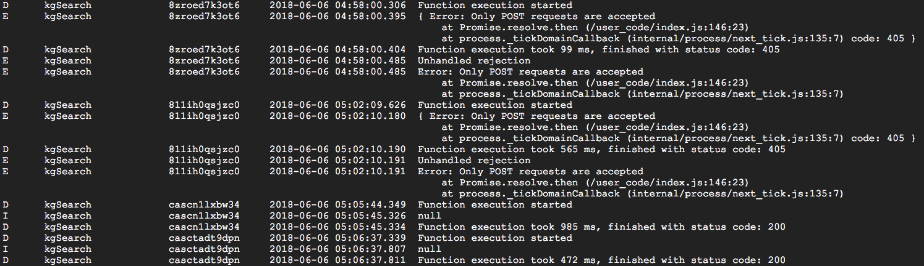
* **Clean up**
  + **To delete just the function, use the command:**
  + 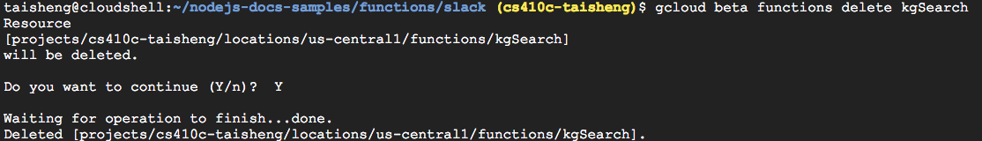
* **Lab link**
* [**https://cloud.google.com/functions/docs/tutorials/slack**](https://cloud.google.com/functions/docs/tutorials/slack)

# ML APIs Lab #1(Taisheng)

* **Integrating Machine Learning APIs (25 min)**
* **Skip project creation step (use your course project)**
* **Ensure Cloud Speech, Cloud Translation, and Cloud Natural Language Processing APIs are enabled**
* **As done with Cloud Vision previously (via web console)**
* **Or via individual gcloud commands within Cloud Shell**
  + 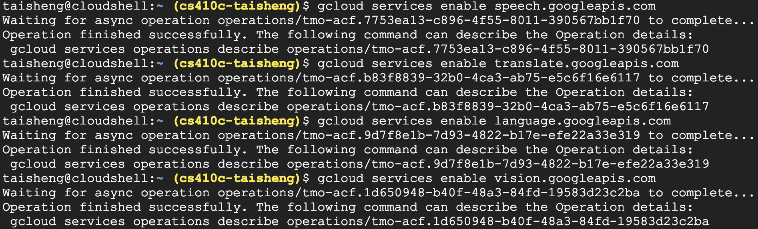
* **Create a service account for you to access ML APIs**
* **Note I've chosen to name it cs410mlapis**
* **Bound to your PROJECT_ID and placed in a JSON file**
  + 
  + 
* **Should get message that cs410mlapis@cs410c- odinid.iam.gserviceaccount.com created**
* **Set environment variable to point to your created credential file**
  + 
* **Note that this will only set the variable for your current session.**
* **Update ~/.bashrc to set credentials for each Cloud Shell session**
  + 
* **If you haven't downloaded the Python samples, do so**
  + 
* **Install Cloud Vision package**
  + 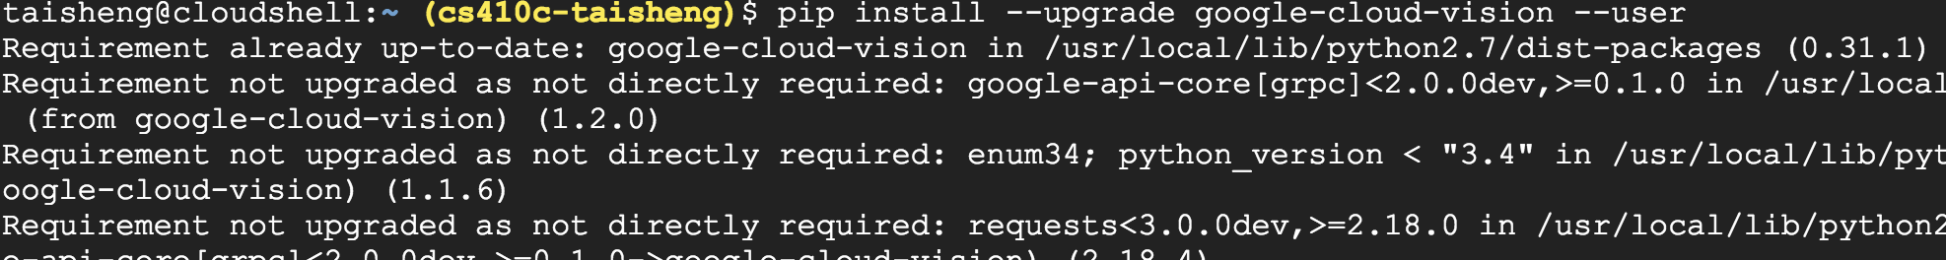
* **Go to Vision cloud-client code**
  + 
* **Run a detection that returns the labels generated with an image of a bird given its URI, show the output**
  + 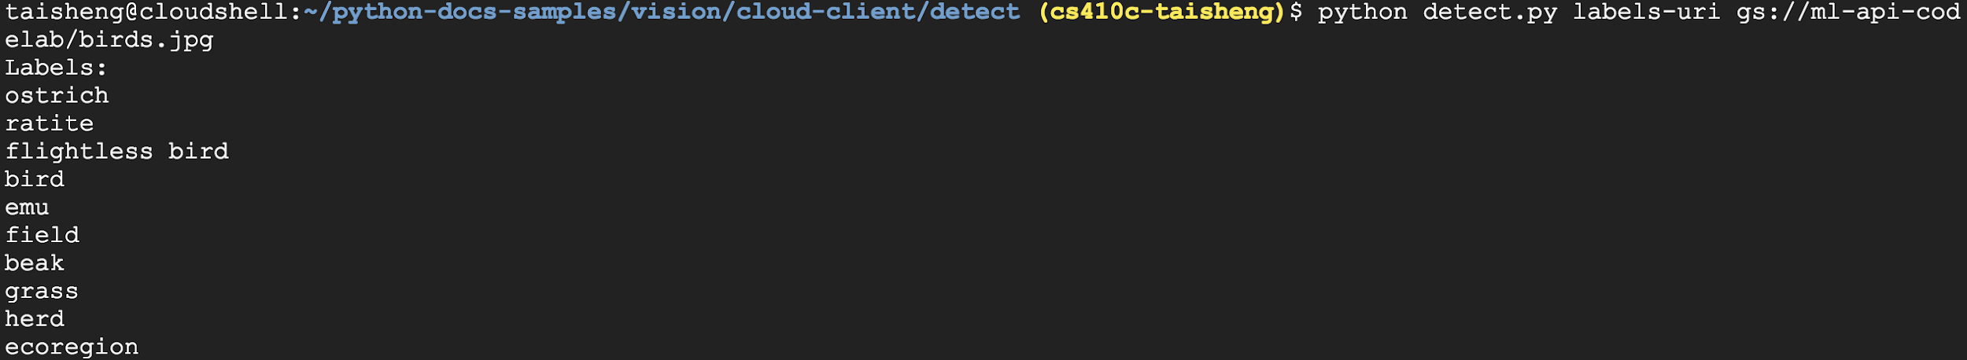
* **Examine detect.py**
  + 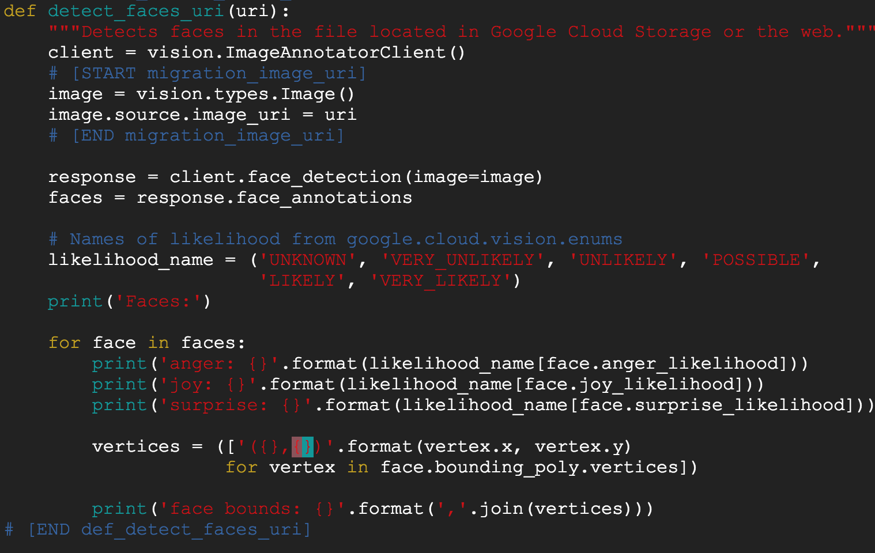
* **Then, use the script to run a detection on a logo you find on the Internet via its URI**
  + 
  + 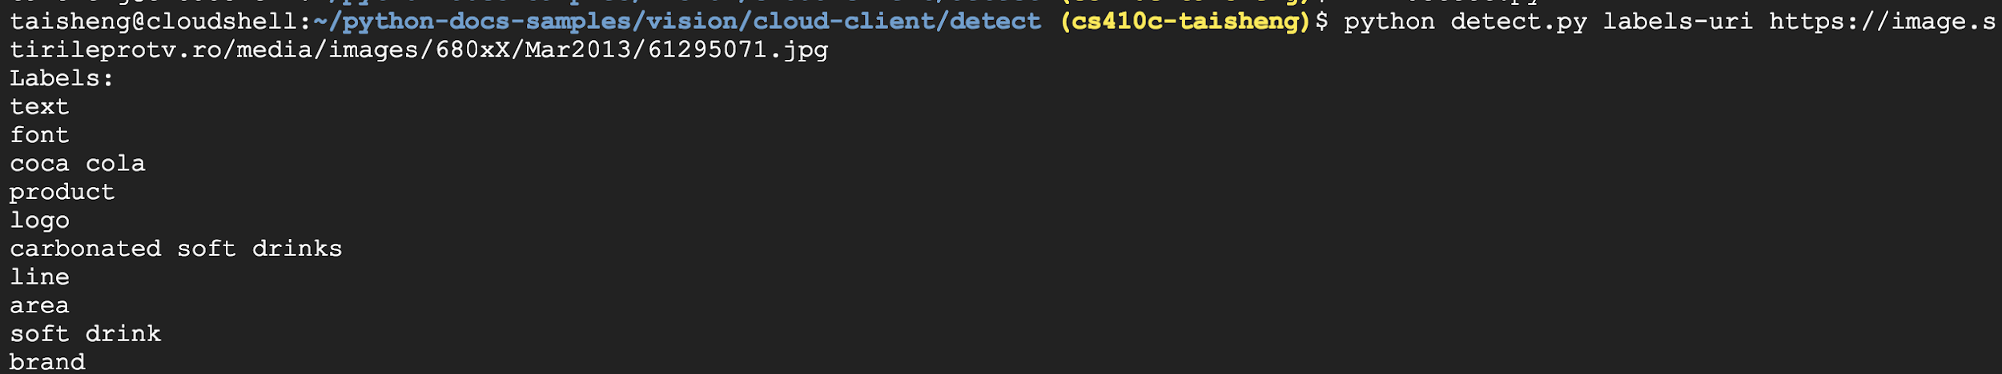
* **Install Cloud Speech package**
  + 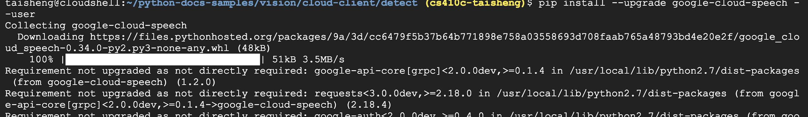
* **Go to Speech cloud-client code**
  + 
* **Fix line 73 of transcribe.py (delete encoding and sample_hertz_rate, set language to tr-TR)**
  + 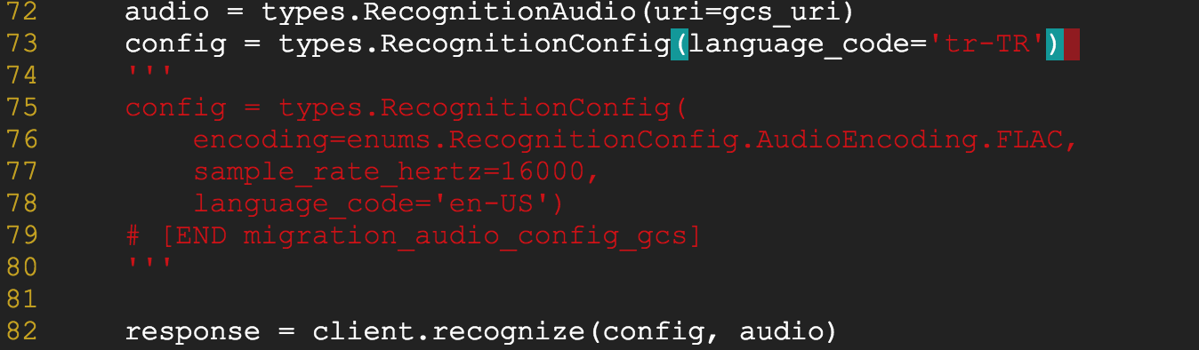
* **Run transcribe.py on the given URI and show output**
  + 
* **Install Cloud Translate package**
  + 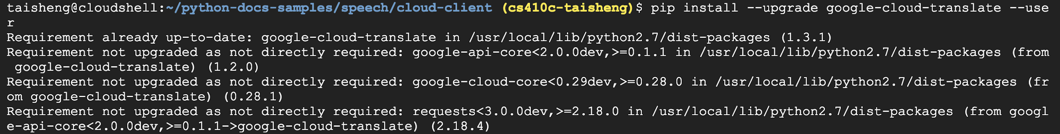
* **Go to Speech cloud-client code**
  + 
* **Examine code**
  + 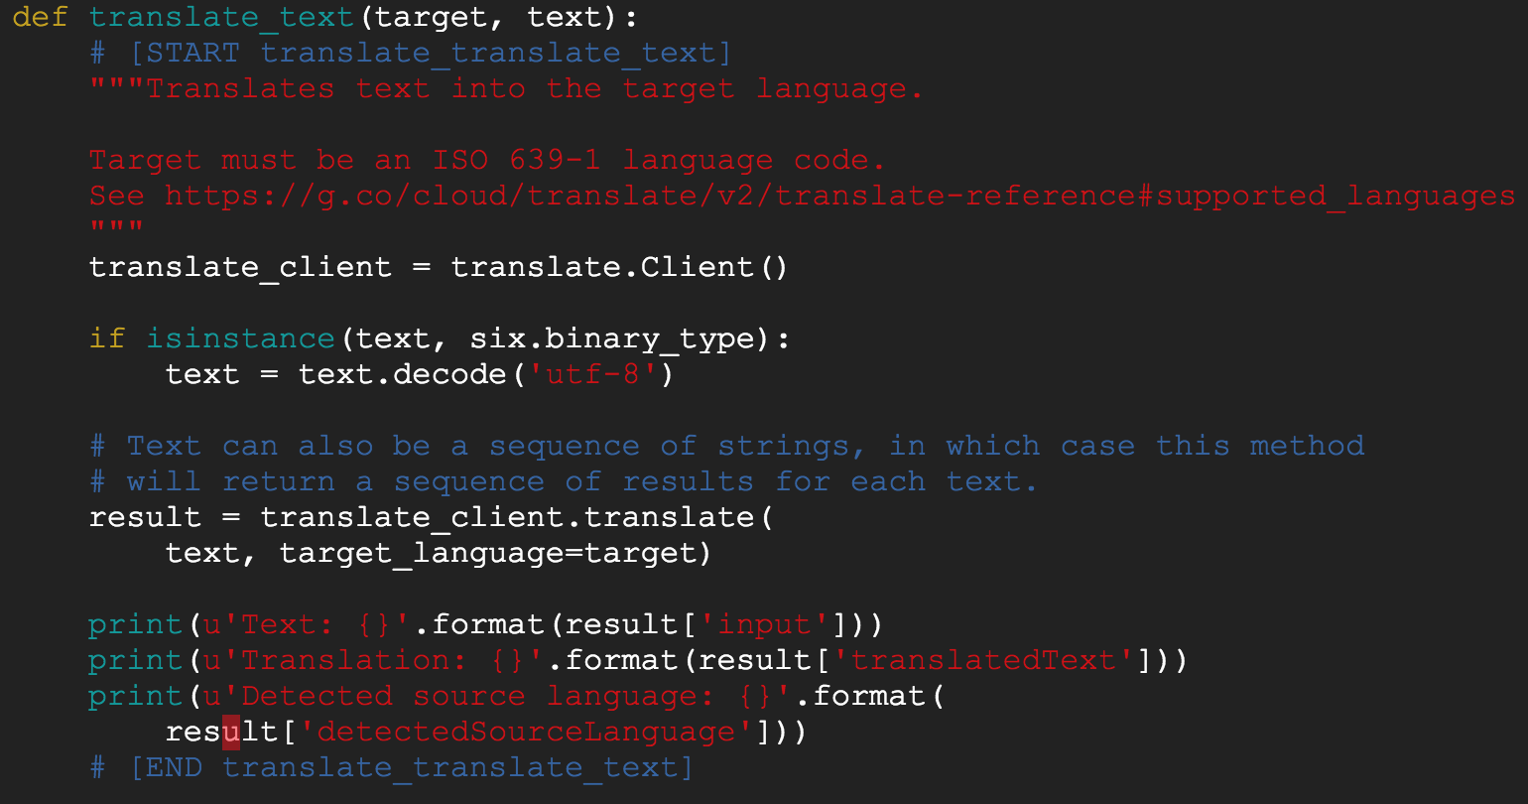
* **Run snippets.py on the text string and show output**
  + 
* **Install Cloud Natural Language package**
  + 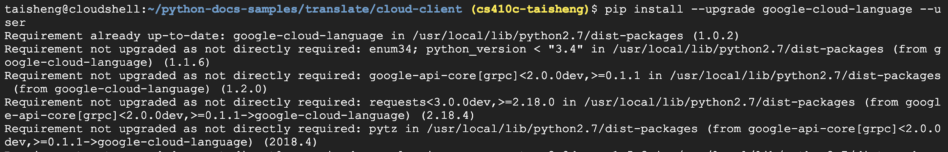
* **Go to Speech cloud-client code**
  + 
* **Examine code for sentiment analysis**
  + 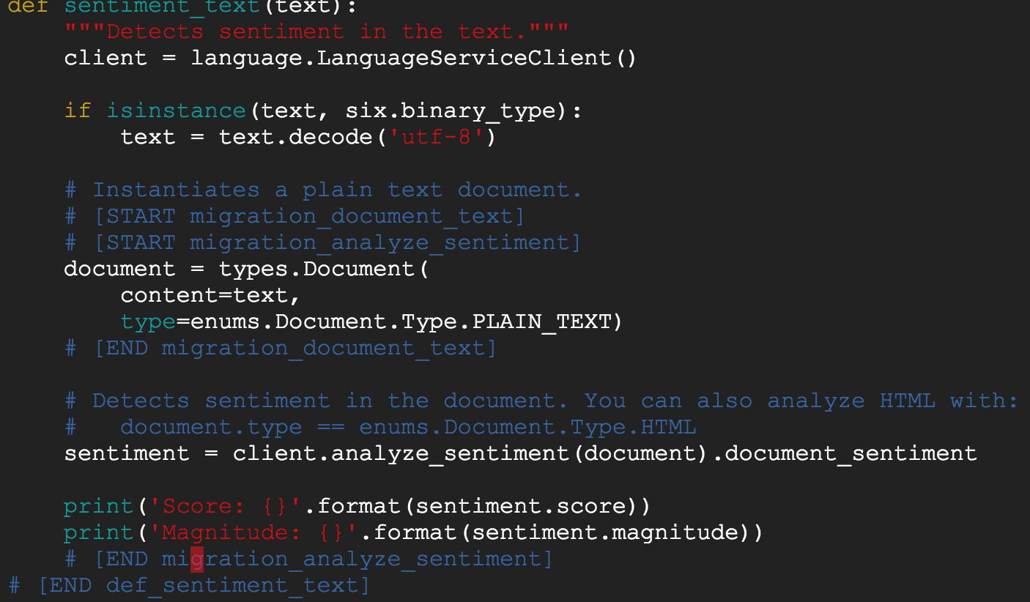
* **Examine code for entity analysis**
  + 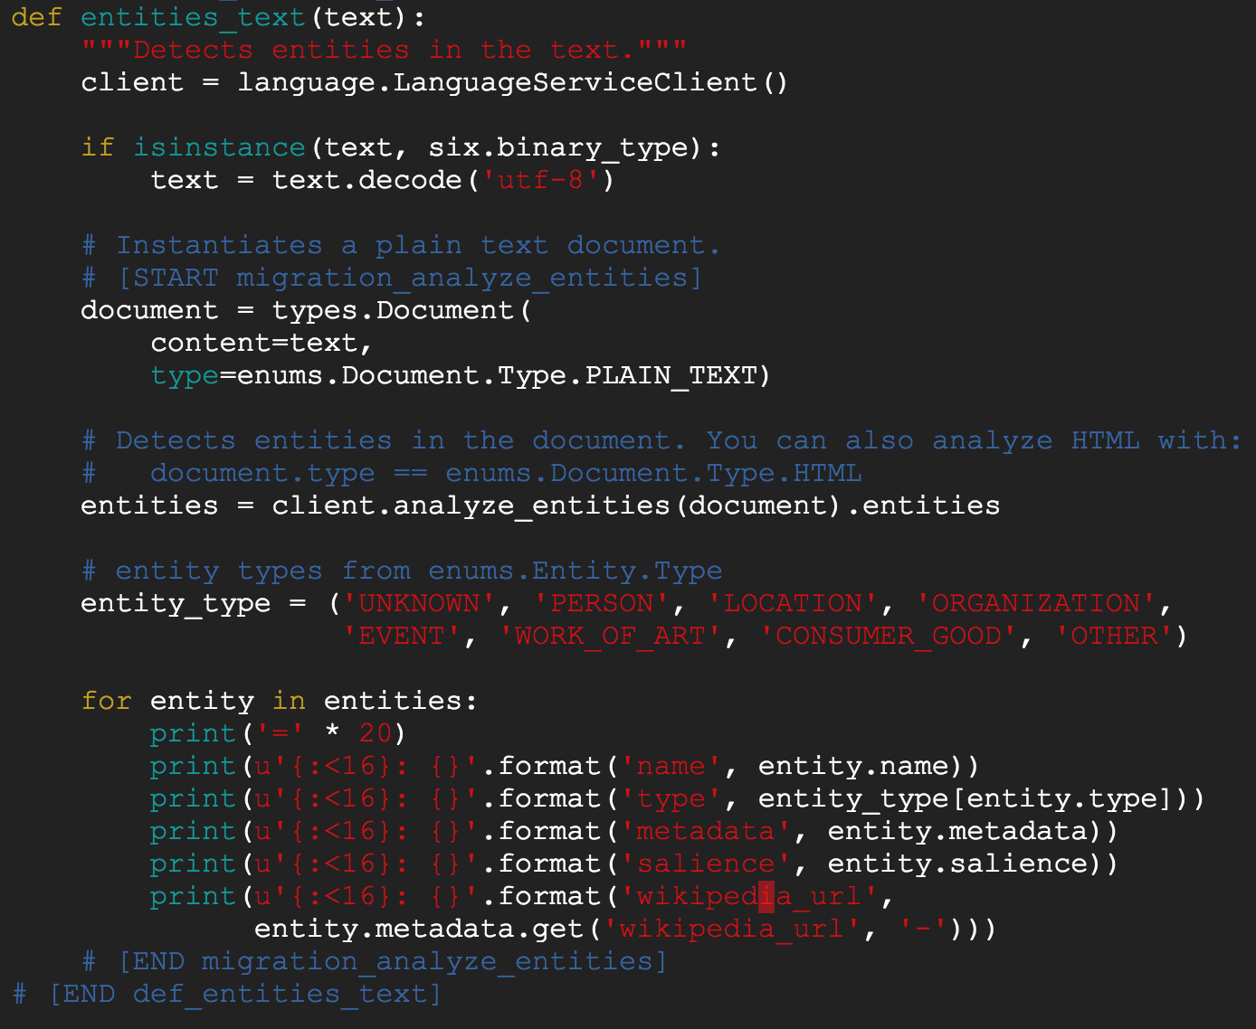
* **Run snippets.py on the text string and show output**
  + 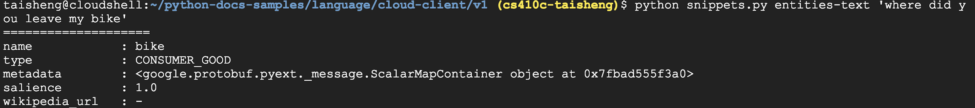
* **For fun, also try sentiment analysis**
  + 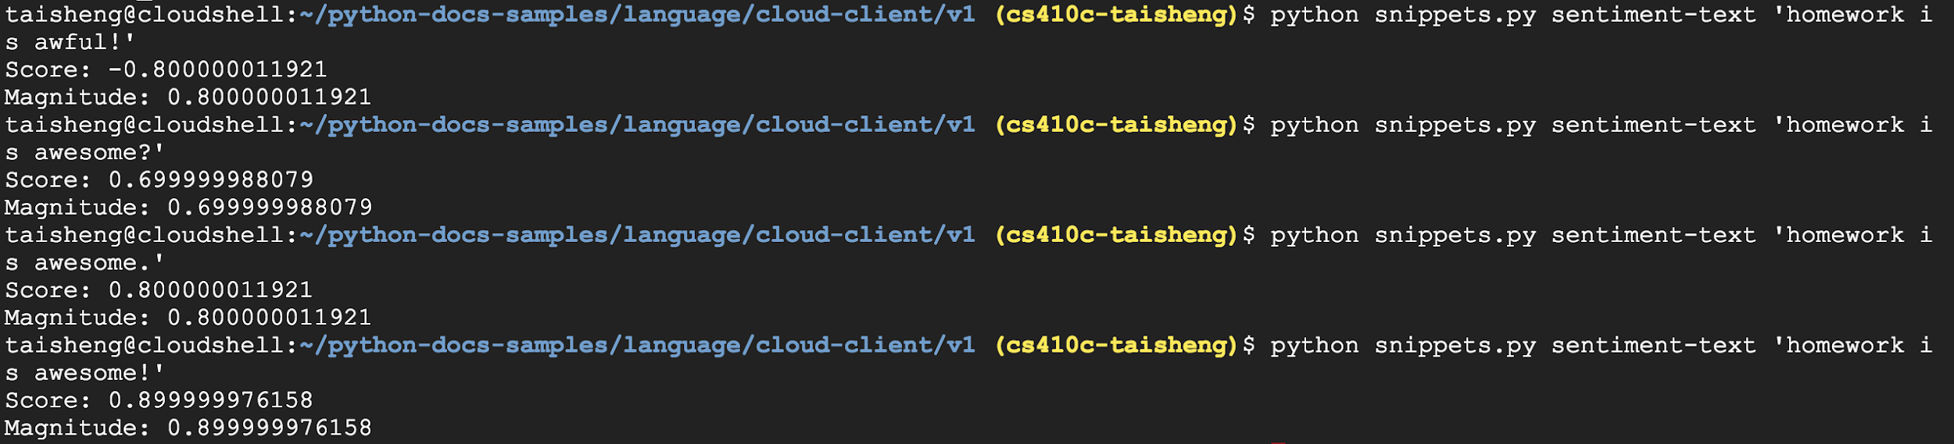
* **See if words in a recording describe an object in an image**
* **Previous calls modified to return results as text (vs. print)**
* **Audio transcription to translation to NLP to obtain entities**
* **Image analysis to obtain labels**
* **Comparison to determine match**
* **https://github.com/googlecodelabs/integrating-ml-apis**
* 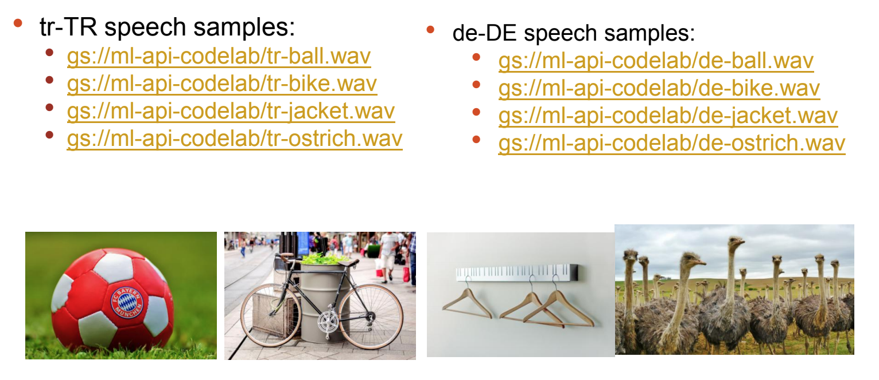
* **See code for mods to transcribe_gcs() (Speech), translate_text() (Translate), entities_text() (Natural Language) and detect_labels_uri() (Vision)**
  + 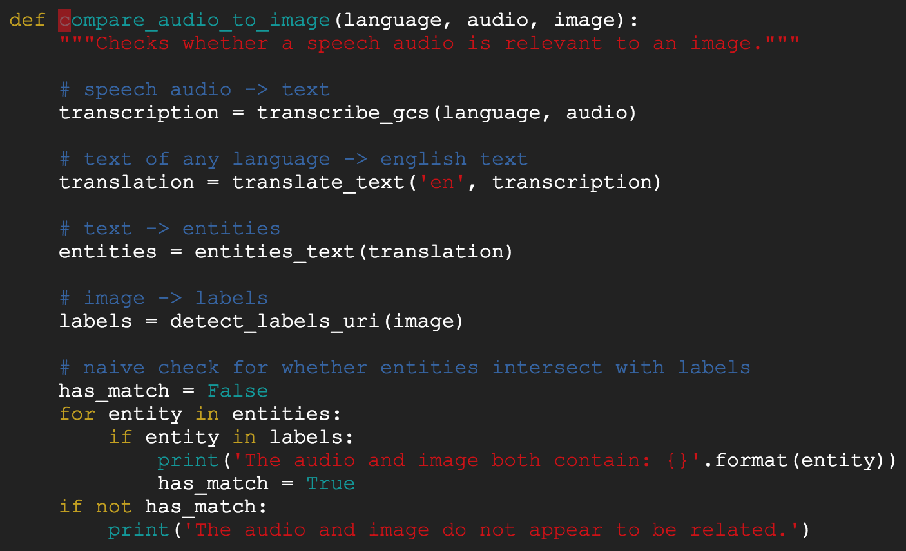
* **Run at least 3 pairs other than the one given in the walk- through**
  + 
  + 
  + 

# ML APIs Lab #2(Taisheng)

* **Using the (rest of the) Vision API with Python (8 min)**
* **Optical Character Recognition (OCR) (text detection)**
* **Landmark detection**
* **Sentiment analysis (face detection)**
* **Skip Steps 2, 3, and 4. (Re-use setup from ML API Lab #1)**
* **Copy image files into your own bucket, then set all files in bucket to publicly readable**
  + 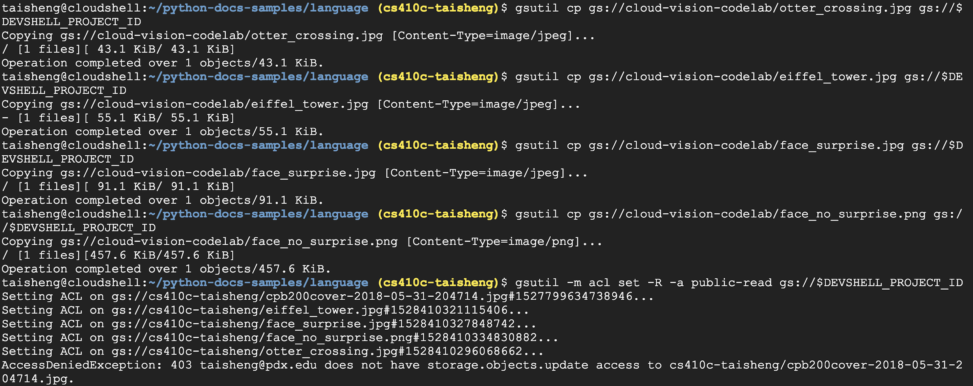
* **For the rest of the examples, my project ID is used in the gs:// URIs, use yours instead**
* **Launch interactive ipython to perform lab**
  + 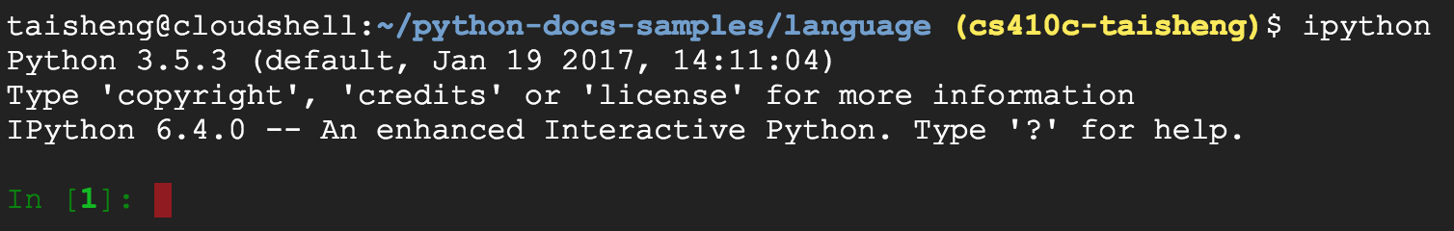
* **Show full image of the Otter Crossing sign via your**
* **bucket**
* **Then use Vision's text_detection() to perform an**
* **OCR operation on a picture of the sign (substitute your**
* **bucket name in the gs:// URL)**
* **Show full image of the Otter Crossing sign via your bucket**
  + 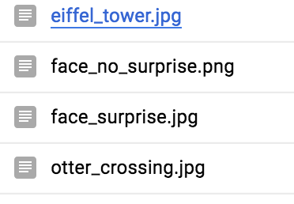
  + 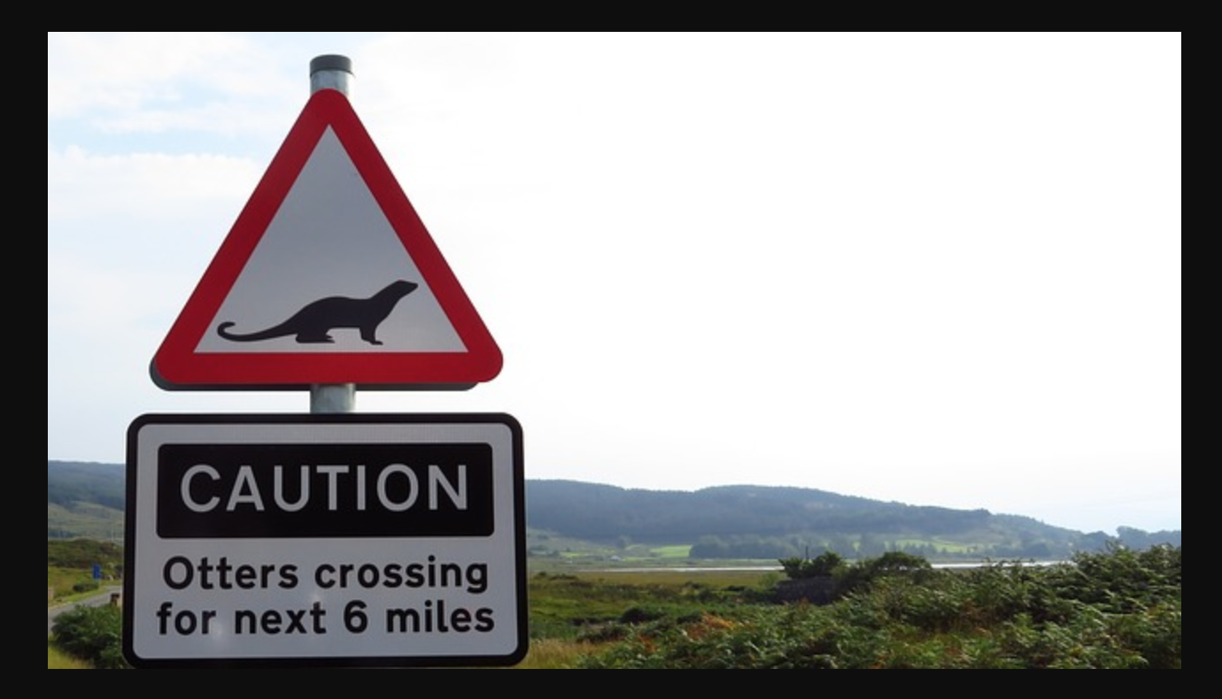
* **Then use Vision's text_detection() to perform an OCR operation on a picture of the sign (substitute your bucket name in the gs:// URL)**
  + 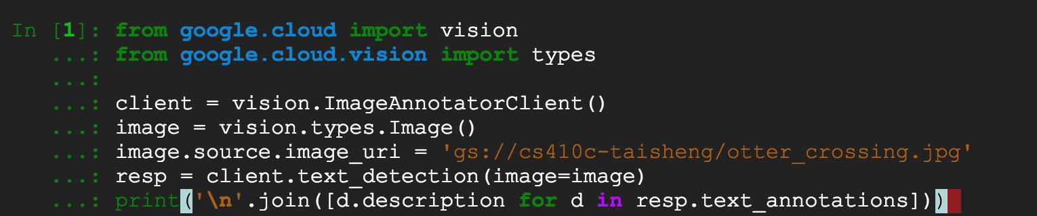
  + 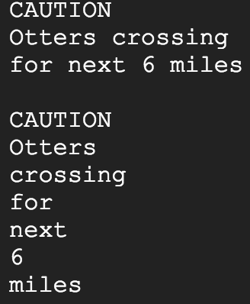
* **Show full Eiffel Tower image in your bucket**
  + 
* **Then use Vision's landmark_detection() to identify it of famous places (substitute your bucket name in the gs:// URL)**
  + 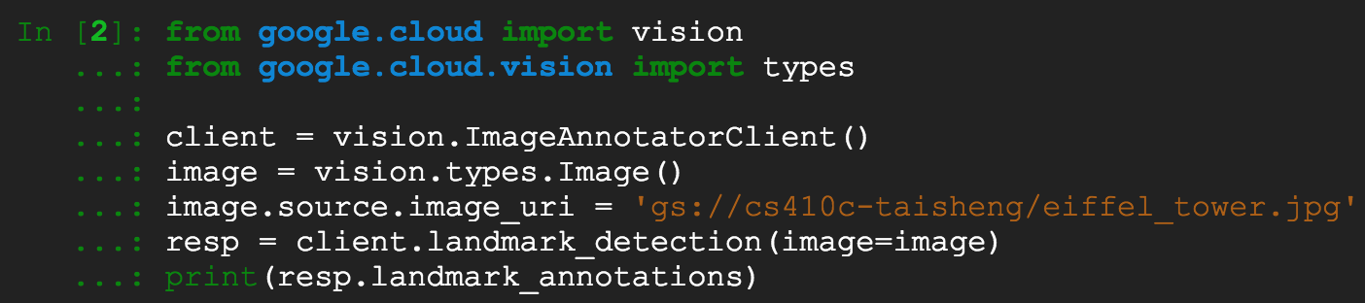
  + 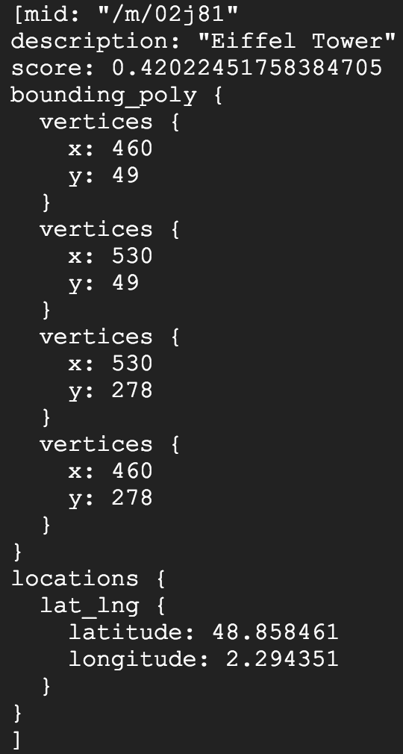
* **Show the two face images in your bucket**
  + 
  + 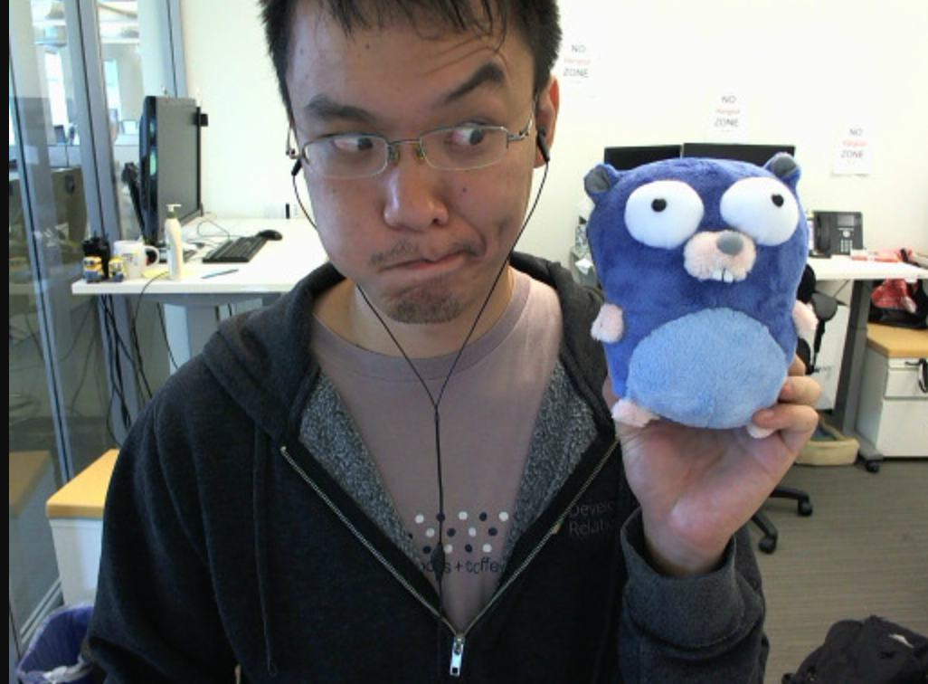
* **Then use Vision's face_detection() to annotate images (substitute your bucket name in the gs:// URL)**
  + 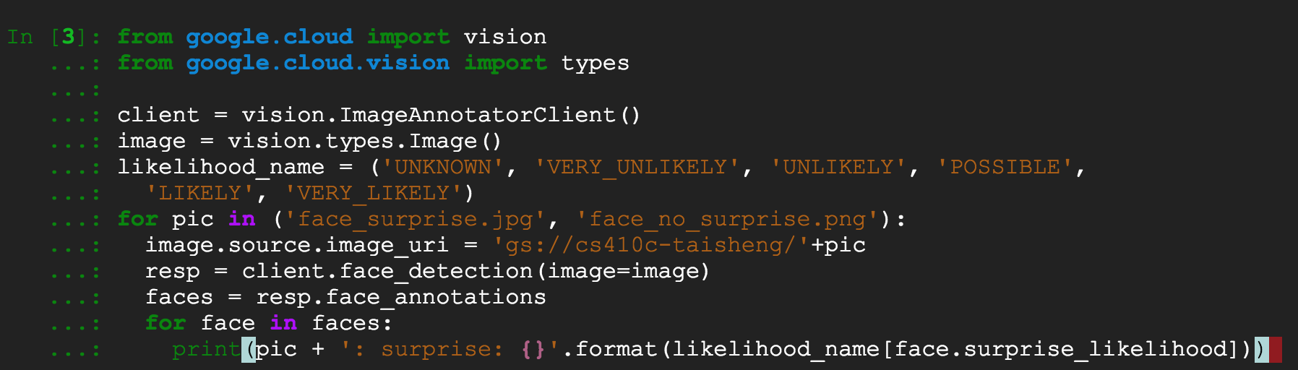
* **See the likelihood of the faces showing surprise**
  + 
* **Using the Vision API with Python (8 min)**
* [**https://codelabs.developers.google.com/codelabs/cloud-vision-api-python**](https://codelabs.developers.google.com/codelabs/cloud-vision-api-python)

# ML APIs Lab #3(Taisheng)

* **Deploying a Python Flask Web Application to App Engine Flexible (24 min)**
* **Skip steps 2, 3, and 5 (already done previously)**
* **Do Step 4 In Cloud Shell**
  + 
* **For Step 6, we will re-use the service account from ML APIs Lab #1**
* **Skip all steps except the one that gives project owner access to service account created in ML APIs Lab #1**
* **Use command below since we named our account cs410mlapis (not codelab)**
  + 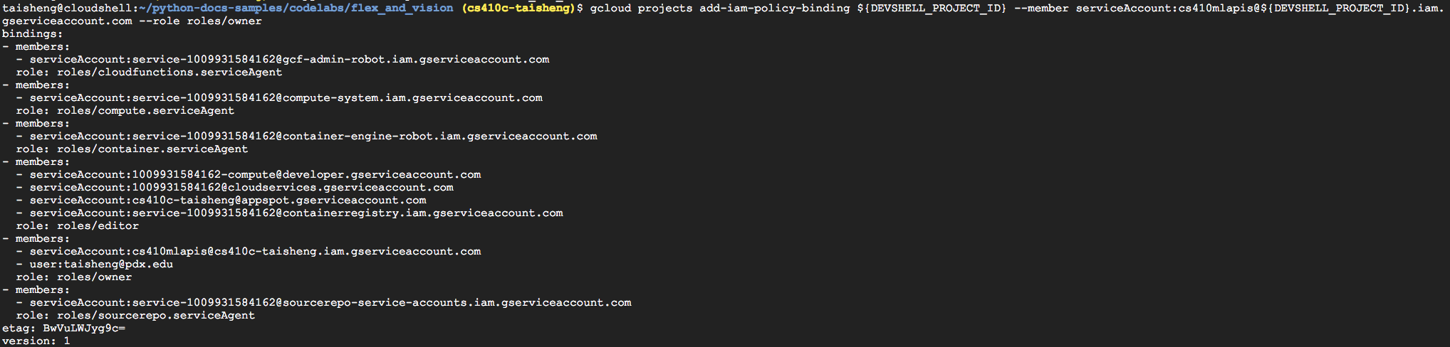
* **Create python3 environment**
  + 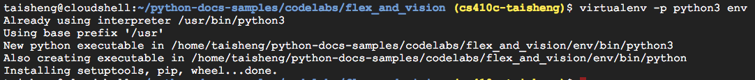
  + 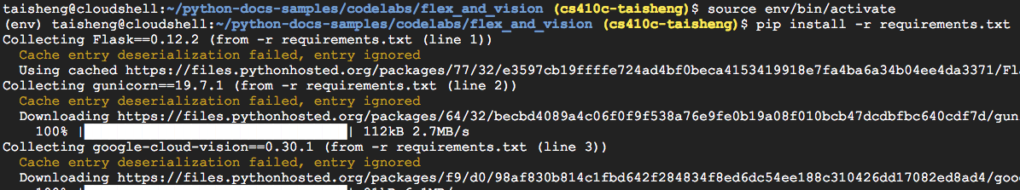
* **Set the location of the Cloud Storage bucket for the app's images via an environment variable**
* **If you have deleted your gs://${DEVSHELL_PROJECT_ID} bucket, create it again, then set the environment variable**
  + 
* **Deploy app**
  + 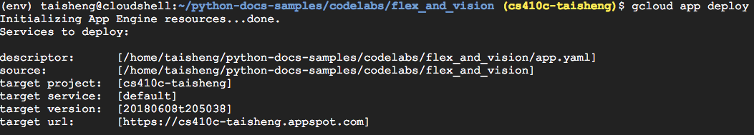
  + 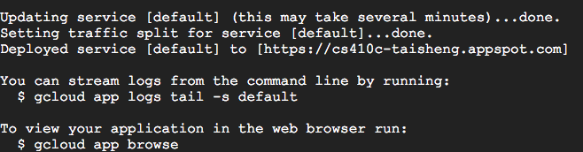
* **Test the app via the web preview**
  + 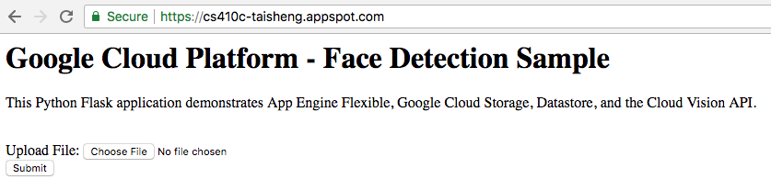
* **Upload a photo to detect joy in faces**
* **Code for default route**
  + 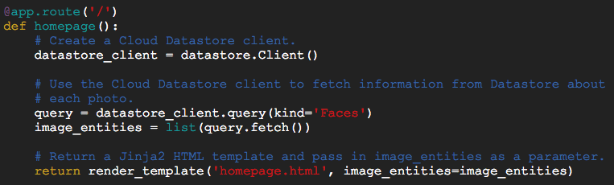
* **Code for uploading new images**
* **upload_photo()**
  + 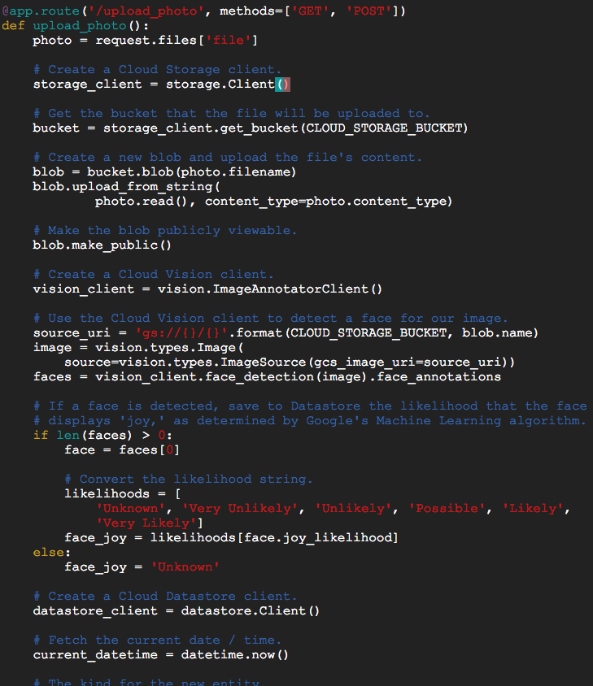
  + 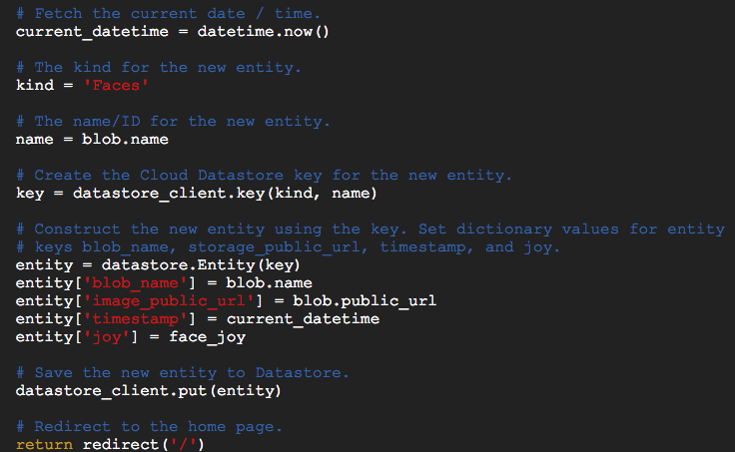
* **App Engine configuration**
* **Change app.yaml to point to your storage bucket**
  + 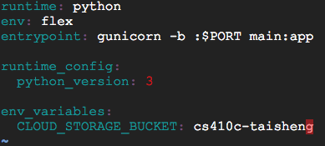
* **Deactivate development environment**
* **Deploy**
  + 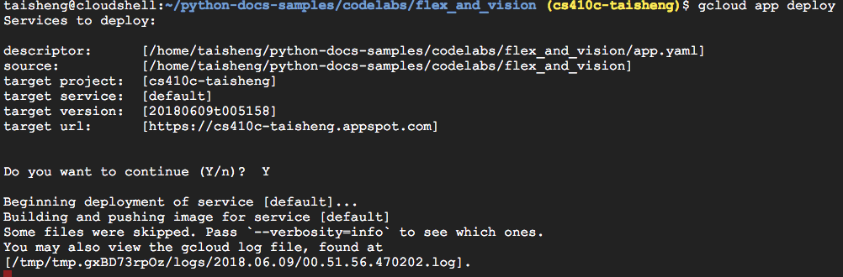
* **Note the custom container built and pushed into gcr.io to support the flexible environment's deployment onto App Engine**
* **Show application running at**
* **https://<PROJECT_ID>.appspot.com**
  + 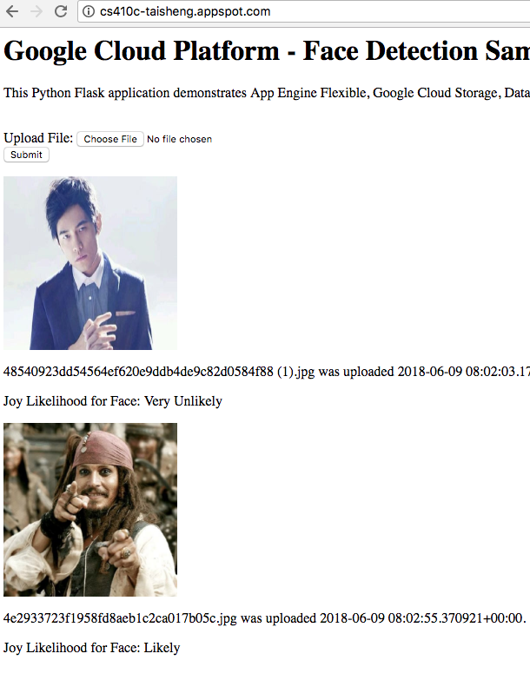
* **Deploying a Python Flask Web Application to App**
* **Engine Flexible (24 min)**
* **https://codelabs.developers.google.com/codelabs/cloud-**
* **vision-app-engine**

# Firebase Lab #1(Taisheng)

* **Firebase Web Codelab (39 min)**
* **Create project in the Google Firebase Console (different from the Google Cloud Console)**
* **Call it firebaselab**
  + 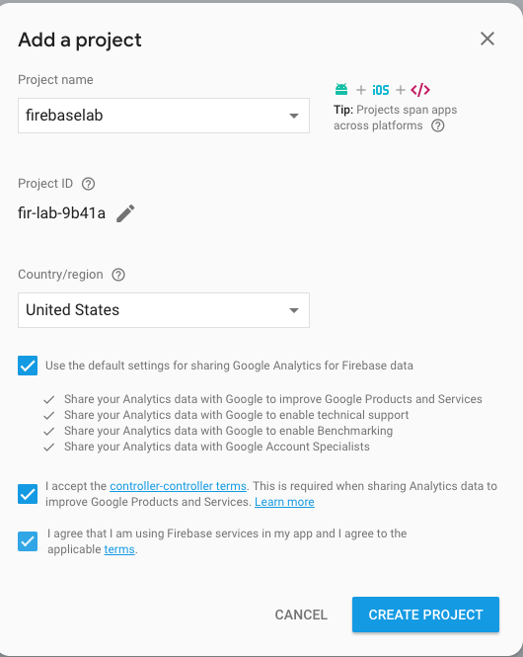
* **From console, Develop=>Authentication->Sign-In Method**
* **Enable the Google Sign-in Provider to allow users of your web app to sign in with their Google Accounts, then Save**
  + 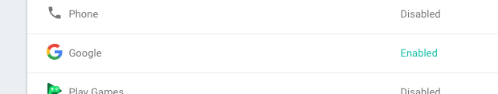
* **(Optional) if you want to do entire lab**
* **Storage > Get Started > Got**
* **Click on "Add Firebase to your web app"**
  + 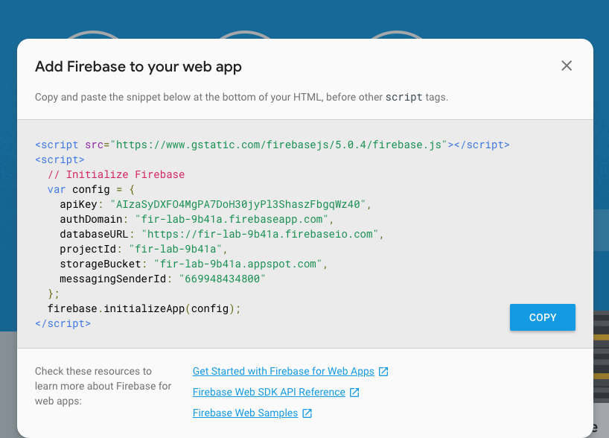
* **Keep tab open so code can be copied into app later**
* **Goto console.cloud.google.com to find the project created (firebaselab)**
  + 
* **Launch Cloud Shell**
* **Clone repository**
  + 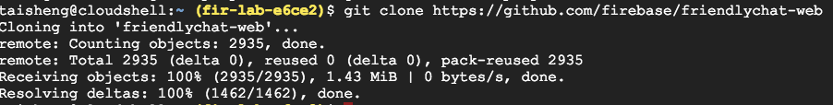
* **Use npm to install the Firebase CLI.**
* **In Cloud Shell**
  + 
  + 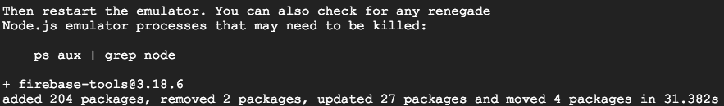
* **To verify that the CLI has been installed correctly, run**
  + 
* **Authorize the Firebase CLI to deploy app by running**
  + 
* **Visit URL given and login to your pdx.edu account**
* **Get authorization code and paste it in to complete login**
  + 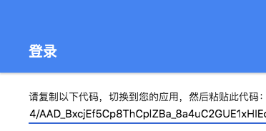
  + 
* **Make sure you are in the web-start directory then set up Firebase to use your project**
  + 
* **Use arrow keys to select your Project ID and follow the instructions given.**
  + 
* **At bottom of index.html before script inclusion**
* **Note: Comment out the other two JS files**
  + 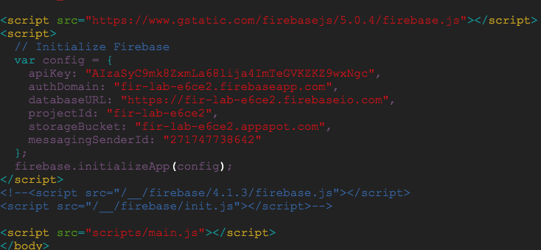
* **Run the app on the development server**
  + 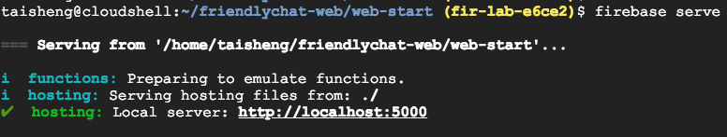
* **Click on link or go to Web Preview, change port to 5000, and preview**
  + 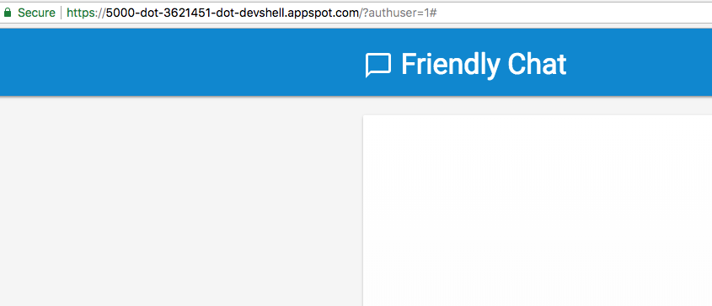
* **In scripts/main.js modify FriendlyChat.prototype.initFirebase function to set shortcuts to Firebase SDK features and initiate auth (Line 57)**
  + 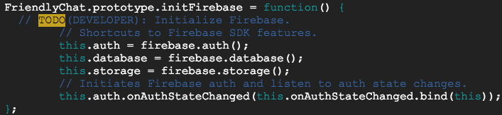
* **Change the FriendlyChat.prototype.signIn function to set Google as identity (OAuth) provider (Near Line 117)**
  + 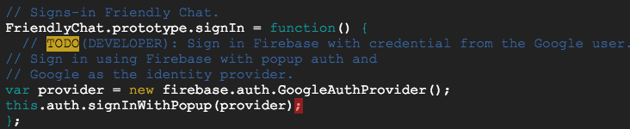
* **Also set the FriendlyChat.prototype.signOut function just below**
  + 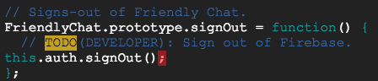
* **FriendlyChat.prototype.onAuthStateChanged function triggers when the auth state changes.**
* **Change the two lines with a TODO to read the user's profile pic and name from OAuth provider (Google)**
  + 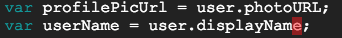
* **To detect if the user is signed-in add these few lines to the top of the FriendlyChat.prototype.checkSignedInWithMess age function where the TODO is located:**
  + 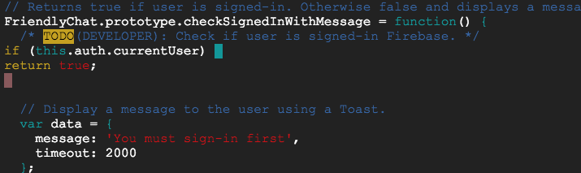
* **If you want to test with the development server (i.e. vi firebase serve), you will need to authorize its appspot domain it is served from**
* **Firebase=>Authentication=>Sign-in Method=>Authorized Domains**
* **The domain used on a firebase deploy is enabled by default ($PROJECT_ID.firebaseapp.com)**
  + 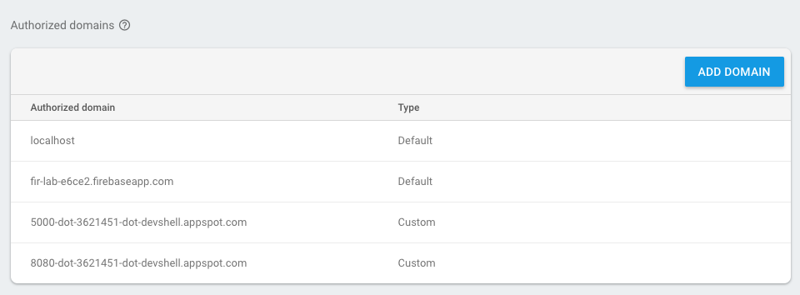
* **Ensure that third-party cookies are enabled**
* **In Chrome=>Settings=>Advanced=>Privacy and Security=>Content Settings=>Cookies=>Block Third Party Cookies**
  + 
* **Update app**
  + 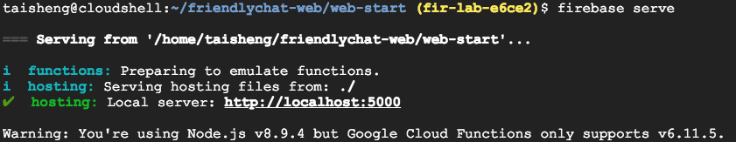
* **Click on link or go to Web Preview and change to 5000**
* **Sign-In with Google**
* **Show that the Google profile pic and name of the user is displayed**
  + 
* **Create a JSON file called initial_messages.json on your local machine**
* **Paste the FriendlyChat messages below into it (for import)**
* **Note that the messages are also included in the initial_messages.json file at repository root**
  + 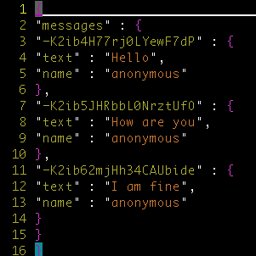
* **Firebase=>Database**
* **Overflow drop-down on the far right, select Import JSON.**
* **Browse to initial_messages.json file created**
* **Select it then click Import**
* **This will replace any data currently in your database.**
  + 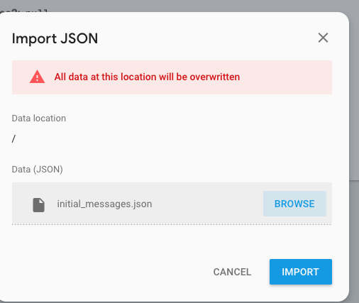
  + 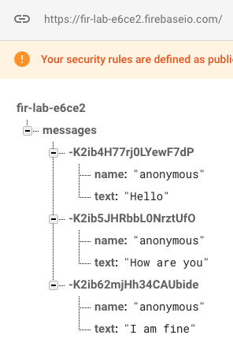
* **Modify FriendlyChat.prototype.loadMessages function in main.js**
* **Synchronize messages on the app across clients**
* **Add listeners that trigger when changes are made to data**
* **Listeners update UI element for showing messages.**
* **Only display the last 12 messages of the chat for fast load**
  + 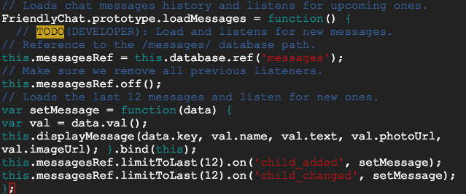
* **Run firebase serve again to update your app**
* **Sample messages imported earlier should be displayed in the Friendly-Chat UI**
  + 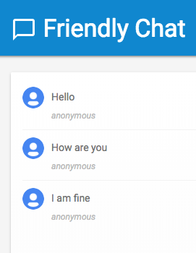
* **Go back to Firebase Database web UI to view messages in database**
* **We will manually add a message and it will update the UI in real-time automatically**
* **Click + to add child to messages**
* **Click on + to add a child to the initial Name:Value entry**
* **Then, in under the parent, click + again to add a second child (Do not embed second child under the first)**
* **Set the name of the Key in first row as well as the Name:Value entry for the name of the user and the text they sent. As soon as you "Add", switch quickly back to running app to see update**
  + 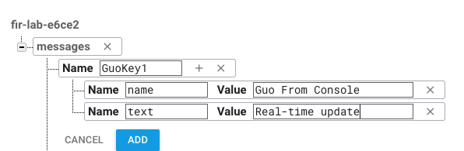
  + 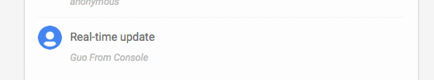
* **Update FriendlyChat.prototype.saveMessage**
  + 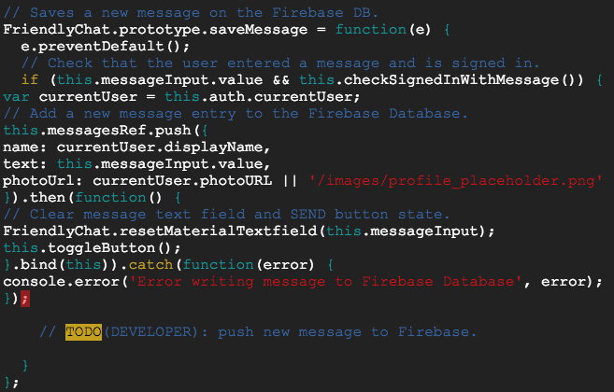
* **Update your app**
* **Sign-in to Google if necessary**
* **Click on Message box, type a message and click Send**
  + 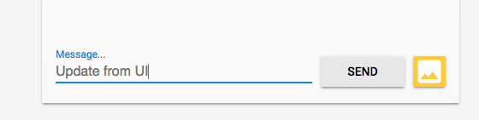
  + 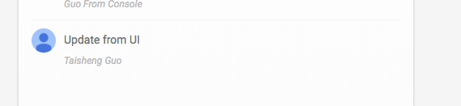
* **Message will be inserted into real-time database**
* **UI will automatically update with message and the account profile picture**
* **Note One can mock up an iOS or Android client version to interoperate (see the two other codelabs)**
* **Skip steps 9, 10, 11, and 12 (unless you want to try it)**
* **Deploy app**
  + 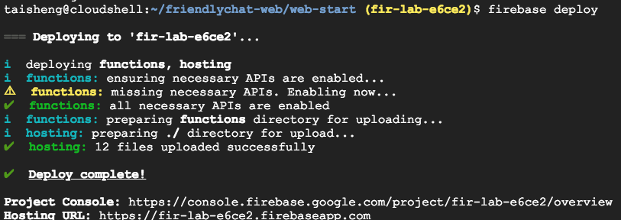
* **Send URL to partner or instructor so they can add messages via their Google account**
* **Show a screenshot of messages sent by multiple users**
  + 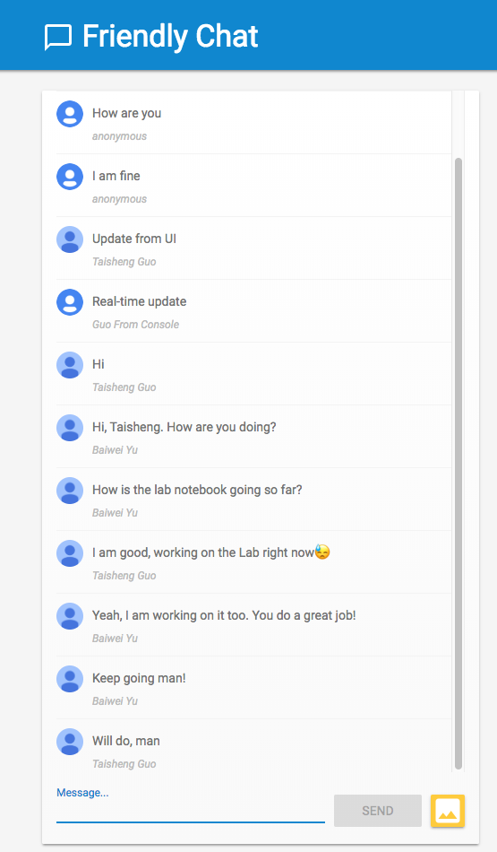
* [**https://codelabs.developers.google.com/codelabs/firebase-web**](https://codelabs.developers.google.com/codelabs/fireb) **(39 min)**

# BigQuery Lab #1(Taisheng)

* **Create datasets and run queries on BigQuery (25 min)**
* **Launch Cloud Shell**
* **List the APIs to see the range of services available**
  + 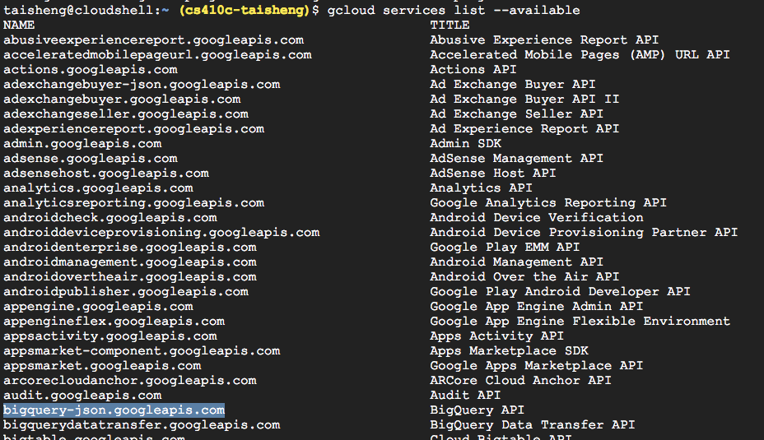
* **To enable a service like the Cloud Datastore API, the command would be**
  + 
* **From the list, enable the BigQuery API**
* **Go to console, and menu of services**
* **BigQuery**
* **Click on drop-down next to project name and create dataset**
* **For Dataset ID, type cp100**
  + 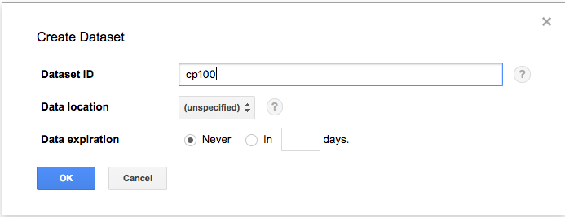
* **Copy file from bucket into Cloud Shell and take a look**
  + 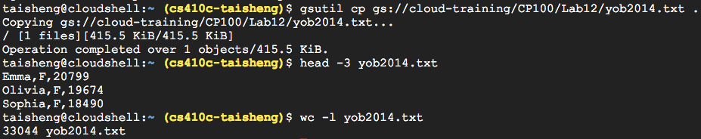
* **Create table from file in bucket**
* **Specify input file location and format (CSV)**
* **Specify table name (namedata), table type (native) and schema columns and types**
* **Edit schema to add fields for name and gender as STRING, count as INTEGER**
* **Field delimiter as a Comma, then Create Table**
* **Click table and Preview, show the number of rows in Details**
  + 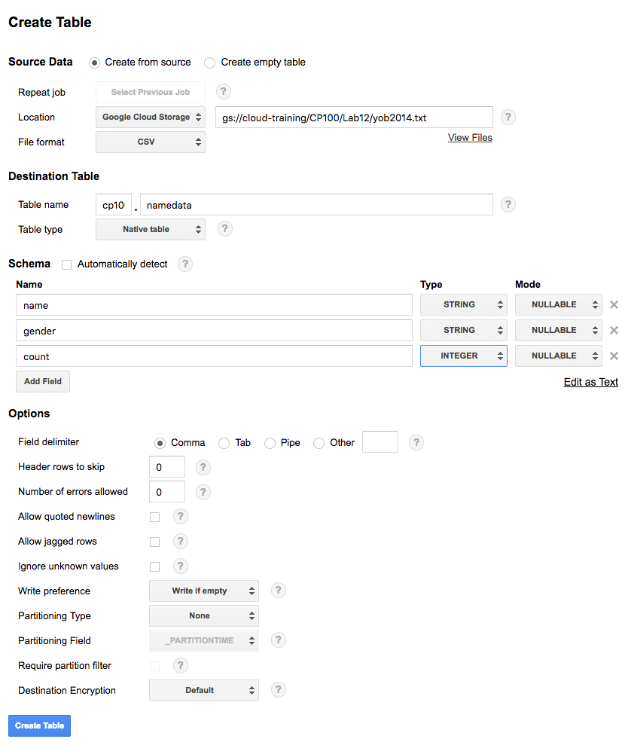
  + 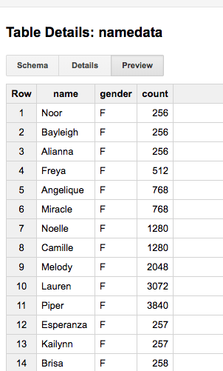
  + 
* **Via UI**
* **Click on "Query Table"**
* **Run a query that lists the 20 most popular female names in 2014**
  + 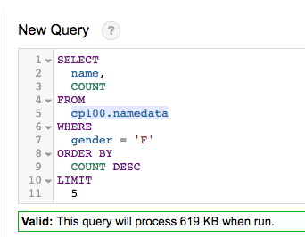
* **Click on Validator to see how much data you will hit before running**
  + 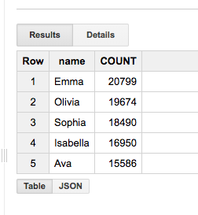
* **Via command-line in Cloud Shell**
* **Run query to get the 20 least popular boys names in 2014**
  + 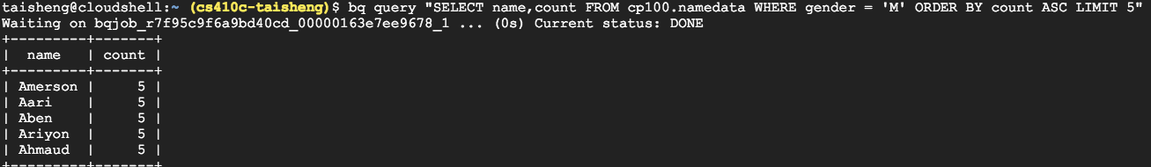
* **Via BigQuery shell (bq shell)**
* **Run a query to find 20 most popular male names in 2014**
  + 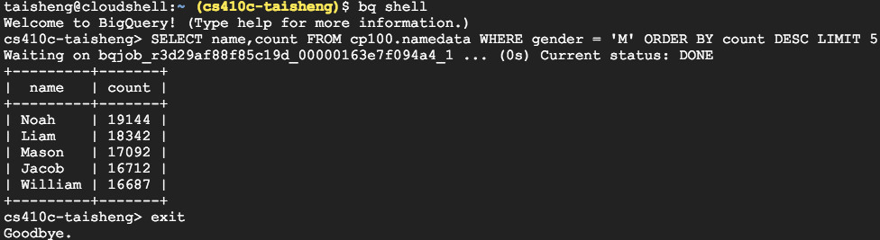
* **Keep project**
* **Create datasets and run queries on BigQuery**
* [**https://codelabs.developers.google.com/codelabs/cp100-big-query/**](https://codelabs.developers.google.com/codelabs/cp100-big-query/) **(25 min)**

# BigQuery Lab #2(Taisheng)

* **Query Github Data Using BigQuery (8 min)**
* **(Extra: not in Codelab) Find public dataset containing all of the blocks and transactions on the Bitcoin block- chain**
* **Click on Preview to find the number of blocks that are currently being stored on a full node.**
  + 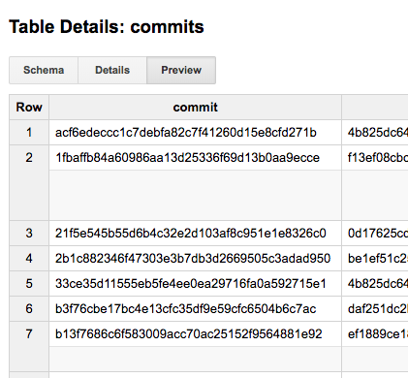
* **Click on Details to find the size of the block-chain in BigQuery (uncompressed).**
  + 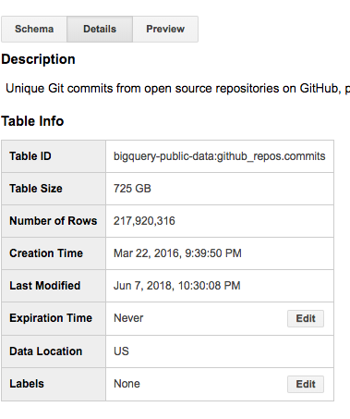
* **Visit dataset containing all github commits**
* [**https://bigquery.cloud.google.com/table/bigquery-public-data:github_repos.commits**](https://bigquery.cloud.google.com/table/bigquery-public-data:github_repos.commits)
* **Click on Preview and examine the columns associated with commits**
* **Click on Details to find the size of the commits table**
* **Go to console, and open a BigQuery window**
* **Click on "Compose Query"**
* **Click Show Options**
* **Unclick Legacy SQL (to use standard SQL)**
  + 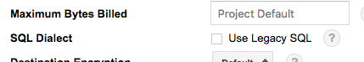
* **Enter a query to find commits with duplicate subject lines (commit messages)**
  + 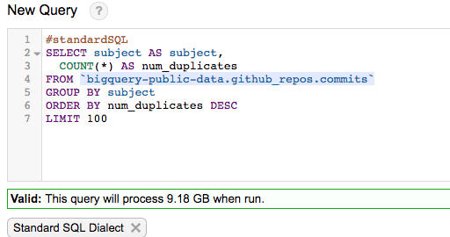
* **Open the validator and show the amount of data that will be processed in query if executed**
* **Run the query to find commits with duplicate subject lines (commit messages)**
* **What is the most common subject message used?**
  + **Update README.md is the most common subject message**
* **Show quickly the query runs**
  + 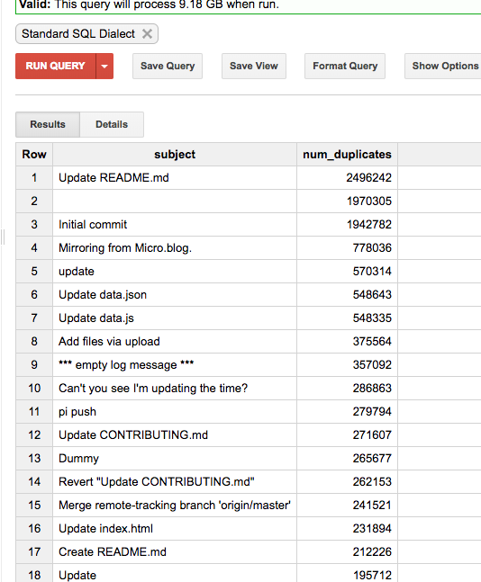
* **Run query to find projects with the most contributors**
* **Extract name of repo from repo_name path**
  + 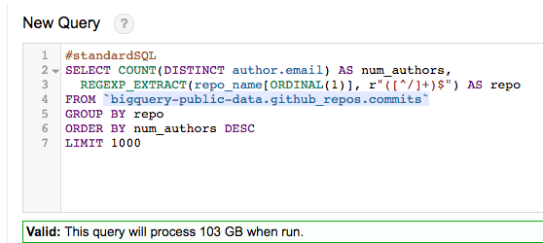
  + 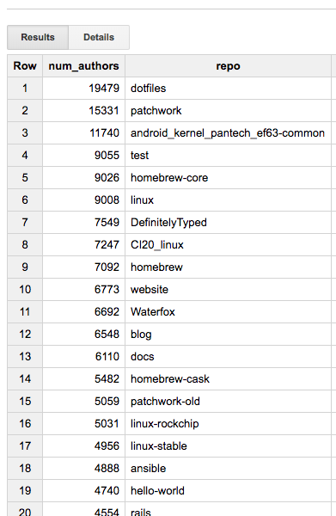
* **Run query to find most popular languages used in commits**
  + 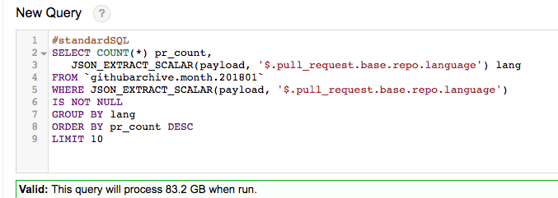
  + 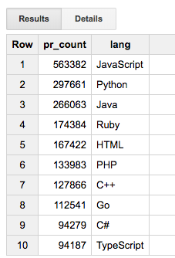
* **Query Github Data Using BigQuery (8 min)**
* [**https://codelabs.developers.google.com/codelabs/bigquery-github**](https://codelabs.developers.google.com/codelabs/bigquery-github)

# 

# BigQuery Lab #3(Taisheng)

* **Looking at campaign finance with BigQuery (14 min)**
* **First 8 steps**
* **Skip step 2 (should already be done)**
* **Create a dataset via bq command-line interface**
  + 
* **Source of campaign finance data and its format are at**
* [**http://www.fec.gov/finance/disclosure/ftpdet.shtml**](http://www.fec.gov/finance/disclosure/ftpdet.shtml)
  + 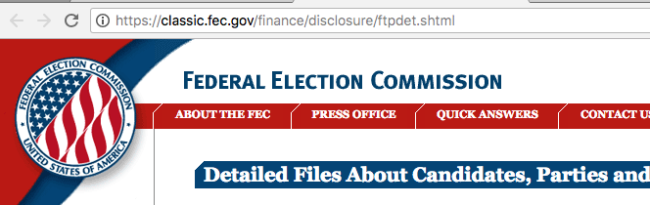
* **Copy uncompressed version from a GCS bucket and examine the last several entries with tail**
  + 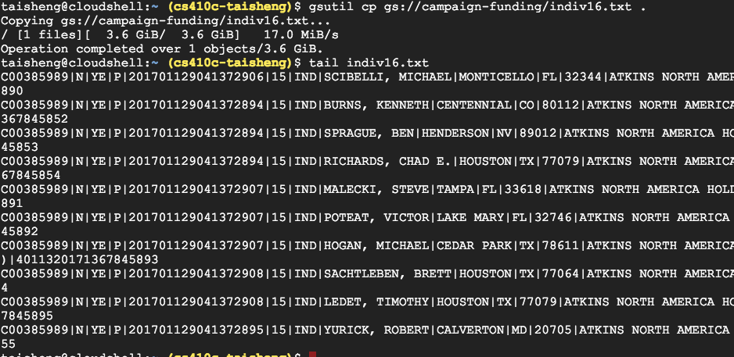
* **Use du and wc to find out how large the file is and how many individual contributions were made**
  + 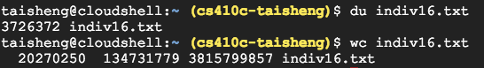
* **Contribution data definitions by individuals (indiv16.txt), by committees, and by candidates available at**
* [**https://classic.fec.gov/finance/disclosure/metadata/DataDictionaryContributionsbyIndividuals.shtml**](https://classic.fec.gov/finance/disclosure/metadata/DataDictionaryContributionsbyIndividuals.shtml)
* [**https://classic.fec.gov/finance/disclosure/metadata/DataDictionaryCommitteeMaster.shtml**](https://classic.fec.gov/finance/disclosure/metadata/DataDictionaryContributionsbyIndividuals.shtml)
* [**https://classic.fec.gov/finance/disclosure/metadata/DataDictionaryCandidateMaster.shtml**](https://classic.fec.gov/finance/disclosure/metadata/DataDictionaryContributionsbyIndividuals.shtml)
* **We will be linking a BigQuery table with these definitions to the downloaded files stored in GCS**
* **Create a BigQuery definition specifying CSV data from the bucket location via command-line and obtain data definition JSON output**
  + 
* **Note that file is not actually in CSV format**
* **Data separated by pipe character '|'**
* **In Line #6, change fieldDelimiter to indicate this**
* **Or run...**
  + 
* **Copy similarly modified definition files for committee and candidate data**
  + 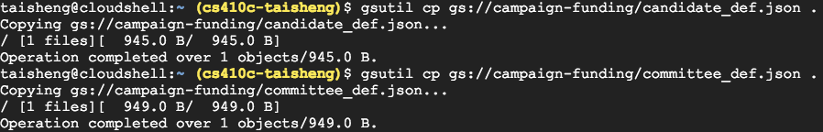
* **Create BigQuery tables with the definitions**
  + 
* **Note that because BigQuery tables are linked to flat files, queries will not perform well for large data**
* **Goto BigQuery UI and run a simple query**
  + 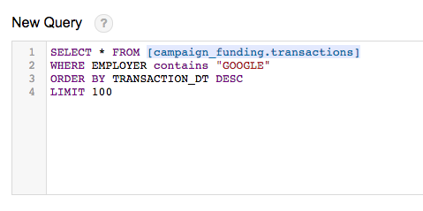
  + 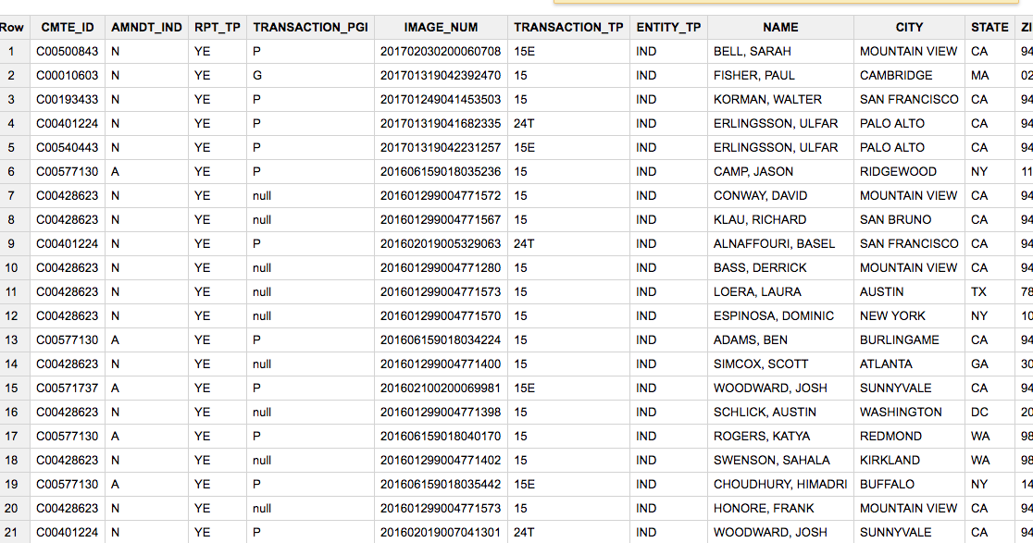
* **Note that because we pointed BigQuery to files in a storage bucket, the validator will not be able to estimate the amount of data that will be processed for the query**
* **Then run the following query to obtain party-based contributions for those with an engineering occupation**
  + 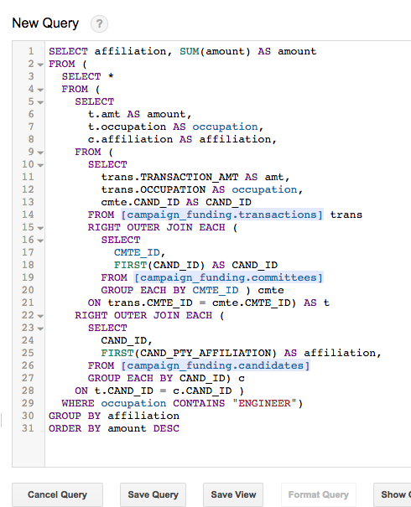
  + 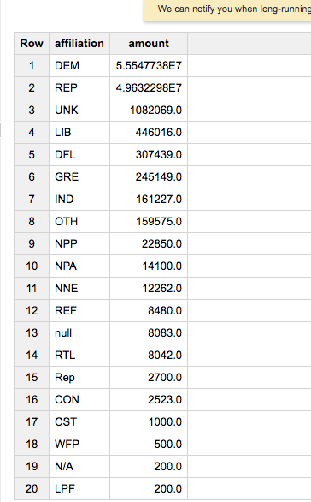
* **Query needs to join with committees table (Republican/Democratic) and candidates table to associate candidate to party for individual contribution**
* **Repeat previous query on any other profession besides Engineer to find**
* **A profession that has more Republican contributions than Democratic**
* **A profession that has more Democratic contributions than Republican**
* **Looking at campaign finance with BigQuery (14 min)**
* **First 8 steps**
* [**https://codelabs.developers.google.com/codelabs/cloud-bq-campaign-finance**](https://codelabs.developers.google.com/codelabs/cloud-bq-campaign-finance)

# Cloud Datalab Lab #1(Taisheng)

* **Analyzing data using Datalab and BigQuery (11 min)**
* **Launch Cloud Datalab docker container onto a VM instance nearby**
* **Go to next step while waiting (takes > 5 min)**
  + 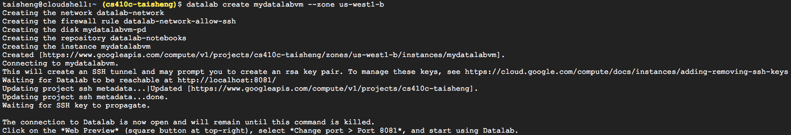
* **Run standard SQL query to list delayed departures**
  + 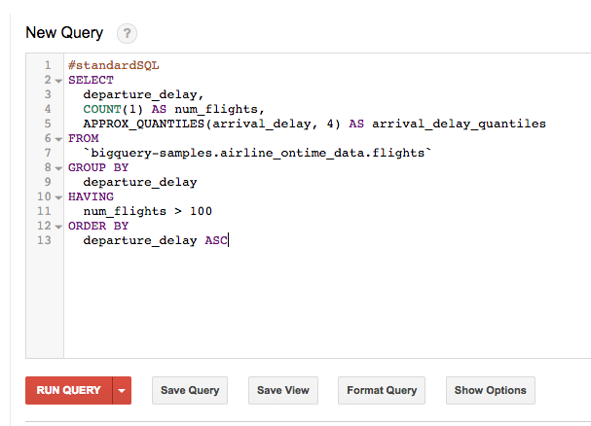
  + 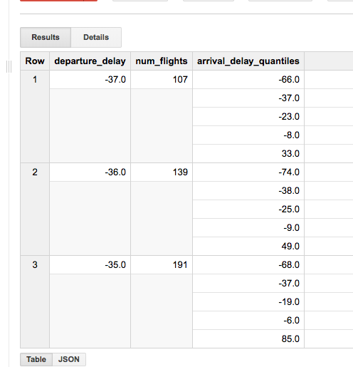
* **Run query to find 20 most popular flights**
  + 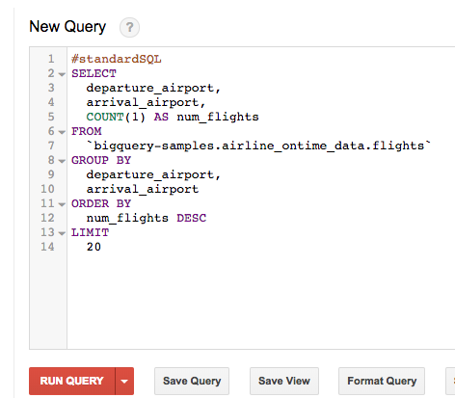
  + 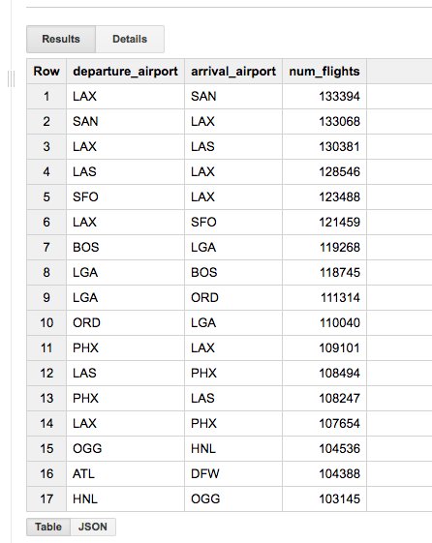
* **Go back to Cloud Shell that launched Cloud Datalab**
* **Go to Web Preview of shell, change port to 8081, and preview to pull up Cloud Datalab UI**
  + 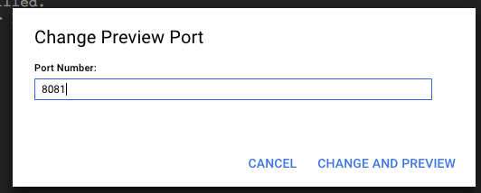
  + 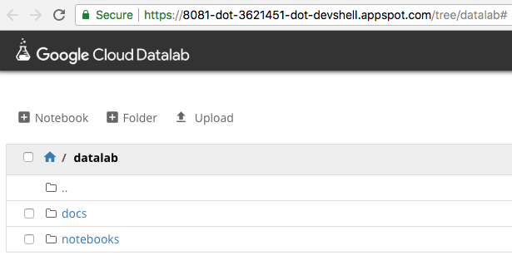
* **Start a new notebook called 'flights'**
  + 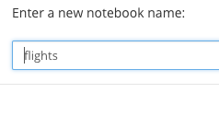
* **Paste Python code into notebook cell and run it**
  + 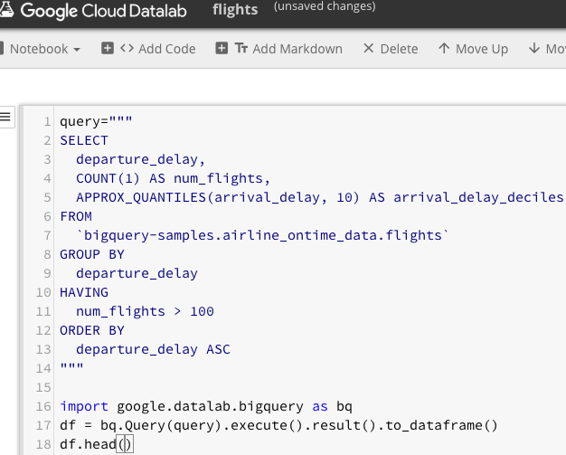
* **Note that df is a pandas data-frame**
* **Get count of flight departure delays and their associated arrival delays, then run**
  + 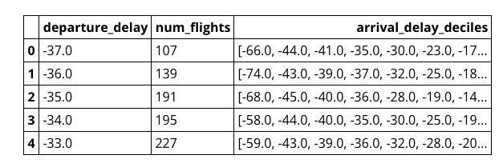
* **Append a new code cell to notebook**
* **Paste Python code to create deciles on arrivals in next notebook cell and run it**
  + 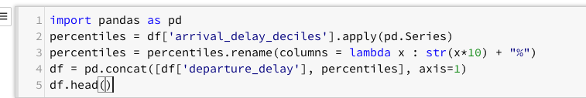
  + 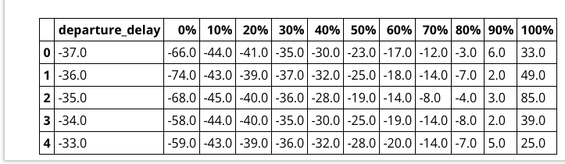
* **Paste Python code to plot delays into next notebook cell and run it**
  + 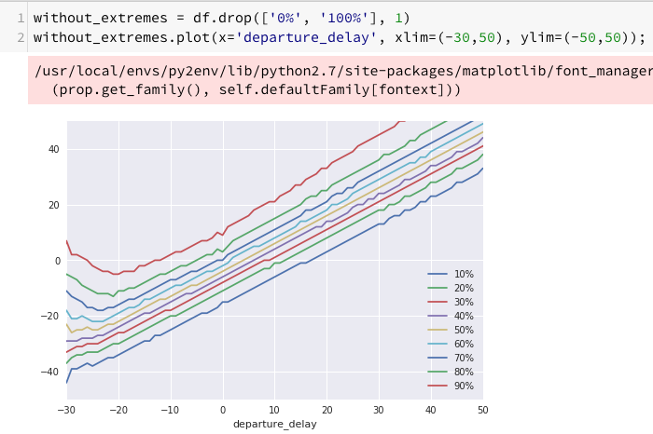
* **Show the plot**
* **Skip Step #5**
* **Analyzing data using Datalab and BigQuery (11 min)**
* **Link**
* [**https://codelabs.developers.google.com/codelabs/mlimmersion-data-analysis/**](https://codelabs.developers.google.com/codelabs/mlimmersion-data-analysis/)

# Cloud Datalab #2(Taisheng)

* **Image Classification Using Cloud ML Engine & Datalab (30 min)**
* [**https://codelabs.developers.google.com/codelabs/cloud-ml-engine-image-classification**](https://codelabs.developers.google.com/codelabs/cloud-ml-engine-image-classification)
* **Steps through work flow of an ML data-scientist**
* **Other notebooks included in samples directory**
* **Codelabs for other scientific computing notebooks in next lecture**
* **Start at Step #4 (use previous Datalab instance)**
* **Plot the initial graph and render some Markdown**
  + 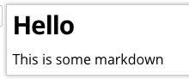
  + 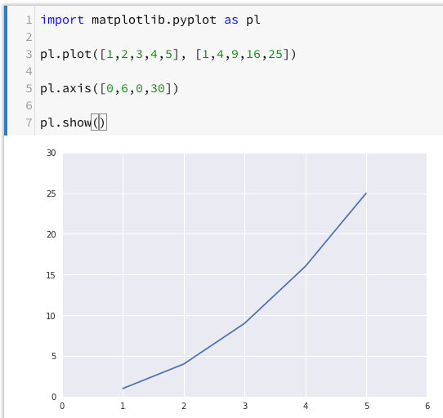
* **In Cloud Datalab, click on Home icon, then navigate to**
  + 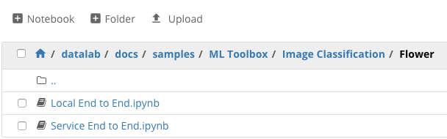
* **Click on**
  + 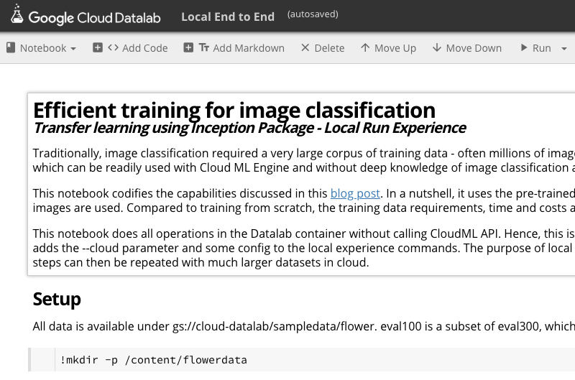
* **In notebook, clear all cells**
  + 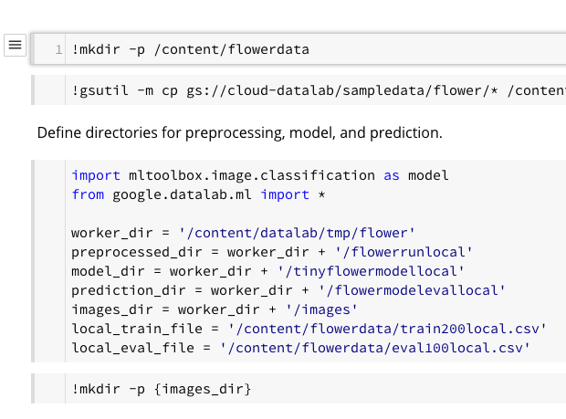
* **The notebook will take a pre-trained model, then allow you to apply transfer learning to modify the model with your own flower images**
* **Performs typical steps in an ML workflow (preprocessing data, training, prediction, and evaluation)**
* **Individually select code cells and click Run**
* **Download and store image information in CSV files and the images themselves from GCS to Datalab VM**
* **Go back to Cloud Datalab to see files**
* **/content places you at the root of the notebook**
* **Run the Cloud Dataflow pipeline to prepare the images and run it through pre-trained model in TensorFlow**
* **Then evaluate the new model, put results into BigQuery and analyze**
* **Stop TensorBoard and delete BigQuery tables at the end**

# Cloud Dataproc Lab #1(Taisheng)

* **Square with sides of length 1 (Area = 1)**
* **Circle within has diameter 1 (radius = 1⁄2)**
* **Area is ?**
* **Randomly throw darts into square**
* **What does the ratio of darts in the circle to the total darts correspond to?**
  + **1/π^4**
* **What expression as a function of darts approximates π ?**
* **Algorithm**
* **Spawn 1000 dart-throwers (map)**
* **Collect counts (reduce)**
* **Modified computation on quadrant**
* **Randomly pick x and y uniformly between 0,1 and calculate "inside" to get ratio**
* **Dart is inside orange when x2 + y2 < 1**
* **Provisioning and Using a Managed Hadoop/Spark Cluster with Cloud Dataproc (Command Line) (20 min)**
* **Enable API**
  + 
* **Skip to end of Step 4**
* **Set zone to us-west1-b (substitute zone for rest of lab)**
  + 
* **Set name of cluster in CLUSTERNAME environment variable to <username>-dplab**
  + 
* **Create a cluster with tag "codelab" in us-west1-b**
  + 
* **Go to Compute Engine to see the nodes created**
  + 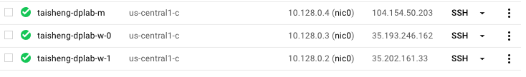
* **Note the current time, then submit job specifying**
  + 
  + **1000 workers**
  + **stdout and stderr sent to output.txt via >&**
  + **Command placed in the background via ending &**
  + 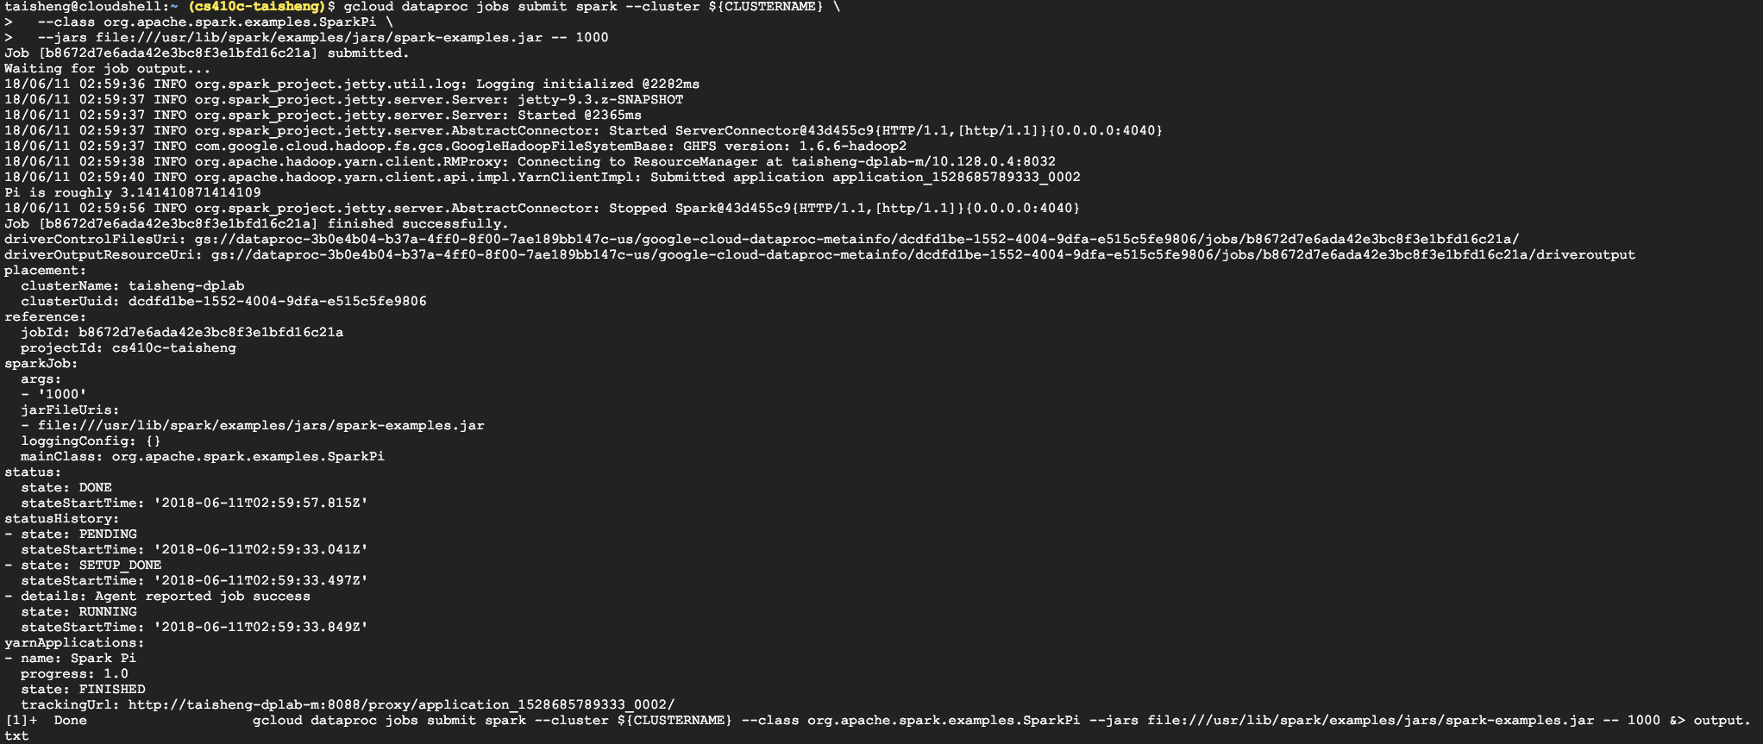
* **List the jobs periodically via**
  + 
* **When done, note the time. How long did it take?**
  + 
  + **It took about 30 seconds**
* **Examine output.txt via less to find the string "Pi is"**
* **What is the estimate for π?**
  + 
* **Show the cluster to find the numInstances used for the master and the workers (save to a file if necessary)**
  + 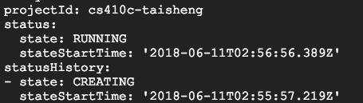
* **Allocate two pre-emptible machines to the cluster**
  + 
* **Repeat listing to see Config section they show up in**
  + 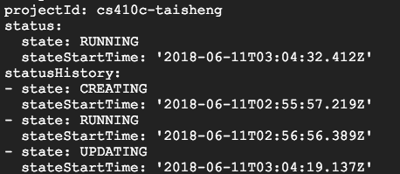
* **Show them in Compute Engine**
  + 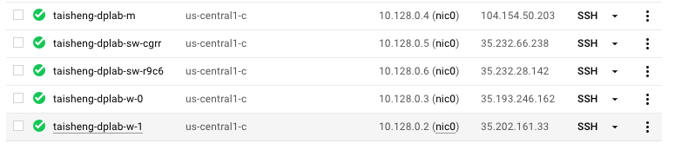
* **Note the current time, then submit job again, saving result to a different file**
  + 
* **List the jobs periodically via**
  + 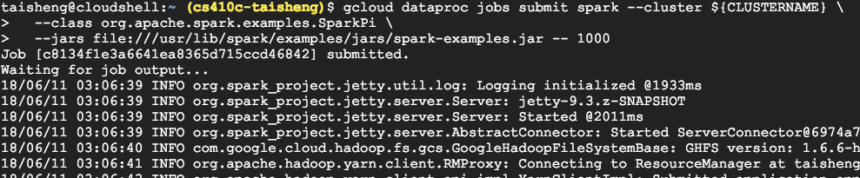
* **When done, note the time. How long did it take?**
  + 
  + **It took about 30 seconds**
* **What is the estimate for π?**
  + 
* **ssh into the master node**
  + 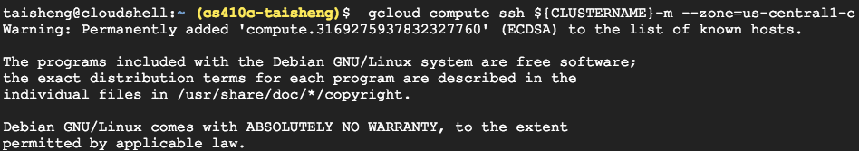
* **Once logged in, get the hostname**
  + 
* **List the cluster to show all VMs**
  + 
* **Then logout**
  + 
* **Skip Step 10**
* **Delete cluster**
  + 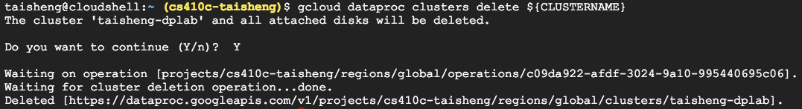
* **Ensure no instances from cluster are running on Compute Engine before continuing to Step 12**
* **Step 12**
* **Click on "Getting Started..." link to do the lab via the console**
* **Version #1: Provisioning and Using a Managed Hadoop/Spark Cluster with Cloud Dataproc (Command Line) (20 min)**
* [**https://codelabs.developers.google.com/codelabs/cloud-dataproc-gcloud**](https://codelabs.developers.google.com/codelabs/cloud-dataproc-gcloud)
* **Skip steps 1, 2, 3**
* **Step 4**
* **Goto Cloud Dataproc**
* **Create a cluster in us-west1-b with master and worker nodes set to n1- standard-2 VMs**
  + 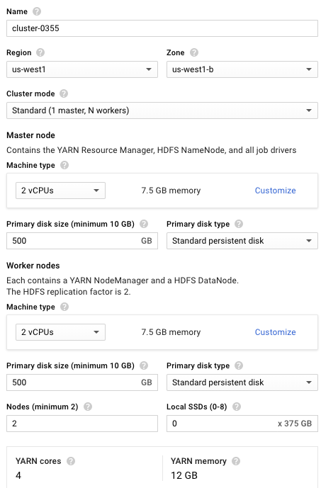
* **Click "Submit a Job", choose region and cluster just**
* **created**
* **Set job type to Spark**
* **Set name of main jar**
* **Java version**
* **Set args to 1000**
* **# of tasks**
* **Set location of jar**
  + 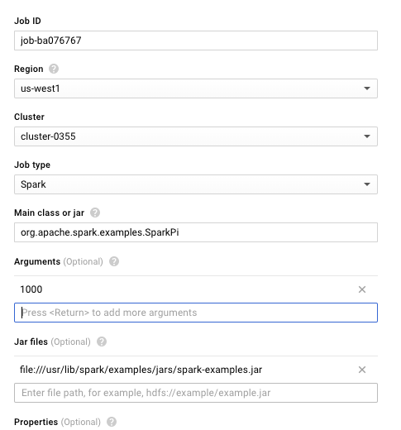
* **Start job and wait a minute for completion**
* **Upon completion, click on job, thenb click on Line wrapping to see output**
  + 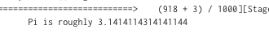
* **Delete cluster**
* **Version #2: Introduction to Cloud Dataproc: Hadoop and Spark on Google Cloud Platform (7 min)**
* [**https://codelabs.developers.google.com/codelabs/cloud-dataproc-starter**](https://codelabs.developers.google.com/codelabs/cloud-dataproc-starter)

# Cloud Dataflow Lab #1(Taisheng)

* **Run a Big Data Text Processing Pipeline in Cloud Dataflow (21 min)**
* **Generates a histogram of words in a file**
* **Default input file**
  + **gs://dataflow-samples/shakespeare/kinglear.txt**
* **Default output files at…**
  + **gs://${YOUR_OUTPUT_PREFIX}/**
* **Done in Java, but equivalents in Python, Go (typical languages used for data processing)**
* **Dataflow**
* **Split file into collection of lines**
* **Split lines into collection words**
* **Count words to generate collection of key-value pairs**
* **Extract word counts to generate collection of formatted output strings**
* **Output results to files**
* **Instantiate options from command-line arguments**
* **Create a Dataflow pipeline with the options**
* **Setup pipeline with transforms**
* **Call "ReadLines" on input file specified in options**
* **Call CountWords() transform**
* **Take histogram and generate formatted output (i.e. Strings**
* **Call "WriteCounts" on output file specified in options to write formatted output**
* **Note: Every transform supports an "apply" method**
* **Chained as in functional programming**
* **Main transform CountWords() done in two steps**
* **ParDo ExtractWordsFn() that takes collections of lines and generates collections of words via call to split**
* **Built-in transform Count() that takes collections of words and generates collections of word-counts (key-value pairs)**
* **Create output string from key-value collection that contains histogram information**
* **List the APIs to see the range of services available**
  + 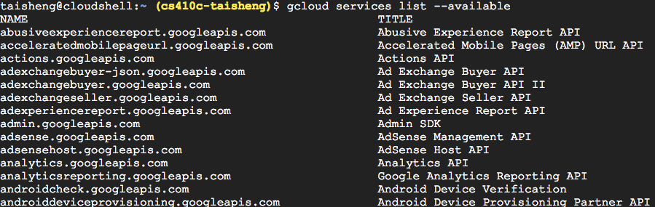
* **To enable a service like the Cloud Datastore API, the command would be**
* **From the list, enable the following services**
* **Google Cloud Datastore API**
  + 
* **Google Dataflow API**
  + 
* **Stackdriver Logging API**
  + 
* **Google Cloud Storage**
  + 
* **Google Cloud Storage JSON API**
  + 
* **BigQuery API**
  + 
* **Google Cloud Pub/Sub API**
  + 
* **Create a multi-regional bucket in Cloud Storage**
  + 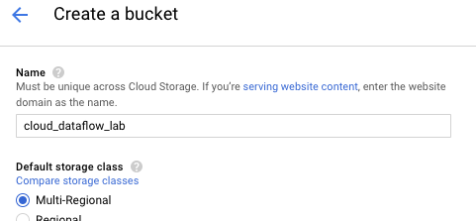
* **Launch Cloud Shell (note that the steps for setting the project are not necessary)**
* **Create an Apache Maven project**
* **Maven is a build automation tool used to construct application (compiles code, run tests, creates JAR file)**
  + 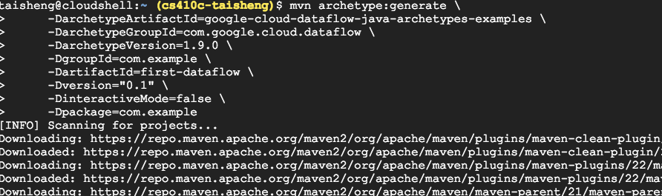
  + 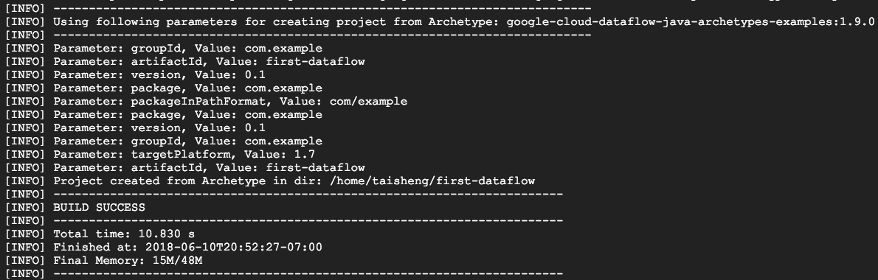
* **first-dataflow directory created**
* **Cloud Dataflow SDK for Java installed along with example pipelines**
* **Set environment variables for your PROJECT_ID and storage bucket**
  + 
* **Ensure GOOGLE_APPLICATION_CREDENTIALS environment variable is set and pointing to a valid JSON containing service account information**
* [**https://console.cloud.google.com/apis/credentials/serviceaccountkey?_ga=2.254517962.-33815533.1524620040**](https://console.cloud.google.com/apis/credentials/serviceaccountkey?_ga=2.254517962.-33815533.1524620040)
* **Change into project directory**
  + 
* **Use Apache Maven to build word-counting application**
* **Compile code, run tests, package results into JAR files**
  + 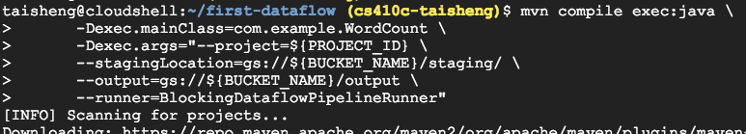
  + 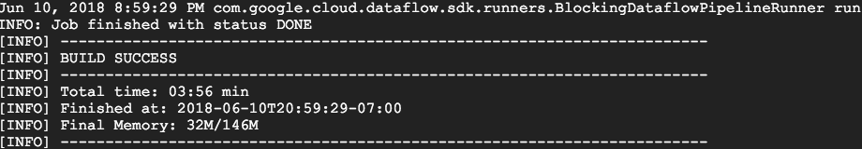
* **Examine timing information and worker execution history by clicking on job**
  + 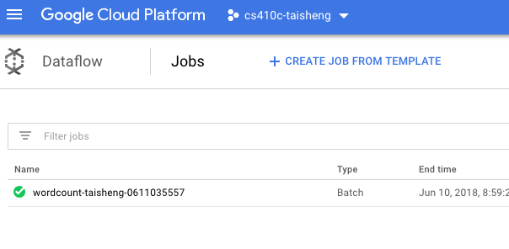
  + 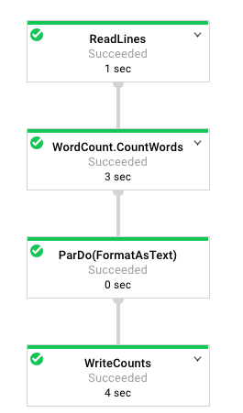
  + 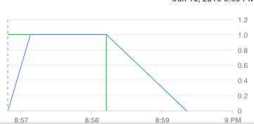
* **View output in bucket**
  + 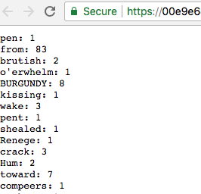
* **Clean-up (bucket)**
* **Run a Big Data Text Processing Pipeline in Cloud Dataflow (21 min)**
* [**https://codelabs.developers.google.com/codelabs/cloud-dataflow-starter**](https://codelabs.developers.google.com/codelabs/cloud-dataflow-starter)

# Data Science Lab #1(Taisheng)

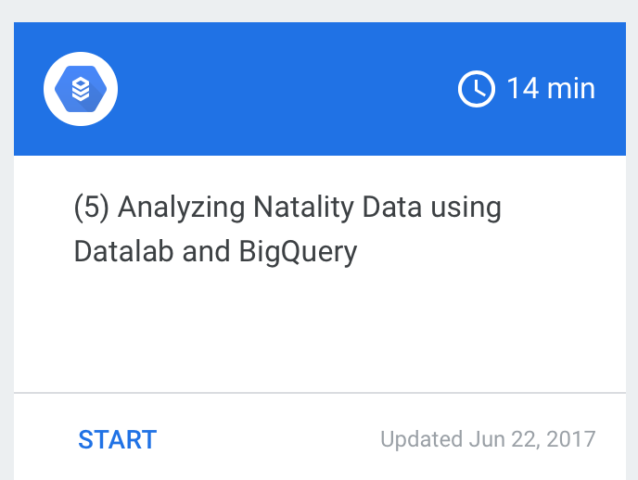

* **Step 2**
* **In Cloud Shell, type:**
  + 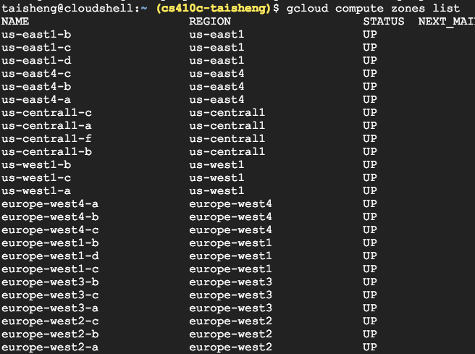
* **In Cloud Shell, type:**
* **datalab create babyweight --zone <ZONE>**
  + 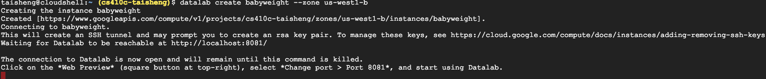
* **Navigate to the BigQuery console by selecting BigQuery from the top-left-corner ("hamburger") menu.**
  + 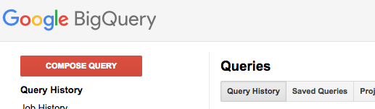
* **In the BigQuery Console, click on Compose Query. Then, select Show Options and ensure that the Legacy SQL menu is NOT checked (we will be using Standard SQL).**
  + 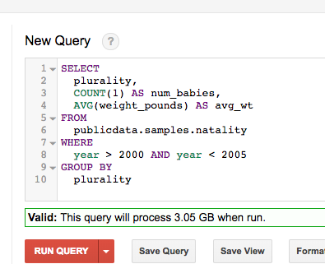
  + 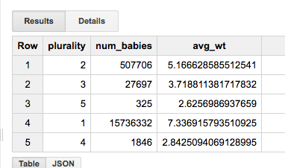
* **Click on the Web Preview icon on the top-right corner of the Cloud Shell ribbon. Switch to port 8081.** 
  + 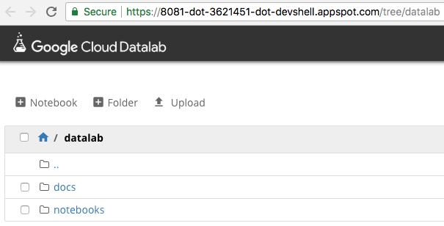
* **In Datalab, start a new notebook by clicking on the +Notebook icon.**
  + 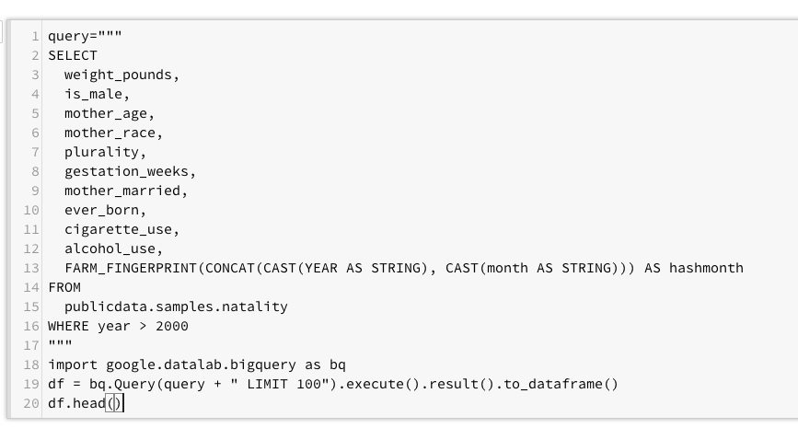
  + 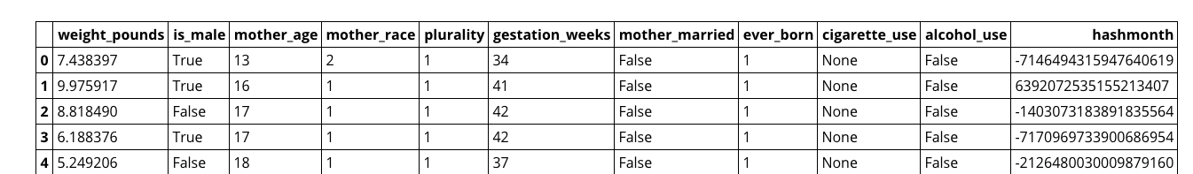
  + 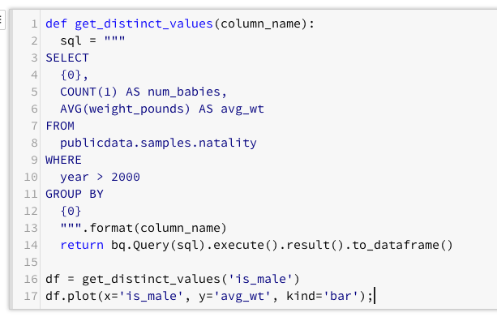
  + 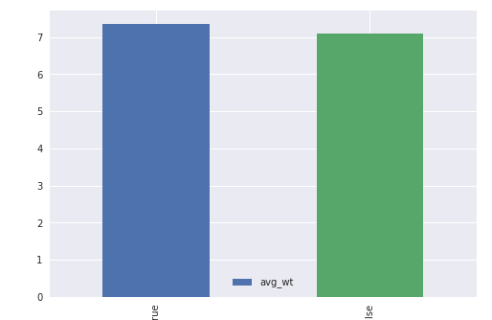
  + 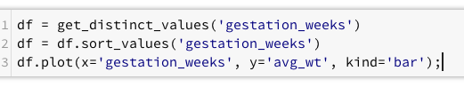
  + 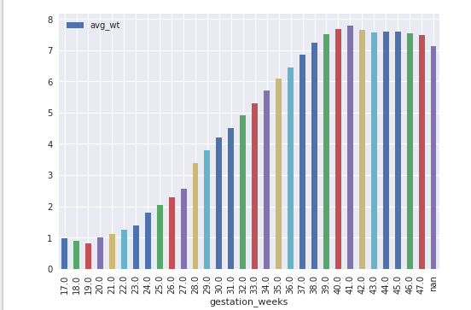

## Clean up